**Materials:**

2 Card Stock Templates

Scissors

Meter stick

Scale for weighing beams and pennies or washers

Ruler (to help fold with straight lines)

Washers or Pennies for weights

2 Books – same thickness, at least 10 inches tall, to support the beams

**Goal:**

We are going to make beams with two different widths and heights, but the same length. We will determine which shape can support the most mass without collapsing. Which beam shape would you predict will be stiffer based on your experience with the meter stick tests? (Circle it.)

F

F

F

**Procedure:**

1. 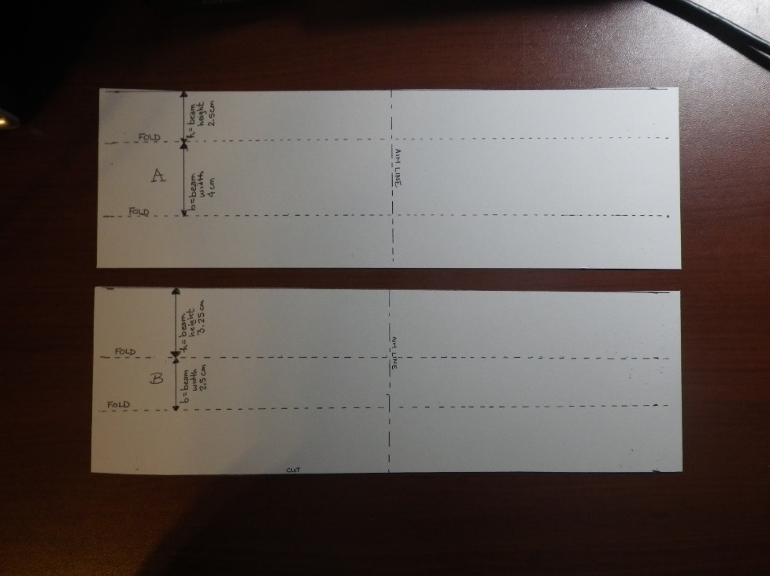Cut the card stock into two pieces that are 28 cm long x 9 cm wide. Label the pieces A and B. Mark the center of the length with an “aim” line across each piece. This line will be 14 cm from the end.
2. Fold piece A to create an open U shape that is 28 cm long. The bottom of the “U” should be 4 cm wide, and the legs of the U should be 2.5 cm tall. The line marking the center of the length dimension should be on the bottom side of the “U” so you can see it if you flip the U over and stand it on its legs. Use the edge of a ruler to help get straight folds. Record the mass of beam A: _________ grams
3. Fold piece B to create a taller U shape that is 28 cm long. The bottom of the “U” should be 2.5 cm wide, and the legs should be 3.25 cm tall. Record the mass of beam B: _______grams

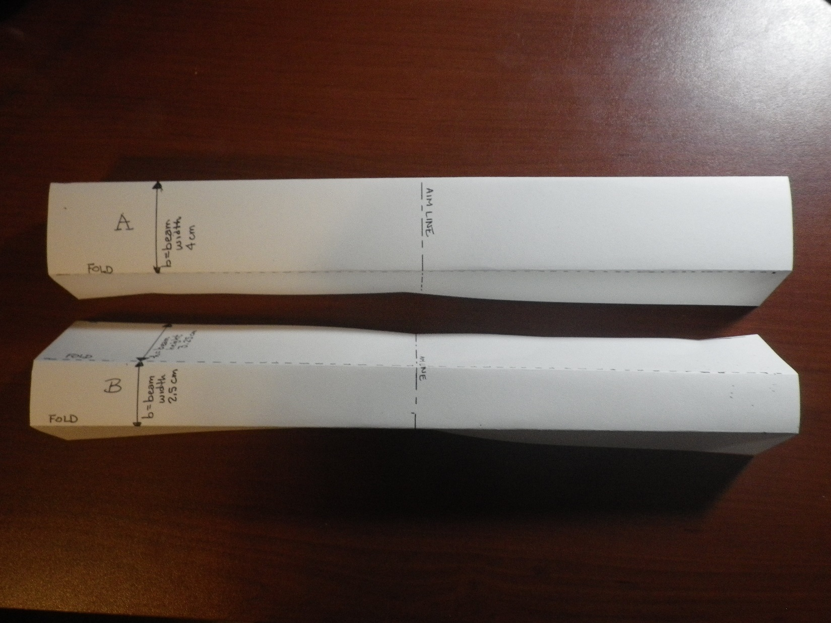

1. Stand both U channels on their legs so the bottom of the U faces up and you can see the centerline mark.
2. Mass 5 washers or pennies and calculate the average mass per washer or penny:

|  |  |  |  |  |  |  |
| --- | --- | --- | --- | --- | --- | --- |
| 1 | 2 | 3 | 4 | 5 | Sum of 1-5 | Average Mass (=sum/5) |
|  |  |  |  |  |  |  |

1. Stack the washers or pennies on the centerline of the beam and record the mass the beam can support.
   1. Channel A ___________grams
   2. Channel B ___________grams
2. Observe how your beam failed. Did both beams fail the same way?
3. Did your prediction match your observation?
4. The “Structural Efficiency” of the beam is a way to determine which beam design supported the most mass for a given mass of the beam structure. Calculate the structural efficiency here:

|  |  |  |  |
| --- | --- | --- | --- |
| Beam | Mass Supported (g)  (Step 6) | Mass of Beam (g)  (Steps 2 and 3) | Structural Efficiency (g/g)  =Mass Supported/  Mass of Beam |
| A |  |  |  |
| B |  |  |  |

1. If we are trying to relate this beam test to the stiffness of the metal between the driver and passenger doors in a car during a side impact crash, how should we change the test method to better represent the car crash test? Draw, diagram, or describe your proposed test method.
2. In the crash test video we watched, the doors were closed when the car was impacted. Make 2 new beams and mass them. Place your beams between two heavy books to act like the doors on the sides of the beam. Load the center line of your beams again and record the mass at which they failed, and how they failed. (If your tower of pennies or washers is too tall, make two towers, one on each side of the center line, and add the weights equally to each tower.)

Channel A:

Mass of beam:

Mass of pennies or washers that caused it to fail: ________ grams

Mass supported divided by Mass of Beam: _________ gram/gram

Failure description or diagram:

Channel B:

Mass of beam:

Mass of pennies or washers that caused it to fail: ________ grams

Mass supported divided by Mass of Beam: _________ gram/gram

Failure description or diagram:

1. Determine the structural efficiency here:

|  |  |  |  |
| --- | --- | --- | --- |
| Beam | Mass Supported (g)  (Step 6) | Mass of Beam (g)  (Steps 2 and 3) | Structural Efficiency (g/g)  =Mass Supported/  Mass of Beam |
| A |  |  |  |
| B |  |  |  |

1. What effect did providing side support have on the beam failure?
   1. The mass supported for the same shape?

Adding side support (increased or decreased) the mass the beam could support.

* 1. The structural efficiency of the same shape?

Adding side support (increased or decreased) the efficiency.

* 1. The ranking of structural efficiency comparing A to B with and without support?

Without support (A or B) had the highest structural efficiency

With side support (A or B) had the highest structural efficiency

(A or B) is the most mass efficient (highest collapse mass per mass of beam) shape.

Test Set Up for Side Supported Beam with Stacked Weights

(It’s easier to stack the weights if your supports are the same height as the beam, or slightly shorter.)

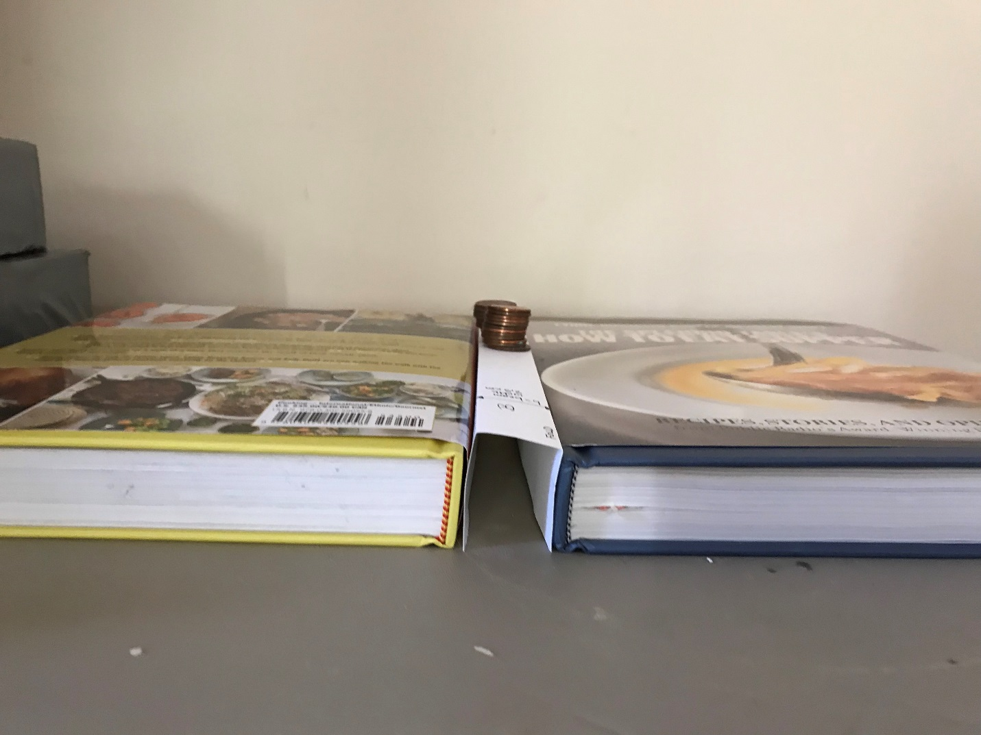



OPTIONAL: Crash test your beams using a pendulum impact

**Teacher Instructions:**

Equipment:

Ring stand

8 oz. water bottle with cap

String

Small cardboard box, 6-8” long

Scissors

C or Flat Clamp

2 Rulers

Masking tape

Graph Paper

Heavy books or a gallon jug of water to brace the box against

Note: The support for the beams is moved from the sides to the ends to open up a space for the pendulum to impact the beam. The fundamental effects of the beam shape on the deflection created by an impact should carry over from the stacked weight experiment.

Remind students that in the crash test video, the car hit with a fixed impact energy. After impact, the deflection of the B Pillar was measured. This lab can be run with fixed or variable impact energies by changing the mass of the impactor (water bottle) or by varying the height from which the bottle is released. To provide the best match to the crash test video, this procedure is written based on a fixed energy with the deflection resulting from the impact being the dependent variable.

Set Up:

* + - 1. Place a ring stand on a table, near the edge.
      2. Hang a small (e.g. 8 oz) water bottle with a cap from the ring stand. Adjust the string length so the water bottle hits the center of the beam length. You will need to do some preliminary testing to determine how much water to put in the bottle. Mass the water bottle, water, and string: M = ____grams.
      3. Make slits in a cardboard box approximately 6-8” long (or wood box ). The slits should be long enough to slide the card stock beam legs into the slits so the wide part of the beam is in contact with the edge of the box. The slits should be centered along the box width. The slits should be 2.5 cm and 4 cm apart. The beams need to overhang the ends of the boxes, or they will slip out of the slits when impacted. (See Figure 1.)
      4. Cut a portion of one side of the box away to create a “window” to view the impacted beams. (See Figure 2.)
      5. Clamp the box and ring stand to the table. I didn’t have a suitable clamp to fit inside the box, so I used a paint stir stick to do the best I could, then braced the back of the box against a jug of water so it didn’t move. I found that placing the box opening just behind the ring stand so that one end of the beam was in contact with the ring stand worked well. In a sense, having the support of the ring stand on the end of the beam is like having the B pillar attached to the roof of the car.

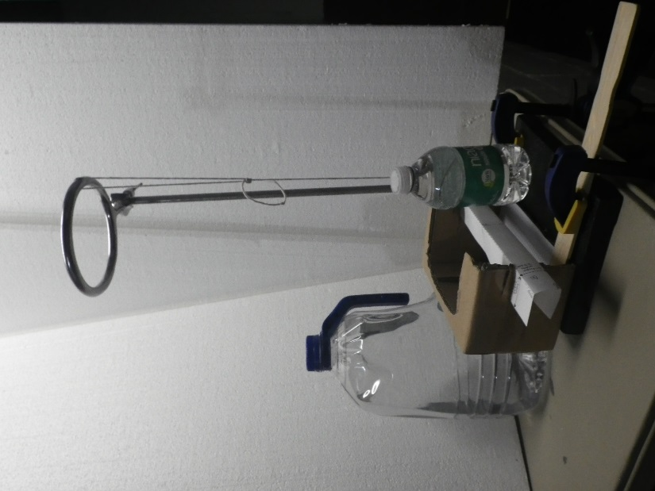 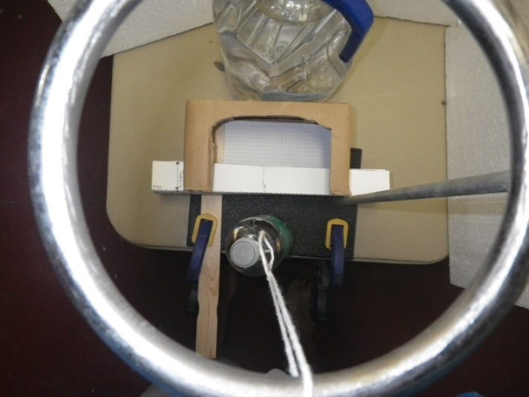

Figure 1: Side and top views of impact test setup using a pendulum anchored with a ring stand. One end of the beam is placed against the ring stand post, and graph paper inside the box to provide a measure of deflection. The gallon jug of water is simply bracing the box so it doesn’t move when the beam is impacted.

* + - 1. Put a line of masking tape on the ring stand straight out from the center of the beam as a guide for the pendulum path – you want to get a direct hit, without angular variation. You may also want to put a piece of tape on the ring to help align the string for the impact.
      2. (Optional) Place a ruler at the end of the tape to measure the height of the water bottle at the top of the pendulum swing. You want to impact the beams with a consistent potential energy. I just lifted the bottle to a visually determined 90°, even with the top of the ring stand

A. Determine the height for the students to use: ___ cm.

B. Calculate the potential energy for your test: PE = mgh = ___ Joules

m = mass of bottle and string, in *kg*

g = Gravitational constant, 9.8 m/s2 on the Earth’s surface

h = height from which the bottle is dropped, in *meters*

* + - 1. Have a second ruler available to measure the maximum beam deflection after impact, while the beam is still in the shoebox fixture, or tape a piece of graph paper in the box to use as a measure of maximum deflection. To accelerate testing, you could mark “good/pass/fail” deflection zones on the graph paper, similar to the system used by the IHSS crash tests.

Test Procedure:

Prepare new “Channel A” and “Channel B” samples. Reusing samples that collapsed under the weight bearing test may cause poor results in the impact test.

Mass the samples and record the mass:

* 1. Channel A ___________grams
  2. Channel B ___________grams

1. Slide the 4 cm wide Channel A into the slits in the test fixture.
2. With the string fully extended, raise the water bottle to a height of __ cm. Use the masking tape line to align the bottle with the center of the beam.
3. Smoothly release the bottle, without trying to throw or push it toward the beam.
4. Measure the maximum deflection of your beam from its starting position using the edge of the box as “zero”. Y = ___ cm
5. Determine your Channel A score:
   1. Divide the maximum deflection by the mass: S =Y/m =
   2. Lowest score wins.
6. Repeat the test for Channel B, using the slots that are closer together to hold the skinnier beam.
   1. Maximum deflection, Y= ___
   2. Channel B Score, S = Y/m = ____
7. Which beam had a better score, A or B?
8. Who had the best score in the class and how much different were the scores within each beam shape?

Example of a failed beam:

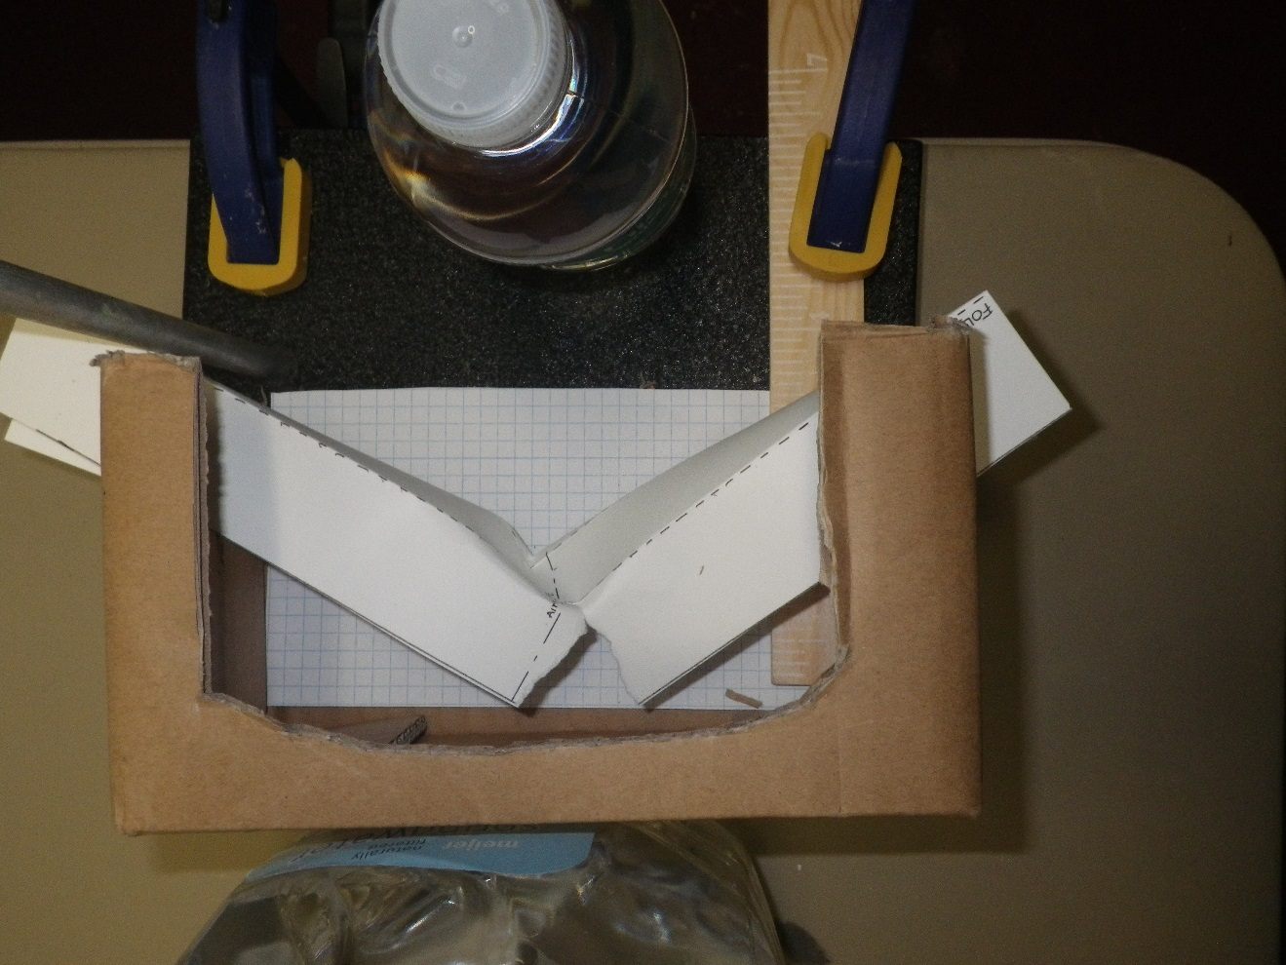

Figure 3: This beam tore after impact with a full 8oz water bottle raised to the top of the ring stand.

**BACKGROUND FOR TEACHERS**

The stiffness of a beam is related to its shape and the materials used to make it. The purpose of this lab is to highlight the effects of shape on stiffness. In this case, stiffness is the resistance to deflection under a force.

Please begin the lab with a quick warm up activity using a meter stick, ruler, or paint stir stick to provide students with a tangible experience of the effect of geometry on the ease of deflecting the beam.

The stiffness of a rectangular beam depends on the shape variables of length, height, and width. For a solid meter stick, the formula to predict how much the beam should deflect is:

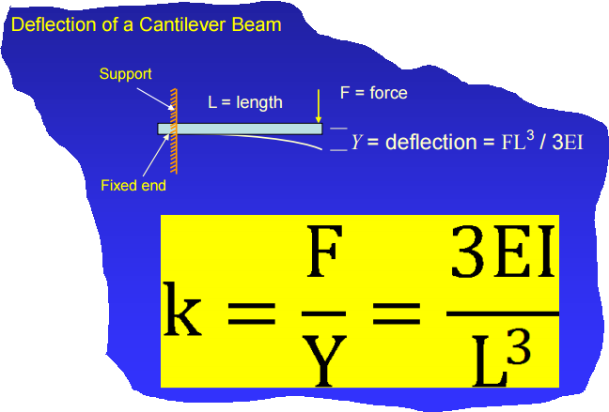

Y = FL3/4Ebh3

Y= deflection of the center or end of the beam

F = applied force

L = beam length

E = Young’s modulus (stiffness) of the beam material

b = width of beam

h = height of beam

Look at the formula and do a thought experiment with the meter stick in 3 positions:

1. Lay the meter stick on the table so the wide side is against the table and the numbers are facing up to the ceiling. Put the edge of the table at the 50 cm mark so half the stick is hanging off the table.
2. Starting from the position “A”, move the meter stick so the 75 cm mark is at the end of the table and 25 cm of the stick is hanging off the table.
3. Turn the meter stick so the numbers face to the side and the thin side is against the table. Move it so the 50 cm mark is at the edge of the table and half the stick is hanging off the table.

Looking at the formula, which meter stick position would you predict to be the hardest to deflect of the 3 positions described?

A. _______ 50 cm/wide side down

B. ______ 25 cm/wide side down

C. ______ 50 cm/thin side down

Let’s test your hypothesis by placing the meter stick as described in A, B, and C and gently pressing on the end of the meter stick hanging off the table to move it down about 1 cm.

Which position of the meter stick was hardest to move? A._______ 50 cm/wide side down

B. ______ 25 cm/wide side down

C. ______ 50 cm/thin side down

This experiment with the meter sticks should be followed by making and testing simple open “U” shaped beams with different shapes. The student’s lab instructions will begin with a hypothesis about which beam shape should be able to support more load without collapsing based on their experience with the meter stick.

Here’s the beginning of the students’ lab instructions:

We are going to make some beams with two different widths and heights, but the same length. We will determine which shape can support the most mass without collapsing. Which beam shape would you predict will be stiffer based on the formula and your experience with the meter stick tests? (Circle it.)

F

F

F

