**Materials:**

Two types of insulation foam board of the same thickness. (Owens Corning Foamular (pink) and expanded polystyrene foam (white). 0.75 - 1” thick work well. Do NOT choose laminated boards.)

Band saw, hack saw, utility knife, or wire saw to cut the boards into beam

Scale

C clamp or bar clamp

Small piece of plastic or wood (e.g. paint stir stick) to spread the clamp load across the specimen.

Meter stick

Permanent Marker

Wire or large paperclip

Flat washer

Wide mouthed water bottle, cup, or bucket that can be filled with mass to load the beam

A weighting material – e.g. water, sand, nuts….

(Alternative: Prefill water bottles with different masses, cap them, and mark the mass on the bottle.)

**Background:**

The deflection of a beam depends on the shape of the beam and on the material from which it is made. In this lab we will compare the stiffness of beams made from two different materials. Both beams will have the same shape. The measurements of the beam stiffness you’ll make in this lab can be used to predict the deflection of beams with different shapes. Engineers call the material property of “stiffness” the Elastic Modulus, and we use the symbol “E” in equations using the Elastic Modulus.

When engineers create a new design, they need the object to be strong enough to perform the required functions. In many cases it is also important to make the object as light as possible. We can divide the strength or stiffness of a component by how much it weighs to rate designs. When we divide strength or stiffness by the mass of the object, the ratio is called “Specific Strength” or “Specific Stiffness”. Using these “specific” ratings allows us to compare different design concepts, just as you can compare the fuel efficiency of a car based on miles per gallon. In addition to determining the stiffness of the beams, we will also determine which beam material provides the greatest stiffness per unit mass.

**Procedure:**

1. If your teacher hasn’t pre-cut the beams, cut 1 beam from each kind of insulation foam so they are as close to the same size as possible. If you are using extruded insulation, all the beams need to be cut in the same direction, because the extrusion process creates differences in strength depending on whether the beam is parallel or perpendicular to the extrusion direction. Target dimensions of 25 cm long x 4 cm wide x 1.8 or 2.5 cm tall worked well. Record the dimensions of your beams and the mass of your beams in Table 1.

Table 1: Beam data.

|  |  |  |  |  |  |
| --- | --- | --- | --- | --- | --- |
| Beam Identification | Length  (L, cm) | Width  (B, cm) | Height  (H, cm) | Mass (grams) | Slope of the Deflection vs. Mass Curve (“F/Y”, grams/cm) |
|  |  |  |  |  |  |
|  |  |  |  |  |  |

1. Mark a point 3 cm from the end of each beam, and try to center it across the width of the beam. Open the paper clip to make a hook. Push the straight end of the paperclip through the beam at the mark 3 cm from the end. Sandwich the washer between the hook part of the paperclip and the top surface of the beam, then pull the paperclip down so the hook is pushed back into the beam. (The washer will spread the force over a bigger area so the paperclip doesn’t come out during the testing.) Bend the straight end of the paperclip to make a hook below the beam. The weights will be hung from this hook during the test.
2. Clamp your beam to the table using a thin flat piece of plastic or wood such as a paint stir stick between your beam and the clamp to spread the clamp load over the clamped area. Don’t crush you sample by clamping too hard. Figure 1 shows an example of a beam ready to test. It is important to keep the length of the beam hanging off the table the same so we can compare results. Please try to have the end of your beam 18 cm from the edge of the table.
3. Mass the empty weighting system and wire to be used to attach it to the beam: Mo = ___________grams_
4. Attach the weighting system near the end of your beam.
   1. Measure the length between the edge of the table and where you attached the weighting system to your beam. This will be your unsupported length to use in calculating the beam deflection. Try to get Lu ~ 15 cm so we can compare the results without having an extra variable.

Beam 1 Lu = ____ cm Beam 2 Lu = ____ cm

1. Hold the meter stick so you can see when the beam bends 1-2 cm as you apply the load.
2. Working as a team, have one person slowly add mass to the weight system. Have a second person measure the beam deflection after each weight addition. Record the total mass and deflection after each addition using Table 2. **Stop** adding mass when your beam deflected more than 2 cm.

Table 2: Force-Deflection data.

|  |  |  |  |
| --- | --- | --- | --- |
| Beam 1  Mass Added (g) | Beam 1  Deflection (cm) | Beam 2  Mass Added (g) | Beam 2  Deflection (cm) |
| Weight of cup or bottle and string: |  |  |  |
| First addition to cup or bottle: |  |  |  |
| Second addition to cup or bottle: |  |  |  |
| Etc. |  |  |  |
|  |  |  |  |
|  |  |  |  |
|  |  |  |  |

1. Graph the force (weight) vs. deflection data for your beam on Figure 2, then calculate the slope of the straight part of the force-deflection curve. We are going to use this value to estimate the “Modulus” (E) of the beam:

Slope (rise over run) = Y/F = ________ cm/_______grams

We need to take the inverse of this value for beam design: 1/Slope = F/Y

Inverse Slope for my beam = F/Y = ___________ (grams)/___________cm = ___________g/cm

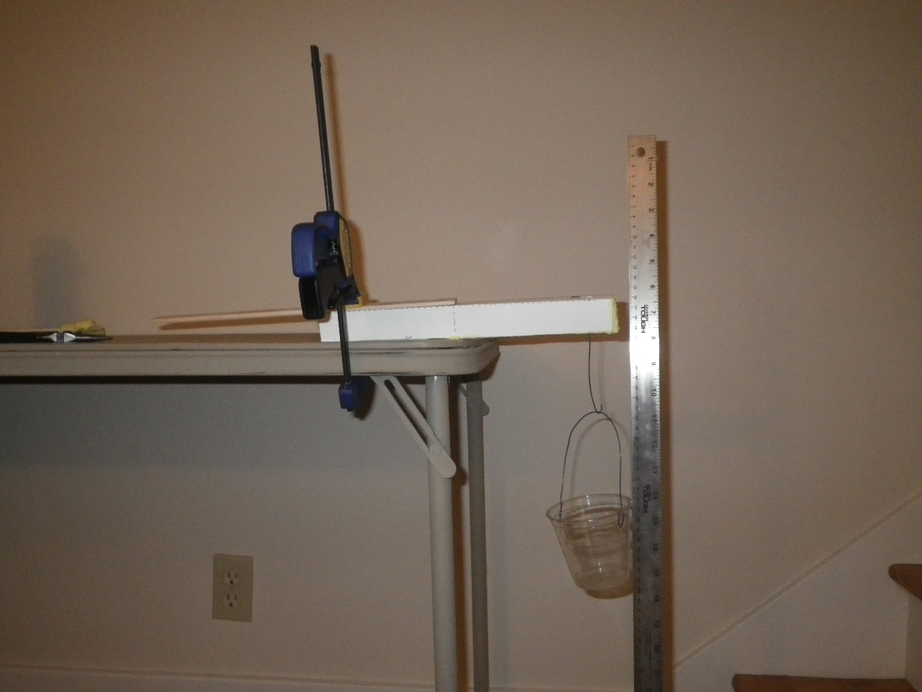

Table Top

Beam

String to Bottle or Cup

Paper Clip

Lu, try to make this 15 cm

CLAMP PROTECTOR

CLAMP

CLAMP

WASHER

Paper Clip

3 cm

Figure 1: Experimental setup. You can try looping the wire connecting to the bottle or cup over the beam, or you can make a wire hook that pierces the beam. If you use the wire, be careful not to stab your hand when you are pushing the wire through the foam. After pushing the straight end of the wire through the beam, use pliers to bend it back toward the beam to make a small second “hook”, and poke that hook back into the center of the beam to help the wire stay in place.

1. Estimate the Modulus (“E”) of your beam: (F/Y is the inverse slope from step 8.)

$E=\frac{\left[(4×L_{u}×L_{u}×L_{u}×\left(\frac{F}{Y}\right)\right]}{BxHxHxH}$ = (4 x ____x ____x____) x ( )_ = g/cm2

x x x

1. Determine your Structural Efficiency score:

|  |  |  |  |
| --- | --- | --- | --- |
| Beam | Force to deflect beam  1 cm (grams) | Mass of Beam  (grams) | Structural Efficiency:  Deflection load/Mass of beam (g/g) |
| 1 |  |  |  |
| 2 |  |  |  |

1. Repeat Steps 2-11 for Beam 2.
2. Which beam was stiffest? ______ Beam 1 ____ Beam 2
3. How did you decide which beam was the stiffest? (Most force to get equal deflection, highest modulus, highest slope of the force-deflection plot, other….)
4. Which beam had the highest structural efficiency? ______ Beam 1 ____ Beam 2
5. Did the beam with the highest structural efficiency have the highest stiffness?

__ Y ___N

1. Using the modulus of elasticity you measured, along with your beam A dimensions, predict the mass required to deflect your beam A 1 cm, and plot your prediction on the graph in Figure 2.

Beam deflection formula for a solid rectangle: $Y=(Fx{L_{u}}^{3})/(4xExBxH^{3})$

Solving for F: $F=\frac{4xYxExBxHxHxH}{L_{u}xL_{u}xL_{u}}=$

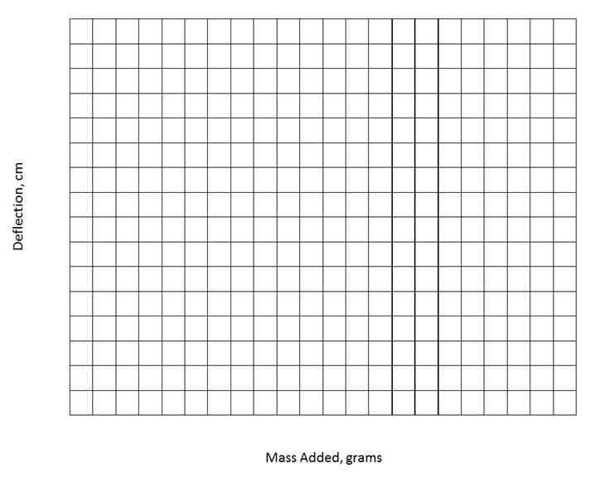

DEFLECTION (cm)

FORCE (grams)

Figure 2: Load-Deflection data for my beams, and predicted load to deflect Beam A 1 cm.

(Take the slope for the straightest part of your data where the deflection and force are low. Slope is rise divided by run. You will need to use the inverse of the slope, or run divided by rise, for design calculations.)

SLOPE: $\frac{RISE}{RUN}= cm/g$

INVERSE SLOPE = $\frac{1}{SLOPE}$ = g/cm

Inverse slope is also how much force is needed to deflect the beam 1 cm

**Teachers Notes:**

The goal of this lab is to begin to introduce the material variable in the stiffness of a beam, while keeping the shape variables the same. The material variable appears in the beam stiffness equations as “Young’s Modulus”.

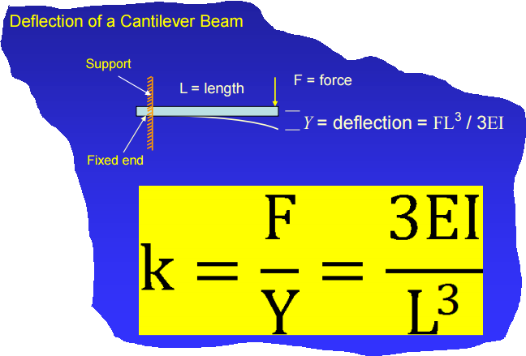

Y = FL3/4EBH3

Y= deflection of the center or end of the beam

F = applied force

L = beam length

E = Young’s modulus (stiffness) of the beam material

B = width of beam

H = height of beam

As long as students use consistent shapes, the material variables should be observable.

We found that insulation board from the hardware store works well for this lab, in particular a pink or blue colored extruded polystyrene which was denser and stiffer than an expanded polystyrene bead board. Do not purchase a board with a paper or foil skin on it. Try to purchase two kinds of insulation board that are the same thickness. Thicknesses in the range of 0.75-1” were successfully tested.

The easiest way to cut the boards into beams is to use a band saw. It is also possible to cut them with a utility knife, hacksaw, or wire saw. A “hot wire” using a wire heated by electrical resistance also works, but generates an odor.

We discovered a hidden variable when we were developing this lab: the orientation of the beam samples compared to the extrusion direction from making the more rigid foam board. There is a strength difference between samples taken parallel to the long axis of the board (the extrusion direction) compared to perpendicular to the long axis. If you purchase a 4x8’ board, keep the long dimension of the beam consistently oriented, either parallel to or perpendicular to the original rectangle.

To add a crash test option to this lab, we recommend a drop weight impact test. Set the beam to span an opening between two supports (such as text books of equal thickness or bricks). Center a weight over the middle of the beam and drop it onto the beam from a fixed height. The energy of the impact test results from the potential energy of the weight being converted to kinetic energy:

P.E. = m x g x h

Where P.E. is the potential energy, m is the mass of the weight being dropped on the beam (kg), g is the gravitational constant (9.8 m/s2 on Earth’s surface), and h is the height from which the weight is dropped (m).

You may want to have the students look up values of the Young’s (or “Flexural”) Modulus and density for various beam materials and compare these data to their measured values. The expanded polystyrene can be found in a range of densities, and the modulus depends on the process by which the polystyrene is shaped into the boards. Here are a few examples:

|  |  |  |  |
| --- | --- | --- | --- |
| Type of Foam | Density (lb/ft3) | Modulus (psi) | Source |
| Expanded polystyrene | 0.70 | 130 | <http://www.universalconstructionfoam.com>  Expanded Polystyrene Data Sheet |
| Expanded polystyrene | 1.80 | 480 | “ |
| Extruded polystyrene | 1.80 | 1600 | <http://msdssearch.dow.com>  for Styrofoam Panel Core 30 |

Solid beams can also be made from Crisp Rice cereal bars. To create a difference in stiffness, replace the marshmallow-butter binder with a sugar syrup cooked to a soft crack or hard crack candy stage (~300F). Try a ratio of 2C white sugar, 1 cup water, and ½ cup light corn syrup. The sugar syrup may result in a brittle beam that doesn’t bend under load, but can still be “crash tested”.