**Materials:**

Card Stock

Scissors or paper cutter for card stock

Popsicle sticks etc. for smoothing beam materials into place

Scale

C clamp

Small piece of plastic or wood (e.g. paint stir stick) to spread the clamp load across the specimen.

Meter stick

Permanent Marker

Wire

Duct tape

Wide mouthed water bottle, cup, or bucket that can be filled with mass to load the beam

A weighting material – e.g. water, sand, nuts….

(Alternative: Prefill water bottles with different masses, cap them, and mark the mass on the bottle.)

Student’s choice of materials used in prior labs or readily available and approved by instructor prior to use: urethane foam, Portland cement, styrene beads, cardboard, bubble wrap, ….

**Background:**

In many mass sensitive designs, like airplanes and structures that protect you in an automobile crash, mass can be reduced by using a thin walled tube or honeycomb shell and filling it with a reinforcing material. In the prior lab, “U Channel Beams”, we observed the effects of geometry on beam stiffness by folding card stock into two shapes. In this lab we will try to improve the stiffness of one beam geometry by filling one of those shapes with the reinforcing material of your choice (subject to my pre-approval). We will determine which design and material concept produces the best stiffness for the least weight (has the highest structural efficiency).

Sketch and describe your design concept and strategy here:

**Procedure:**

1. Use the Beam B geometry on the card stock template. Fold the card stock to create an open U shape that is 28 cm long. The bottom of the “U” should be 4 cm wide, and the legs of the U should be 2.5 cm tall. The line marking the center of the length dimension should be on the bottom side of the “U” so you can see it if you flip the U over and stand it on its legs. Use a ruler to help you fold the sides as straight as possible. Put duct tape over the ends and wrap the duct tape about 1 cm along the sides and bottom of the channel to hold your filler material in place.
2. Fill the U channel with the material of your choice. Think ahead if you choose a material that takes time to cure (cement) or crosslink (urethane foam, glue). Try to pick something that will be easy to cut away or file if it expands and overfills the channel.

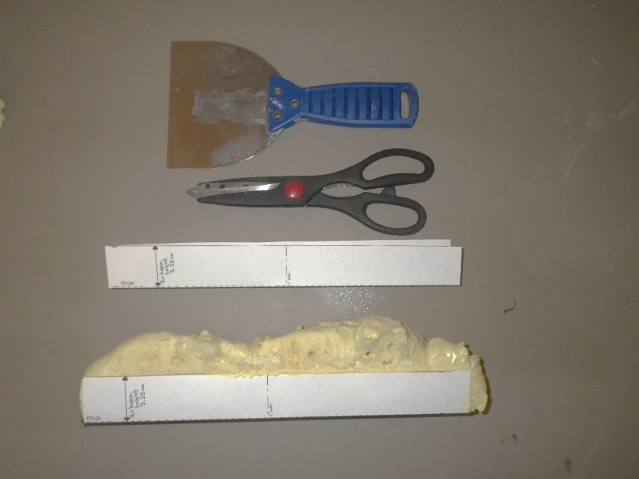

Figure 1: Example of empty U channel, and the U channel filled with “Great Stuff” window and door insulating foam. The foam could be cut with scissors, a coping saw, or a utility knife blade to get a fairly uniform beam for testing. The spatula was helpful in prying apart channels that had been filled with foam while next to each other in a box.

1. When your beam is ready to test, record the mass and the beam dimensions in Table 1:

Table 1: Beam dimensions, mass, and failure load and deflection

|  |  |  |  |  |  |
| --- | --- | --- | --- | --- | --- |
| Length  (L, cm) | Width  (B, cm) | Height  (H, cm) | Mass  (g) | Slope of Force vs. Deflection Curve (g/cm) | Modulus (g/cm2) |
|  |  |  |  |  |  |

1. Mark a point 3 cm from the end of each beam, and try to center it across the width of the beam. Open the paper clip to make a hook. Push the straight end of the paperclip through the beam at the mark 3 cm from the end. Sandwich the washer between the hook part of the paperclip and the top surface of the beam, then pull the paperclip down so the hook is pushed back into the beam. (The washer will spread the force over a bigger area so the paperclip doesn’t come out during the testing.) Bend the straight end of the paperclip to make a hook below the beam. The weights will be hung from this hook during the test.
2. Clamp your beam to the table using a thin flat piece of plastic or wood such as a paint stir stick between your beam and the clamp to spread the clamp load over the clamped area. Put the beam in the clamp so the card stock faces up. Don’t crush you sample by clamping too hard. Figure 2 shows an example of a beam ready to test. It is important to keep the length of the beam hanging off the table the same so we can compare results. Please try to have the end of your beam 23 cm from the edge of the table.
3. Mass the empty weighting system and wire to be used to attach it to the beam: Mo = ___________grams_
4. Attach the weighting system near the end of your beam using the hook.
   1. Measure the length between the edge of the table and where you attached the weight system to your beam. This will be your unsupported length to use in calculating the beam deflection. Try to get Lu ~ 20 cm so we can compare the results without having an extra variable.

Beam 1 Lu = ____ cm

1. Hold the meter stick so you can see when the beam bends 1 cm as you apply the load.
2. Working as a team, have one person slowly add mass to the weight system. Record the total mass and deflection after each addition using Table 2. **Stop** adding mass when your beam deflected more than 1 cm.
3. Graph the load vs. deflection data for your beam on Figure 3.

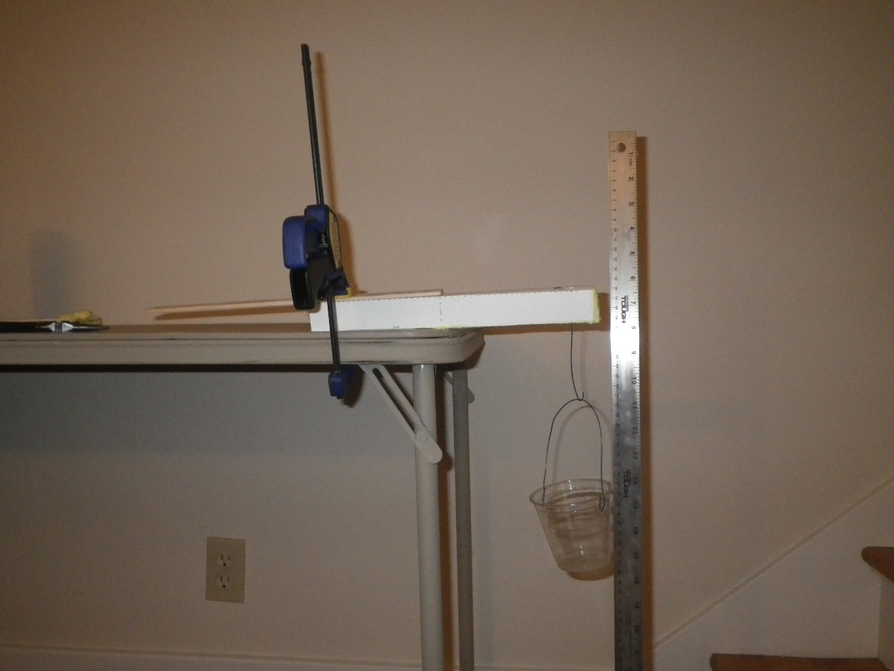

Table Top

Beam

String to Bottle or Cup

Paper Clip

Lu, try to make this 20 cm

CLAMP PROTECTOR

CLAMP

CLAMP

WASHER

Paper Clip

3 cm

Figure 2: Experimental setup. You can try looping the wire connecting to the bottle or cup over the beam, or you can make a wire hook that pierces the beam. If you use the wire, be careful not to stab your hand when you are pushing the wire through the foam. After pushing the straight end of the wire through the beam, use pliers to bend it back toward the beam to make a small second “hook”, and poke that hook back into the center of the beam to help the wire stay in place.

Table 2: Force-Deflection data.

|  |  |
| --- | --- |
| Beam 1  Mass Added (g) | Beam 1  Deflection (cm) |
| Weight of cup or bottle and string: |  |
| First addition to cup or bottle: |  |
| Second addition to cup or bottle: |  |
| Etc. |  |
|  |  |
|  |  |
|  |  |

1. Estimate the Modulus (“E”) of your beam:

$E=\frac{\left[(4×L_{u}×L_{u}×L_{u}×\left(\frac{F}{Y}\right)\right]}{BxHxHxH}$ = (4 x ____x ____x____) x ( )_ = g/cm2

x x x

1. Determine your Structural Efficiency score:

|  |  |  |  |
| --- | --- | --- | --- |
| Beam Identification | Load to deflect beam 1 cm (grams) | Mass of Beam  (grams) | Structural Efficiency:  1 cm Deflection load/Mass of beam (g/g) |
|  |  |  |  |

1. If your beam failed before it deflected 1 cm., observe how your beam failed. Did the card stock rip before your reinforcement broke? Did it break in one place or in many places?
2. If you could change something about your design concept to improve your beam, what would you change and why?
3. As a class, determine who had the best score for the mass efficiency of the beam based on the force it took to deflect the beam 1 cm divided by the mass of the beam. Discuss their design strategy. How did their strategy differ from the beams with that had the worst scores for mass/deflection at failure

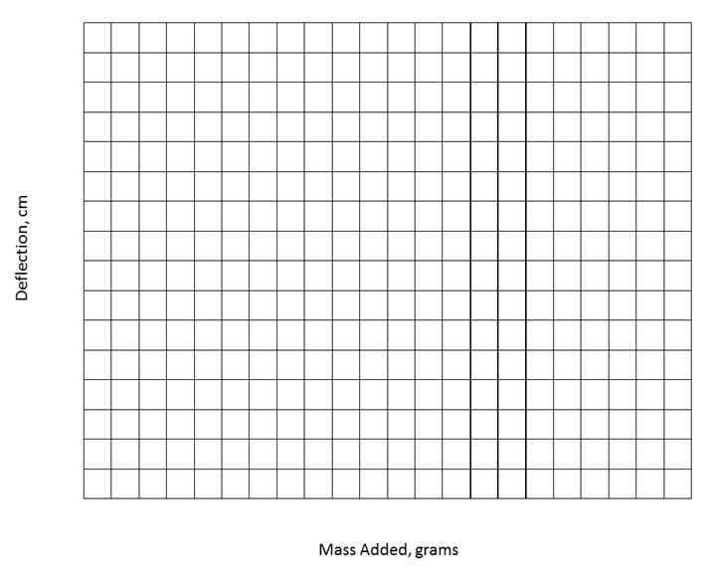

DEFLECTION (cm)

FORCE (grams)

Figure 2: Load-Deflection data for my beam.

**Teachers Notes:**

The goal of this lab is to begin to introduce the material variable in the stiffness of a beam, while keeping the shape variables the same. The material variable appears in the beam stiffness equations as “Young’s Modulus”.

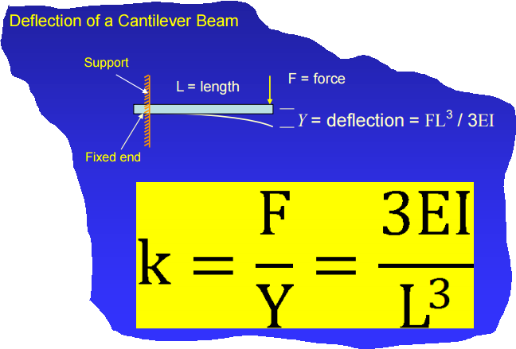

Y = FL3/4EBH3

Y= deflection of the center or end of the beam

F = applied force

L = beam length

E = Young’s modulus (stiffness) of the beam material

B = width of beam

H = height of beam

Figure 1: Equation describing the deflection of a solid rectangular beam under cantilever loading.

We based this lab on the wider open beam “B” in the “U Channel Beam” lab. You may want to have half the students make the beam A geometry if your groups can handle both geometric and multiple materials variables, or you may want to try a different mold idea such as those described below. As long as students use consistent shapes, the material variables should be observable.

This lab will take two class periods, one to make the beams and one to test them in cantilever bending.

Materials Options For Open Cardstock Beam Molds:

The open cardstock beams work well with spray-in foam insulation, such as the “Great Stuff” door and window sealer pictured above. Different foam insulations have different stiffnesses, and the stiffness and density of the foam can be increased by stirring it to collapse the bubbles after the channels are filled. The downside is that it can be hard to keep the beam shapes rectilinear, and the foam spray tubes plug after about 10 minutes. We also tried making this with the two part urethane foam resins (e.g. “Eurocast”, available from Tesco-Iasco).

If you decide to use very rigid materials such as cement or Eurocast resins, you will need to mold the paper clip for hanging the weight into the beam when you make it. Put a piece of tape across the beam mold opening to hold the paper clip hook system. Straighten one end of the paper clip, then put a 90* bend in it so there’s about a cm of paper clip that will sit flat against the bottom of the mold. This will make it harder for the paper clip to simply pull out of the beam when loaded. Jab the straightened end of the paper clip through the center of the tape, position the bent end against the base of the mold, and leave the hook above the tape.

Rice cereal treats can be made in a disposable foil pan and then cut to fairly uniform sizes. You can change the stiffness of the rice krispy treats by eliminating the butter and replacing the marshmallows with an 2C water, 1C white sugar and ½ C light corn syrup boiled to a hard crack candy stage (about 300F). This syrup can increase the rigidity of the rice krispy treats to the point where it can be hard to cut them into samples.

Wood glue mixed with sawdust could also be a filler candidate – the mass ratio of glue to sawdust could be a variable assigned to different lab groups.

Expanded polystyrene beads can used to create “light weight” Portland cement composites. To make the beads, simply toss unexpanded polystyrene beads into boiling water, then drain the water through a fine sieve to retrieve the beads. (You can also try breaking up packing material, but this is more difficult and will give you a coarser particle size distribution.) The easiest way to mix them with the cement is to put them in a clean peanut butter jar or wide mouthed bottle, add water with a few drops of dish soap to aid wetting, then add the cement and shake vigorously. As in the case of the sawdust and glue beams, the amount of polystyrene can be varied from lab group to lab group. You may need to put tape across the beam opening in several places to provide adequate support for the heavier cement samples.

Mold Options:

Silicone ice cube trays for making long cubes for water bottles can also be used to produce uniform shape beams from different materials. Use mold release spray on the silicone molds before using them with rapid set cement or Eurocast resins. The disadvantage of the silicone ice cube trays is that the beams will be fairly short (4”) and may be difficult to test with reasonable weights for stronger materials.

You may be able to buy plastic “J Channel” or corner protectors at the hardware store. Two of these can be taped together to create a longer beam mold. Spray the inside with mold release if you plan to use them for cast resins or wipe them with a thin coating of petroleum jelly if you want to try them with cement. The spray in foam had different densities when we filled a tall plastic mold vertically – the mass of the foam collapsed some of the bubbles on the bottom of the sample. Pry the samples out of the molds when they are cured. We soak the plastic molds in hot soapy water and scrub any cement off so they are reusable.

Paper towel rolls can also be used as molds. If you use them for cement you may want to rubber band or tape several tubes together, or stand them in an empty coffee can to provide support. Make sure you tape the bottom end of the tube shut with duct tape before pouring the cement in!

Testing Alternatives:

If your beams are very stiff, such as cement beams or Eurocast resin, you may have difficulty deflecting them with the cantilever beam set up. We have tested stiff beams in a 3 point bend tester constructed from 2x4” lumber. This wood frame allows us to apply higher loads, but it does not work well for polymer foams because they deflect too much and the unsupported length of the beam varies significantly as you take data.

You may want to have the students look up values of the Young’s Modulus for various beam materials instead of trying to measure them with the cantilever beam setup. In this case, you could skip the cantilever lab entirely and move straight to an impact test to determine which beam material provided the best structural efficiency in terms of deflecting the least under a fixed energy emulating the IIHS crash test. The foam beams will fail the crash test at lower energies than a resin or cement beam, but they will be much more mass efficient. The “winner” is the beam that passes the crash test requirement with the lowest mass.

Research Ideas:

Advanced students may find it interesting to investigate foam filled structures to improve crashworthiness. Dow Automotive markets a polyurethane foam, “Betafoam”, specifically for this purpose.[1] B Pillars have been reinforced with foam to improve the roof crush performance with minimal impact on mass. This short article by the American Chemistry Council has some highlights of the B Pillars with foam reinforcements: <https://plastics-car.com/plasticfoams>. Compared with using more sheet metal, adding foam to meet the greater roof crush strength requirements saved 45% of the mass, and the potential to use a smaller steel structure to achieve the same strength with foam fill is also mentioned. A more detailed case study on the advantages of foam filled B pillars, originally published by ASM in 1998, is attached.

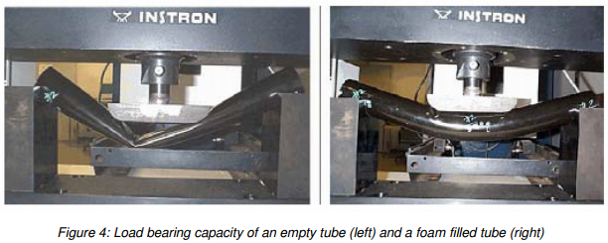

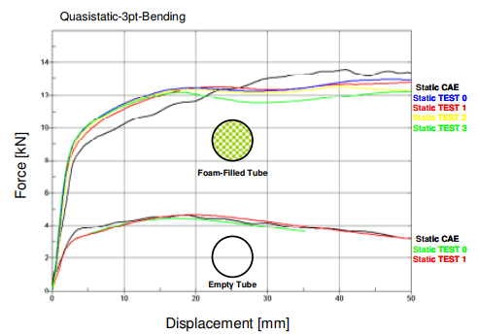

Figure 1: Adding polyurethane foam to a steel tube increased the energy absorbed by 300%. Top left: empty steel tube in 3 point bending. Top right: Foam filled tube in 3 point bending. Bottom: Force-displacement curves for the empty and filled steel tubes tested in 3 point bending. (https://www.dynamore.de/en/downloads/papers/07-forum/forum07/crash/crash-performance-increase-with-structural)

1. https://www.dynamore.se/en/resources/papers/07-forum/crash/crash-performance-increase-with-structural