**Materials:**

Styrofoam or insulating foam from hardware store

Packing tape, duct tape, or other tape

Band saw, hack saw, serrated or utility knife to cut the foam (or hot wire cutter)

Scissors to cut the tape

Meter stick

Permanent Marker

C clamp or bar clamp

Small piece of plastic or wood (e.g. paint stir stick) to spread the clamp load across the specimen.

Wire

Wide mouthed water bottle, cup, or bucket that can be filled with mass to load the beam

A weighting material – e.g. water, sand, nuts….

(Alternative: Prefill water bottles with different masses, cap them, and mark the mass on the bottle.)

**Background:**

The stiffness of a beam is related to its geometry and what the beam is made from. We are going to determine if there are ways to significantly improve the stiffness of the beam without adding much mass by making a “stressed skin composite”. A low mass foam material will be used for the main part of the beam, and tape will be added to reinforce it. A simple example of a stressed skin composite is a banana – the skin adds a lot of resistance to deformation to the fruit. The key to creating the stiffest beam per gram of beam mass is in where you put the tape, and what kind of tape you use.

Our test is related to the “B Pillar”, which is the metal beam between the driver and passenger doors on a car (Figure 1). This beam needs to deflect as little as possible if you are hit from the side. In real life the “B Pillars” are made of layers of different materials sandwiched together so that the areas that are most critical to protecting the passenger in a crash have the stiffest geometry and material. Away from the critical areas you might notice that there is less material. Figure 2 shows an example of how using a different shape and a stronger steel made a B Pillar that did a better job protecting the passengers and weighed less:

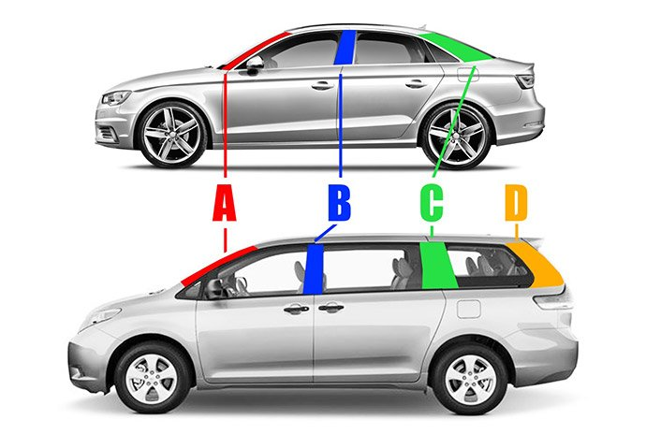

Figure 1: The A, B, and C Pillars on a car. (www.edmunds.com)

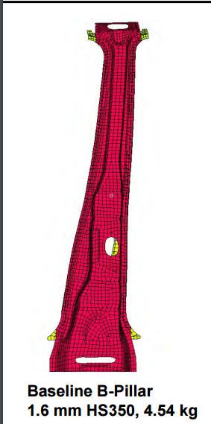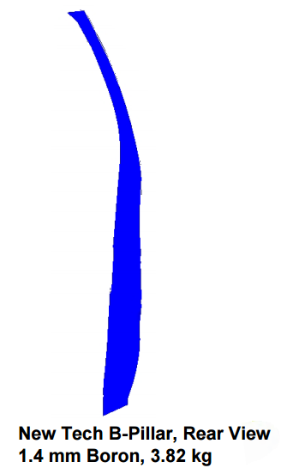 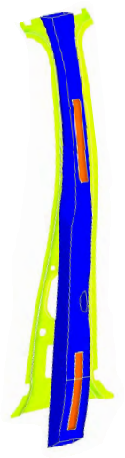

Figure 2: Optimizing the geometry and using a stronger steel produced a B Pillar design that was thinner, 16% lighter, and stiffer than the original design (red) when the new design (blue) was glued to the inner part of the support (yellow). The glued areas are shown in orange. (reference: T. Vikstrom, P. McKune, K. Palanisamy, R. Kozak, “Highly Engineered Structural Solutions for the 21st Century Auto Body”, presented at Great Designs in Steel, and posted at www.steel.org)

**Procedure:**

1. Using the example beam as a template, cut the foam into three pieces that are 25 cm long. Try to cut as straight a line as possible, and try not to crush the foam as you cut it. All 3 pieces should be 4 cm wide. The height of the beams will depend on how thick your foam is. Label the pieces A, B, and C. Mark the center of the beam at 3 cm from one end of the beam. Beam A will be the control sample.
2. Select the kind of tape you want to test. You may use no more than 3 meters of tape total for the entire experiment. Remember that every cm of tape you use adds weight to your beam.
3. Put one layer of tape over the wide surface of Beam B, as shown in Figure 3.

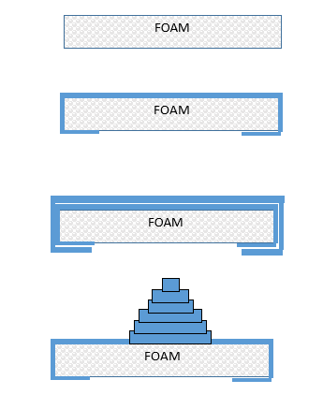

Figure 3: Apply the tape (dark blue) to the wide top surface of Beam B. It does not need to extend down the sides or around the ends.

,

1. Beam C will get the same first layer of tape as Beam B. After that you can decide where you want to apply more tape to give you the most benefit in stiffness, and how much more tape you want to use. Do not use more than 3 meters of tape total on Beams B and C combined. You may also want to carve off some of the foam to reduce the mass. Sketch your design and describe your reinforcement and mass reduction strategy here:

Mass Beams A, B, and C and record the mass in Table 1.

Table 1: Beam mass, failure load and deflection

|  |  |  |  |  |  |
| --- | --- | --- | --- | --- | --- |
| Beam Name | Mass  (g) | Mass for 1 cm deflection (g) | Failure Load  (g) | Failure Deflection (Y, cm) | Slope of Straight Part of Load-Deflection Plot (g/cm) |
| A (control, no tape) |  |  |  |  |  |
| B (1 layer of tape) |  |  |  |  |  |
| C (my design) |  |  |  |  |  |

1. Open the paper clip to make a hook. Push the straight end of the paperclip through the beam at the mark 3 cm from the end. Sandwich the washer between the hook part of the paperclip and the top surface of the beam, then pull the paperclip down so the hook is pushed back into the beam. (The washer will spread the force over a bigger area so the paperclip doesn’t come out during the testing.) Bend the straight end of the paperclip to make a hook below the beam. The weights will be hung from this hook during the test.
2. Clamp your beam to the table using a thin flat piece of plastic or wood such as a paint stir stick between your beam and the clamp to spread the clamp load over the clamped area. Put the beam in the clamp so the tape faces up. Don’t crush you sample by clamping too hard. Figure 4 shows an example of a beam ready to test.
3. Mass the empty weighting system and wire to be used to attach it to the beam: Mo = ___________grams_
4. Attach the weighting system near the end of your beam.
   1. Measure the length between the edge of the table and where you attached the weight system to your beam. This will be your unsupported length to use in calculating the beam deflection. Try to get Lu ~ 15 cm so we can compare the results without having an extra variable.

Beam A Lu = ____ cm Beam B Lu = ____ cm Beam C Lu - _____ cm

1. Hold the meter stick so you can see when the beam bends 1 cm as you apply the load.
2. Working as a team, have one person slowly add mass to the weight system. Record the total mass and deflection after each addition using Table 2.
3. Stop adding mass when your beam deflected more than 1 cm and record the mass in Table 1.
4. Resume adding mass and record the mass at which your beam breaks.
5. Repeat steps 7-13 for Beams B and C.
6. Graph the load vs. deflection data for both beams on Figure 2.
7. Calculate the slope of the straight part of the force-deflection curve (rise over run) and then take the inverse of that slope. We are going to use this inverse slope to estimate the “Modulus” (E) of the beam:

Inverse Slope for my beam = F/Y = ___________ (grams)/___________cm = ___________g/cm

1. Estimate the Modulus (“E”) of your beam:

$E=\frac{\left[(4×L_{u}×L_{u}×L_{u}×\left(\frac{F}{Y}\right)\right]}{BxHxHxH}$ = (4 x ____x ____x____) x ( )_ = g/cm2

x x x

1. Determine your Structural Efficiency scores:

|  |  |  |  |
| --- | --- | --- | --- |
| Beam | Load to deflect beam 1 cm (grams) | Mass of Beam  (grams) | Structural Efficiency:  1 cm Deflection load/Mass of beam (g/g) |
| A |  |  |  |
| B |  |  |  |
| C |  |  |  |

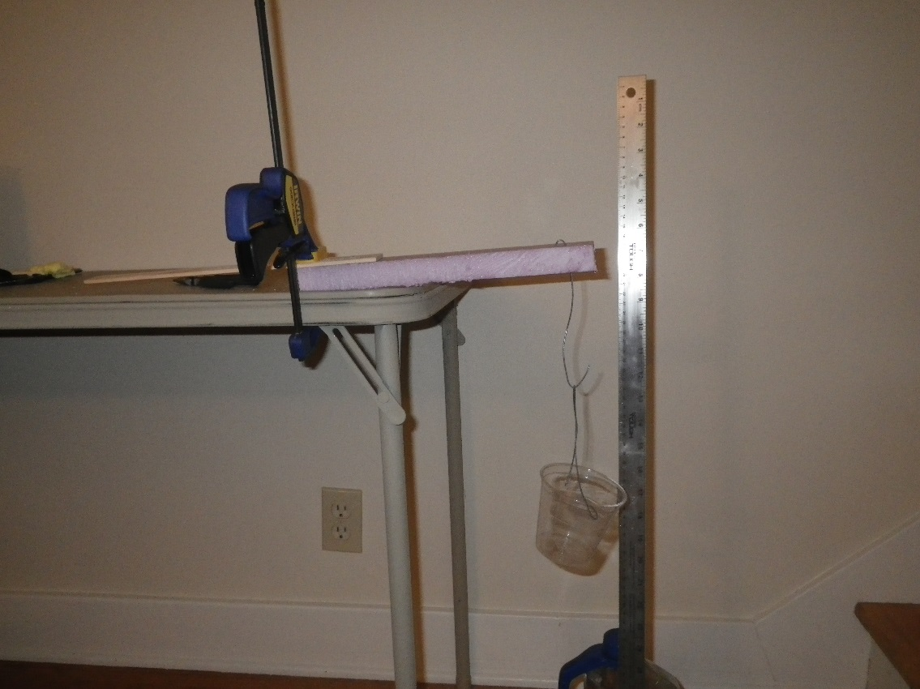

Table Top

Beam

String to Bottle or Cup

Paper Clip

Lu, try to make this 15 cm

CLAMP PROTECTOR

CLAMP

CLAMP

WASHER

Paper Clip

3 cm

Figure 4: Experimental setup schematic and example. You can try looping the wire connecting to the bottle or cup over the beam, or you can make a wire hook that pierces the beam. If you use the wire, be careful not to stab your hand when you are pushing the wire through the foam. After pushing the straight end of the wire through the beam, use pliers to bend it back toward the beam to make a small second “hook”, and poke that hook back into the center of the beam to help the wire stay in place.

Table 2: Load-Deflection Data Sheet

|  |  |  |  |  |  |  |
| --- | --- | --- | --- | --- | --- | --- |
| Load Event | BEAM A  Deflection (cm) | BEAM A  Load  (g) | BEAM B  Deflection (cm) | BEAM B  Load  (g) | BEAM C  Deflection (cm) | BEAM C  Load  (g) |
| 0 |  |  |  |  |  |  |
| 1 |  |  |  |  |  |  |
| 2 |  |  |  |  |  |  |
| 3 |  |  |  |  |  |  |
| 4 |  |  |  |  |  |  |
| 5 |  |  |  |  |  |  |
| 6 |  |  |  |  |  |  |
| 7 |  |  |  |  |  |  |
| 8 |  |  |  |  |  |  |
| 9 |  |  |  |  |  |  |
| 10 |  |  |  |  |  |  |
| 11 |  |  |  |  |  |  |
| 12 |  |  |  |  |  |  |
| 13 |  |  |  |  |  |  |
| 14 |  |  |  |  |  |  |
| 15 |  |  |  |  |  |  |
| 16 |  |  |  |  |  |  |
| 17 |  |  |  |  |  |  |
| 18 |  |  |  |  |  |  |
| 19 |  |  |  |  |  |  |
| 20 |  |  |  |  |  |  |
| 21 |  |  |  |  |  |  |
| 22 |  |  |  |  |  |  |
| 23 |  |  |  |  |  |  |
| 24 |  |  |  |  |  |  |
| 25 |  |  |  |  |  |  |
| 26 |  |  |  |  |  |  |
| 27 |  |  |  |  |  |  |
| 28 |  |  |  |  |  |  |
| 29 |  |  |  |  |  |  |
| 30 |  |  |  |  |  |  |

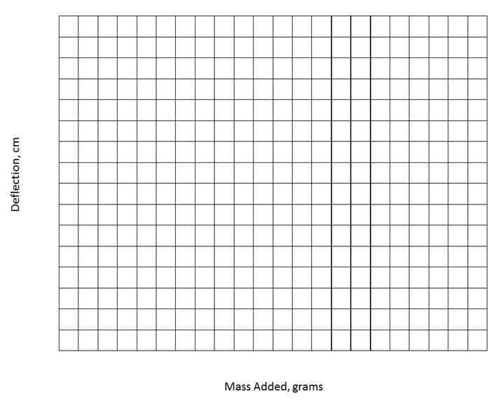

DEFLECTION (cm)

FORCE (g)

Figure 5: Load-Deflection data for my beams, and predicted loads for a deflection of 1 cm.

(Take the slope for the straightest part of your data where the deflection and force are low. Slope is rise divided by run. You will need to use the inverse of the slope, or run divided by rise, for design calculations.)

SLOPE: $\frac{RISE}{RUN}= cm/g$

INVERSE SLOPE = $\frac{1}{SLOPE}$ = g/cm

Inverse slope is also how much force is needed to deflect the beam 1 cm

1. Using the modulus of elasticity you measured, along with your beam A dimensions, predict the mass required to deflect your beam A 1 cm, and plot your prediction on the graph in Figure 2.

Beam deflection formula for a solid rectangle: $Y=(Fx{L_{u}}^{3})/(4xExBxH^{3})$

Solving for F: $F=\frac{4xYxExBxHxHxH}{L_{u}xL_{u}xL_{u}}=$

1. If you could change something about your design concept to improve your beam, what would you change and why?
2. As a class, determine who had the best score for the structural efficiency of the beam based on the force it took to deflect the beam 1 cm divided by the mass of the beam. Discuss their design strategy. How did their strategy differ from the beams with that had the worst scores for mass/deflection at failure?
3. Optional: Engineers also have to factor the cost of their design ideas into their decisions. Calculate the cost of the tape used for the top 3 most structurally efficient designs and determine which design is the best in terms of both mass and cost. This can be done by dividing the structural efficiency of the design by the cost of the tape added to the foam.

**Teachers Notes:**

* + - 1. If you purchase the insulating foam in a 1” thickness, the 4 cm wide beams will almost exactly match the Beam “B” geometry from the folded card stock “U Channel” lab 1. This lab uses 25 cm long beams vs. the 27 cm long beams made from 8.5x11” card stock.
      2. “Topological design” and “biomimicry” describe lightweight design methods that follow Nature’s example of only putting mass where it is required to meet functional requirements. In addition to the hollow bird bones with internal reinforcements, diatoms provide another great example of Nature optimizing designs. These tiny single cell animals need to be light enough to float in seawater, but they are protected by silica cell walls. The silica is only deposited where it is necessary. There are over 100,000 kinds of diatoms, each with unique geometry of the silica. Engineers are studying these forms and applying Nature’s lessons in two main ways. First, computer programs have been created to design shapes by starting with an empty volume, then adding mass only where it is needed to support the required forces. Second, additive manufacturing methods such as 3D printing, are making it possible to bring these design concepts to life.
      3. Depending on your budget, we found that some very strong tape, like high temperature muffler tape, produced surprisingly good increases in beam stiffness. It might be interesting to have one lab group use a significantly stronger tape that costs more to better illustrate the engineering tradeoffs between cost, mass, and performance.
      4. If you don’t want to make foam beams, you can do a simple version of this lab with uncooked lasagna noodles, or by cutting wood dowel rods (which come in square and circle shapes of different thicknesses) into short sections. If you use the lasagna noodle approach, impact test the samples with the tape on the bottom side of the sample.

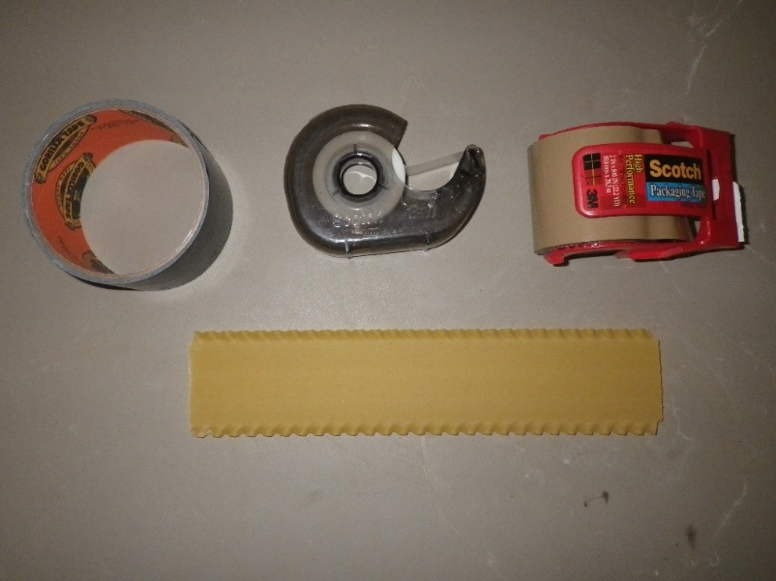

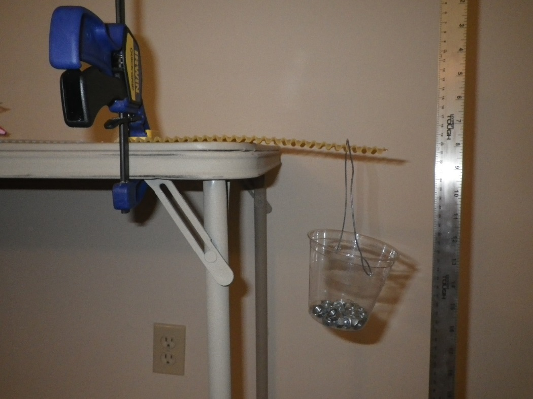

Figure 6: An uncooked lasagna noodle with 1 layer of duct tape can support a surprising amount of weight. Loop the handle of the cup over the noodle instead of trying to pierce the noodle with a paper clip.