**Materials:**  (actual materials may vary from this list)

Expanded or extruded polystyrene insulation foam boards from hardware store

Packing tape, duct tape, or other tape

Hot wire, hacksaw, serrated or utility knife to cut the foam

Scissors to cut the tape

Popsicle sticks or sticks from outdoors

Urethane foam resins to make high and low density foams

Portland cement

Meter stick

Permanent Marker

C clamp or bar clamp

Small piece of plastic or wood (e.g. paint stir stick) to spread the clamp load across the specimen.

Wire

Wide mouthed water bottle, cup, or bucket that can be filled with mass to load the beam. (Some beams may be so strong that you need a 1 gallon water or milk jug, or even a 5 gal. Bucket with a handle.)

A weighting material – e.g. water, sand, nuts….

(Alternative: Prefill water bottles with different masses, cap them, and mark the mass on the bottle.)

Scale to weigh the beams and the weighting material.

**Background:**

The stiffness of a beam is related to its geometry and what the beam is made from. We are going to determine if there are ways to significantly improve the stiffness of the beam without adding much mass using the insights about geometry and materials effects on beam behavior from our prior labs. Our test is related to the “B Pillar”, which is the metal beam between the driver and passenger doors on a car (Figure 1).

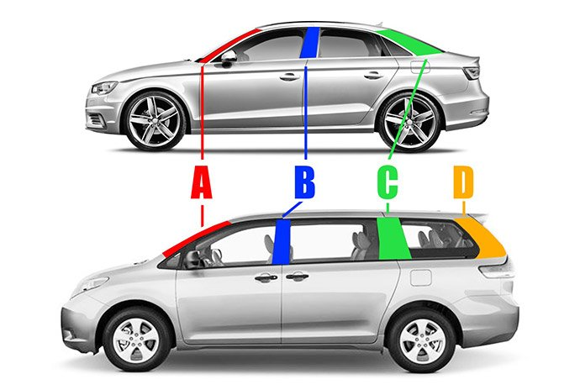

Figure 1: The A, B, and C Pillars on a car. (www.edmunds.com)

This beam needs to deflect as little as possible if you are hit from the side. In real life the “B Pillars” are made of layers of different materials sandwiched together so that the areas that are most critical to protecting the passenger in a crash have the stiffest geometry and material. Away from the critical areas you might notice that there is less material. Figure 2 shows an example of how using a different shape and a stronger steel made a B Pillar that did a better job protecting the passengers and weighed less:

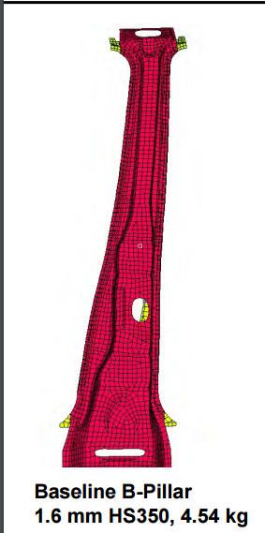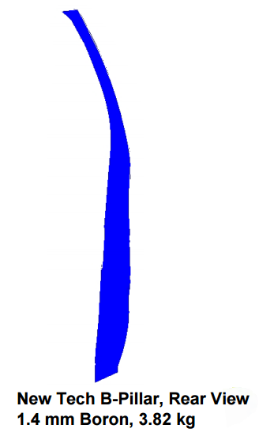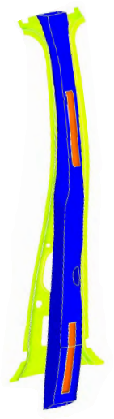

Figure 2: Optimizing the geometry and using a stronger steel produced a B Pillar design that was thinner, 16% lighter, and stiffer than the original design (red) when the new design (blue) was glued to the inner part of the support (yellow). The glued areas are shown in orange. (reference: T. Vikstrom, P. McKune, K. Palanisamy, R. Kozak, “Highly Engineered Structural Solutions for the 21st Century Auto Body”, presented at Great Designs in Steel, and posted at www.steel.org)

**Procedure:**

1. Sketch your design and describe your reinforcement and mass reduction strategy here:
2. In consultation with your teacher, create a beam that is 25 cm long, 4 cm wide, and 2.5 cm tall.
3. Mass your beam and record the mass in Table 1.

Table 1: Beam mass, failure load and deflection

|  |  |  |  |  |  |
| --- | --- | --- | --- | --- | --- |
| Beam Name | Mass  (g) | Mass for 1 cm deflection (g) | Failure Load  (g or kg) | Failure Deflection (Y, cm) | Slope of Straight Part of Load-Deflection Plot (g/cm) |
|  |  |  |  |  |  |

1. Clamp your beam to the table using a thin flat piece of plastic or wood such as a paint stir stick between your beam and the clamp to spread the clamp load over the clamped area. Decide which side of your beam you want on the top for the test. Don’t crush you sample by clamping too hard. Figure 3 shows an example of a beam ready to test.
2. Mass the empty weighting system and wire to be used to attach it to the beam: Mo = ___________grams
3. Attach the weighting system near the end of your beam. Try to put it about 3 cm from the end of the beam away from the table.
   1. You may need to use tape to hold the wire in place. When you remove the weight system, mass the tape you used: Mt = ___________grams.
   2. Measure the length between the edge of the table and where you attached the weight system to your beam. This will be your unsupported length to use in calculating the beam deflection. Try to get Lu ~ 15 cm so we can compare the results without having an extra variable.

Beam Lu = ____ cm

1. Hold the meter stick so you can see when the beam bends 1 cm as you apply the load.
2. Working as a team, have one person slowly add mass to the weight system. Record the total mass and deflection after each addition using Table 2.
3. Stop adding mass when your beam deflected more than 1 cm and record the mass in Table 1.
4. Resume adding mass and record the mass at which your beam breaks.
5. Graph the load vs. deflection data for your beam on Figure 4.
6. Calculate the slope of the straight part of the force-deflection curve. We are going to use this value to estimate the “Modulus” (E) of the beam:

Slope for my beam = F/Y = ___________ (grams)/___________cm = ___________g/cm

1. Estimate the Modulus (“E”) of your beam:

E = (4 x L x L x L) x F/Y = (4 x ____ x ____x____x___ ) x ( )_ = g/cm2

B x H x H x H ____x____x____x____

1. Determine your mass efficiency scores:

|  |  |  |  |
| --- | --- | --- | --- |
| Beam Identification | Load to deflect beam 1 cm (grams) | Mass of Beam  (grams) | Mass Efficiency:  Deflection load/Mass of beam (g/g) |
|  |  |  |  |

1. If you could change something about your design concept to improve your beam, what would you change and why?
2. As a class, determine who had the best score for the mass efficiency of the beam based on the force it took to deflect the beam 1 cm divided by the mass of the beam. Discuss their design strategy. How did their strategy differ from the beams with that had the worst scores for mass/deflection at failure?

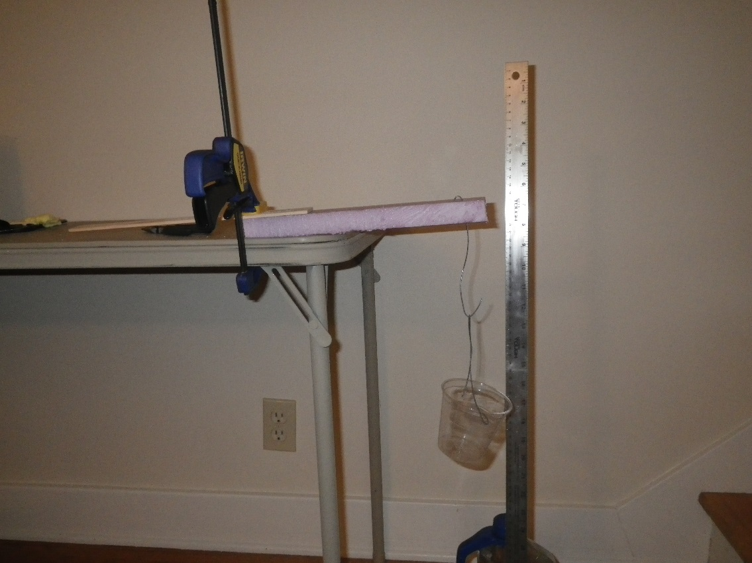

3 cm

Table Top

Beam

String to Bottle or Cup

Wire

TAPE

Lu, try to make this 15 cm

CLAMP PROTECTOR

CLAMP

CLAMP

Figure 3: Experimental setup schematic and example. You can try looping the wire connecting to the bottle or cup over the beam, or you can make a wire hook that pierces the beam. If you use the wire, be careful not to stab your hand when you are pushing the wire through the beam. After pushing the straight end of the wire through the beam, use pliers to bend it back toward the beam to make a small second “hook”, and poke that hook back into the center of the beam to help the wire stay in place.

Table 2: Load-Deflection Data Sheet

(If your beam is very stiff, you may need to change the measurement units to mm and kg.)

|  |  |  |
| --- | --- | --- |
| Load Event | BEAM A  Deflection (cm) | BEAM A  Load  (g) |
| 0 |  |  |
| 1 |  |  |
| 2 |  |  |
| 3 |  |  |
| 4 |  |  |
| 5 |  |  |
| 6 |  |  |
| 7 |  |  |
| 8 |  |  |
| 9 |  |  |
| 10 |  |  |
| 11 |  |  |
| 12 |  |  |
| 13 |  |  |
| 14 |  |  |
| 15 |  |  |
| 16 |  |  |
| 17 |  |  |
| 18 |  |  |
| 19 |  |  |
| 20 |  |  |
| 21 |  |  |
| 22 |  |  |
| 23 |  |  |
| 24 |  |  |
| 25 |  |  |
| 26 |  |  |
| 27 |  |  |
| 28 |  |  |
| 29 |  |  |
| 30 |  |  |

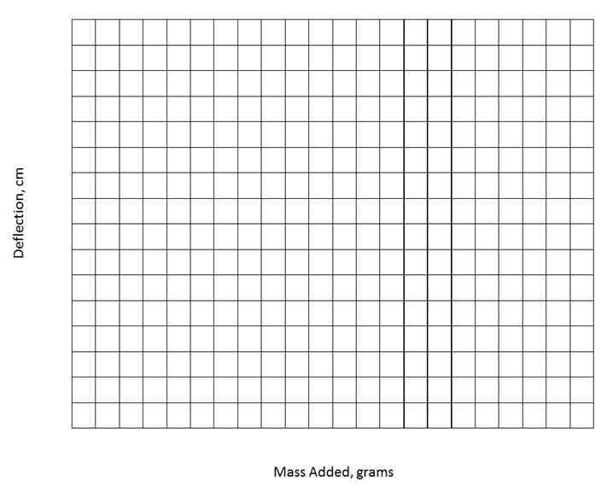

DEFLECTION (cm)

FORCE (grams)

Figure 4: Load-Deflection data for my beam.

**Teachers Notes:**

* + - 1. The intention of this lab is to allow your students to experience the creative pleasure of engineering design, taking advantage of what they learned from more structured labs about the impacts of geometry, materials choices, and composites.
      2. The materials list is based on materials used in a typical 1 semester materials science elective based on the ASM Materials Camp for Teachers ® syllabus. The list is a guideline and can be modified to suit what you have on hand.
      3. Popsicle sticks duct taped to an insulating foam beam required a 1 gallon milk jug to hold enough mass to create significant deflection.
      4. Mrs. Laura Moore’s Materials Science classes at Hartland High School in Hartland, MI tested this procedure in June 2017. They found that they needed to agree on the amounts of raw materials (reinforcements, tape) that could be used, and they started from a standard sized beam cut from insulation foam. Many of them carved the foam, then added reinforcements. Example beams included:

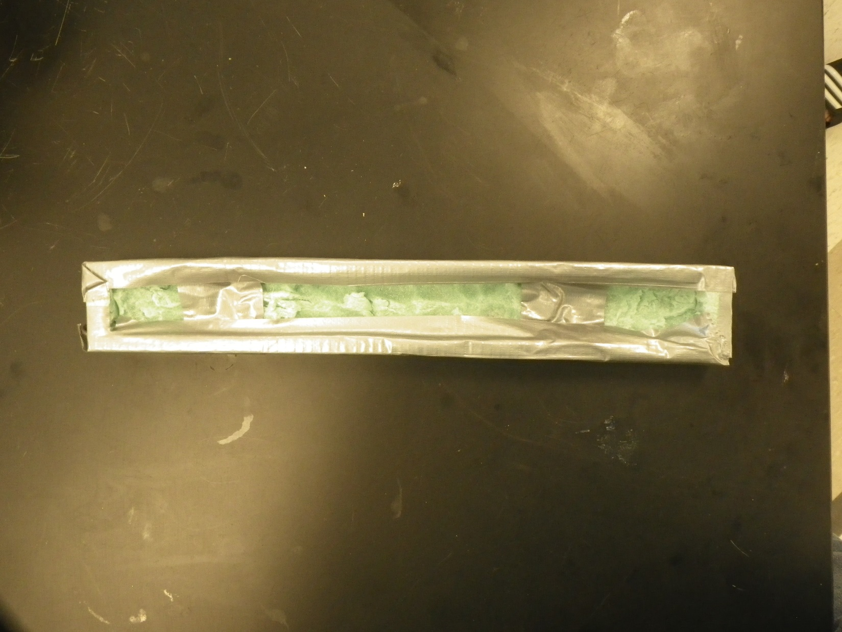

Hollowed out and wrapped with duct tape

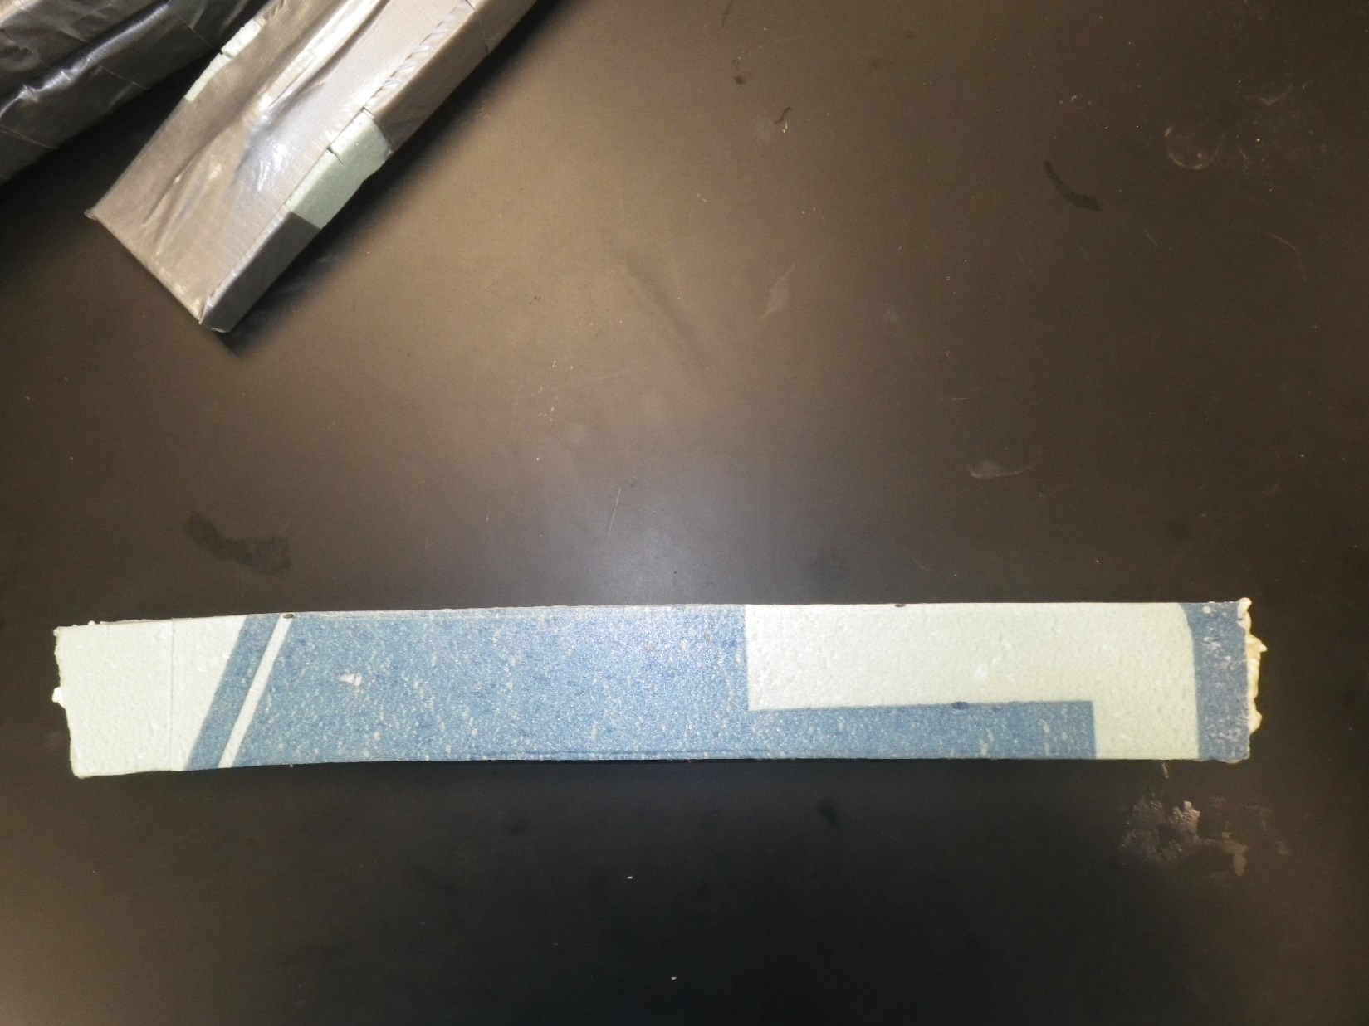

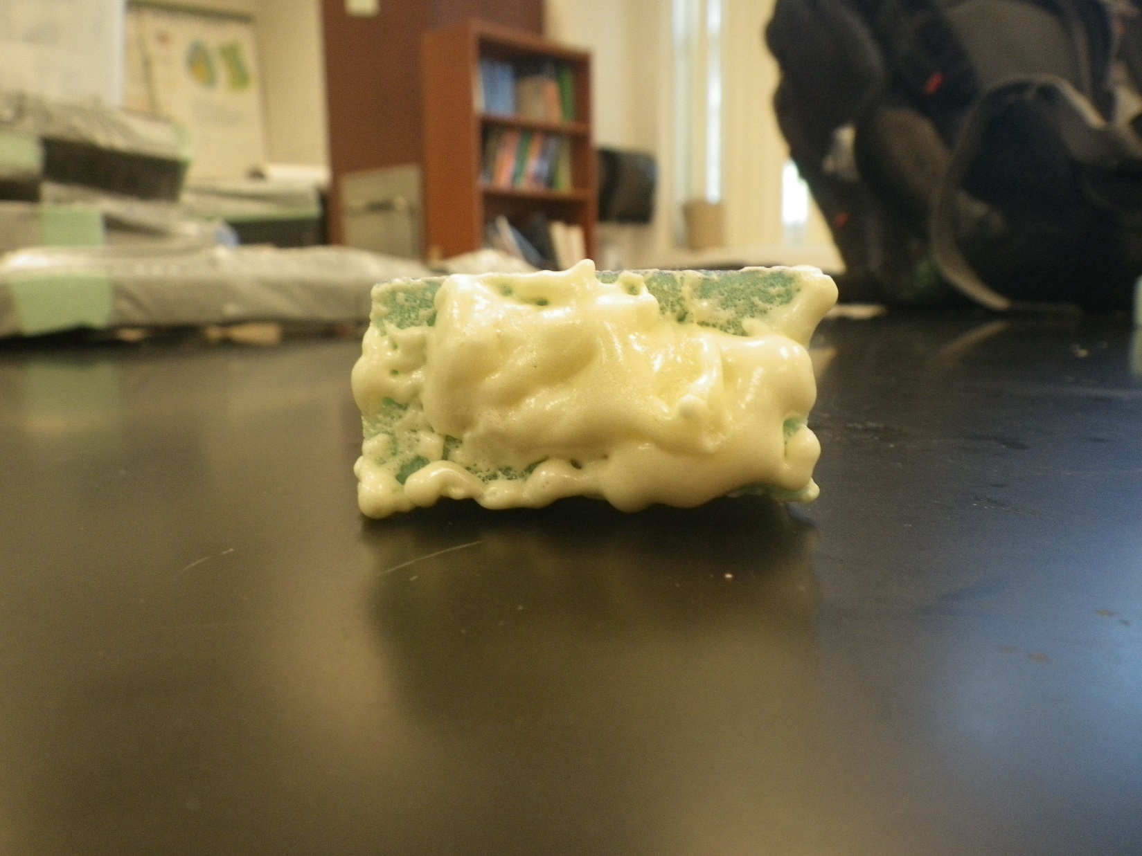

Hollowed out and filled with spray in insulating foam

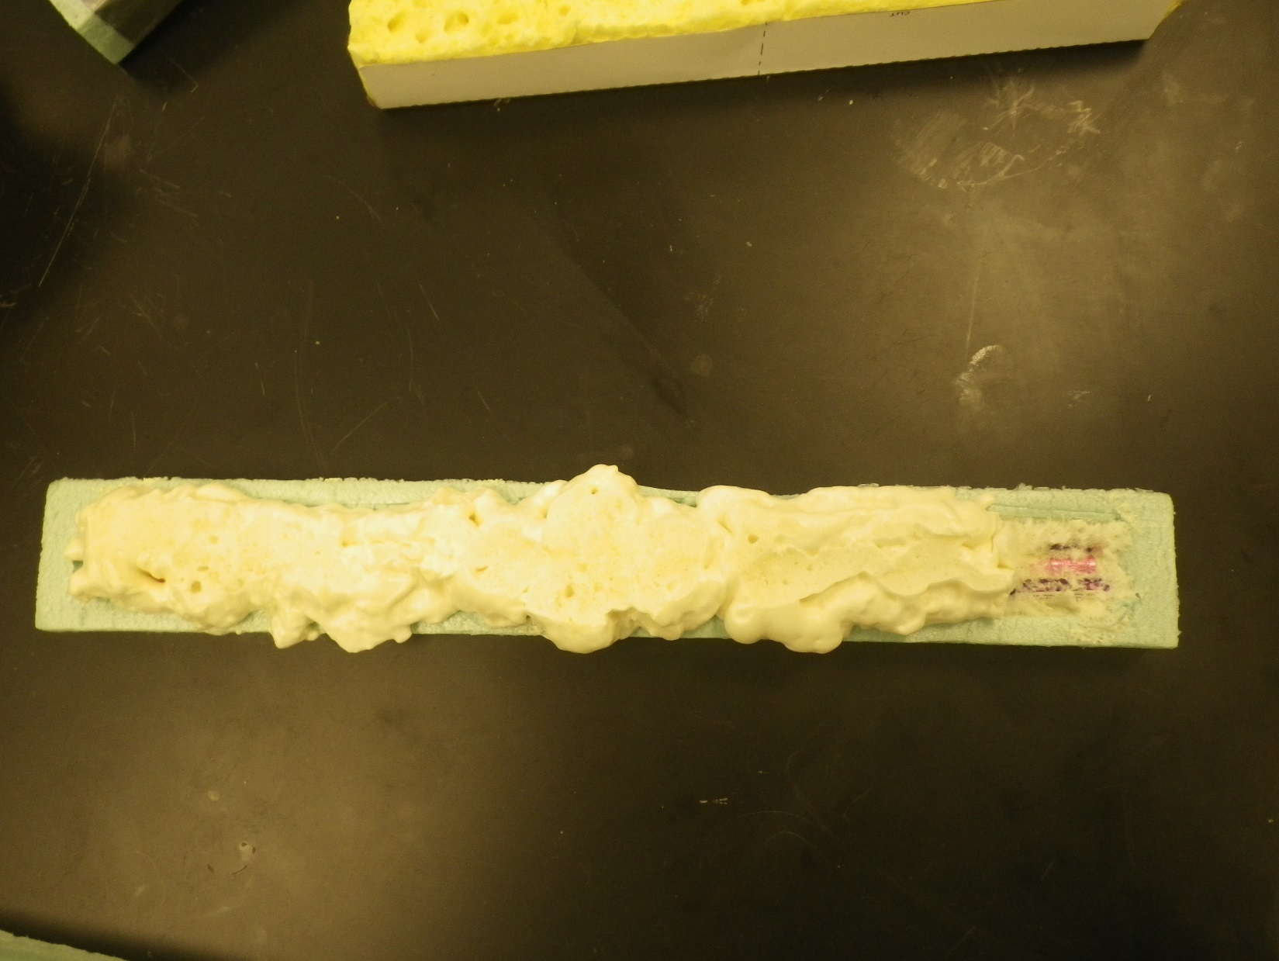

Hollowed out, reinforced with pencils (Pink and purple), and spray in foam insulation.

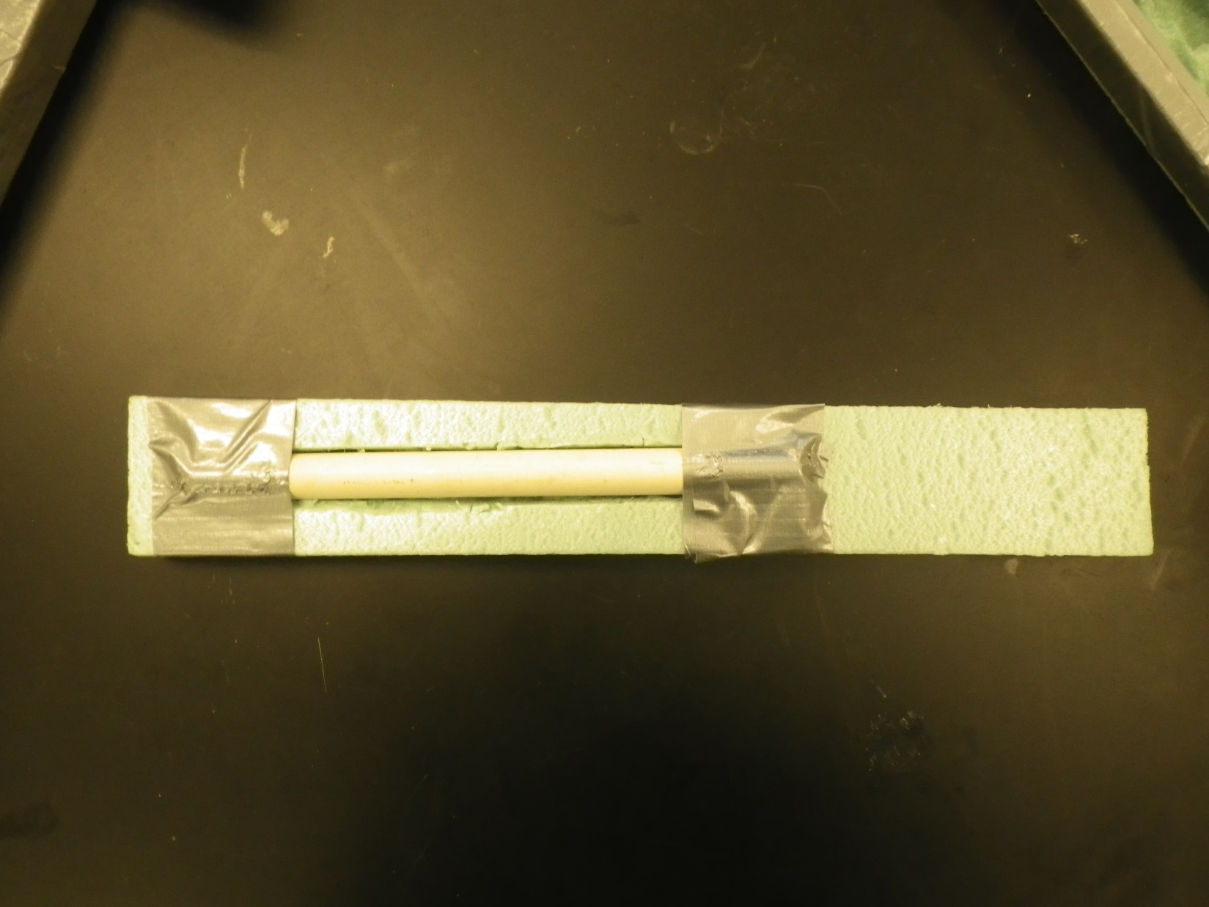

Partially hollowed out, reinforced with PVC pipe held in place with duct tape.

* + - 1. You can introduce I- Beams and have students discuss why railroad rails are shaped somewhat like I-Beams as part of the design process.