Materials Engineering in Lightweight Design:
Side Impact Automobile Crash Test Curriculum Modules

Developed by Peggy E. Jones, Ph.D., Debbie Goodwin, and Andrew Nydam
for the ASM Materials Education Foundation

Curriculum development sponsored by LIFT, Lightweighting Innovations for Tomorrow





INTRODUCTION

The activities presented in this curriculum module were developed to give middle and high school students an opportunity to experience the engineering design process from the perspective of a materials scientist. This package includes:
- Curriculum alignment and pacing guides,
- An introduction to lightweight design,
- Videos illustrating the design challenge of protecting automobile passengers in a side crash,
- Equations needed to optimize student designs to make stiff and mass efficient beams,
- Lab worksheets and teacher guides,
- Short video clips that can be used to preview the labs with your students,
- Online videos about an athlete who happens to be a lower limb amputee. These videos focus on the materials engineering involved in creating her prosthetic, and how the limits of current materials and processes affect what she can do, and
- Overview video to introduce teachers to the activities (35 minutes)
The lab activities are designed to be modular and inexpensive. Depending on your objectives and time available, you can offer the students one to four labs with an optional crash test for each lab. We have a suggested order for the labs, but feel free to adapt them to suit your students.
The labs were developed by a materials engineer who loves introducing teachers and students to her field and two outstanding retired high school Materials Science teachers, one with a traditional science background and one with a technology background. The lab procedures were tested and critiqued by ASM Materials Education Foundation Master Teachers, and also by participants in ASM Teachers Materials Camps. We are especially grateful to Laura Moore who bravely test drove the first drafts with her high school students and gave us helpful feedback.
We believe these activities will be useful beyond Materials Science elective courses. They should fit well in physics and math courses, and satisfy NGSS requirements to teach the engineering process. We salute all you do for your students – thank you for choosing to teach.

Peggy E. Jones, Ph.D. | Debbie Goodwin | Andrew Nydam
Materials Engineer | ASM Master Teacher | ASM Master Teacher

CONTENTS

Topic | Page
Introduction | 2
- Curriculum Alignment | 4
- What is Lightweight Design? | 5
- Side Impact Crash Test | 7
- Beam Design: Shape and Material Variables | 9
- Overview of the Labs | 11
- Lab 1: Shape Variables | 15
- Lab 2: Material Variables | 40
- Lab 3: Stressed Skin Composites | 64
- Lab 4: “Freestyle” –Integrating Shape and Material Variables, Design Optimization | 76
- Classroom Crash Test Methods | 86
- Classroom Video Discussion Starters: Prosthetics | 95
- Further Information Sources | 99

- Curriculum Alignment
The activities in this module involve creating beams of different sizes and shapes, and made from different materials, with a goal of making the lightest possible beam that meets a required deflection limit under a fixed force (or energy if you do the crash test options). We believe the content meets these NGSS requirements:
Performance Expectations for Engineering Design:
HS-ETS1-1. Analyze a major global challenge to specify qualitative and quantitative criteria and constraints for solutions that account for societal needs and wants.
HS-ETS1-2. Design a solution to a complex real-world problem by breaking into smaller, more manageable problems that can be solved through engineering.
HS-ETS1-3. Evaluate a solution to a complex real-world problem based on prioritized criteria and trade-offs that account for a range of constraints, including cost, safety, reliability, and aesthetics as well as possible social, cultural, and environmental impacts.
Disciplinary Core Ideas for Engineering Design and Physical Science:
ETS1.A – Defining and Delimiting Engineering Problems
ETS1.B – Developing Possible Solutions

ETS1.C – Optimizing the Design Solutions
PS3.B – Conservation of Energy and Energy Transfer
Science and Engineering Processes:
Asking questions and defining problems
Planning and carrying out investigations
Analyzing and interpreting data
Developing and using models
Constructing explanations and designing solutions
Engaging in argument from evidence
Using mathematics and computational thinking
Obtaining, evaluating, and communicating information

Crosscutting Concepts:
Cause and effect: mechanism and prediction
Scale, proportion and quantity
Systems and system models
Energy and matter: flows, cycles and conservation
Structure and function
Connections to Engineering, Technology and Applications of Science:
Interdependence of Science, Engineering and Technology
Influence of Science, Engineering and Technology on Society and the Natural World
Connections to the Nature of Science:
Scientific Investigations Use a Variety of Methods

- What Is Lightweight Design?

Engineers strive to use the least amount of material to achieve the required strength when we create new designs. We are still catching up to nature, where bones and shells exemplify light weight design. The shapes of the bones and shells gradually change over generations to use the least amount of energy to satisfy the required strength. Figure 1 shows the architecture of a vulture’s wing bone, specifically the humerous. The bone has a complex external shape, reinforced with internal struts where the bone has the most force applied to it. In addition to changing shape, the density of the bone varies as well. The vulture’s wing bones had average densities varying from 0.28 to 0.98 g/cm³ depending on what was required for successful function.

Using the least amount of material reduces the financial and environmental costs of producing components. For components that move in operation, reducing the mass has ongoing benefits in saving energy. One familiar example is improving fuel economy of cars by reducing their mass. Students may relate to the importance of lightweight design in sporting equipment, marching band instruments, and electronics.
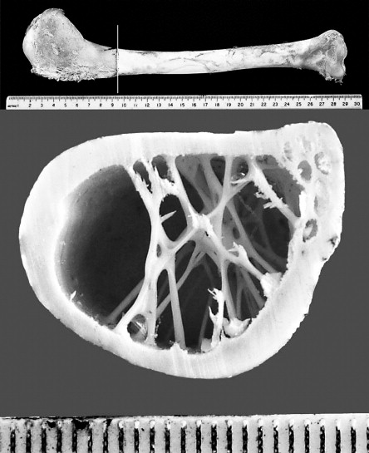
1
2
3
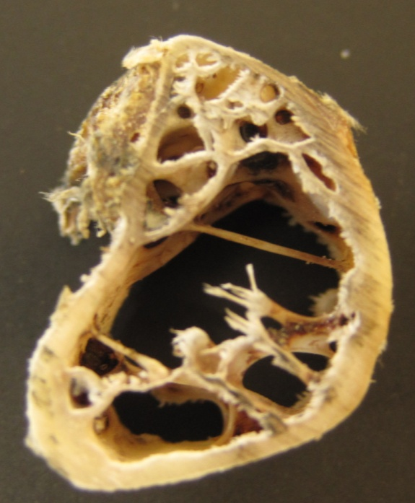
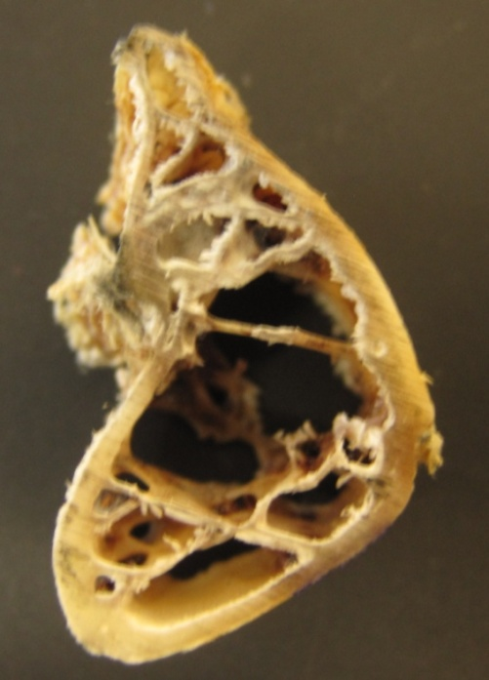
2
1

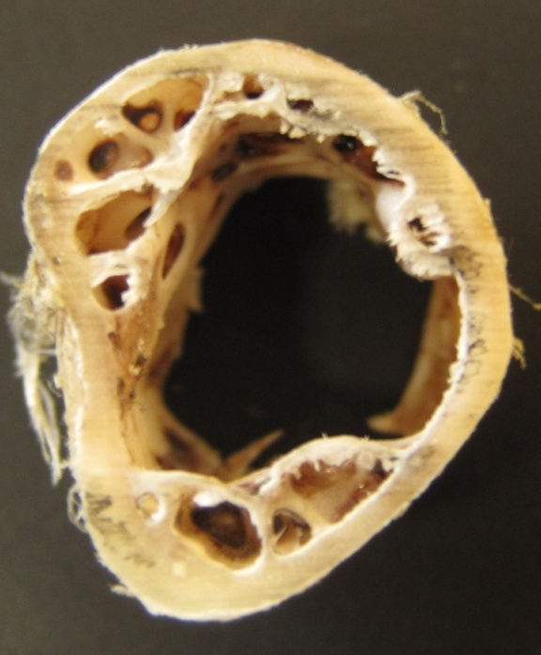
3
BONE | AVG. DENSITY  (g/cm³)
Humerous | 0.98
Radius | 0.28
Ulna | 0.91

0.2 cm

Figure 1: Vulture wing bones are contoured and internally reinforced to place bone only where it is needed to support the forces on the wing. The bone density also varies. Lower density bone is found in the radius which experiences lower forces than the humerous.¹
- Side Impact Crash Test

A current lightweight design challenge is safety critical structures in automobiles. Automobiles are designed with “crush zones” and “safety cages”. The front and rear of the car absorb energy by deforming in a crash. The structures around the passenger compartment form the “safety cage” which must resist denting and crushing. Over time, the design requirements for the safety cages have become more stringent. The U.S. National Highway Traffic Safety Administration doubled the roof crush strength requirements to reduce injuries in rollover accidents in 2009.

Our activities are based on the “B Pillar”, which is the structure between the front and rear doors of a 4 door sedan. This structure protects passengers from intrusion when a vehicle is hit from the side. The Insurance Institute of Highway Safety (IIHS) rates the side impact crash resistance based on how far the “B Pillar” deflects across the driver’s seat after the test car is hit by a 1500kg sled going 50 km/hour. The test is designed to have an independent variable of a fixed kinetic energy, and a dependent variable of the deflection resulting from the impact. Figure 2 shows the location of the B Pillar, and Figure 3 shows the crash test and how the ratings are done after the test. Our labs can be run with a fixed impact energy like the IIHS test, or with variable energy.

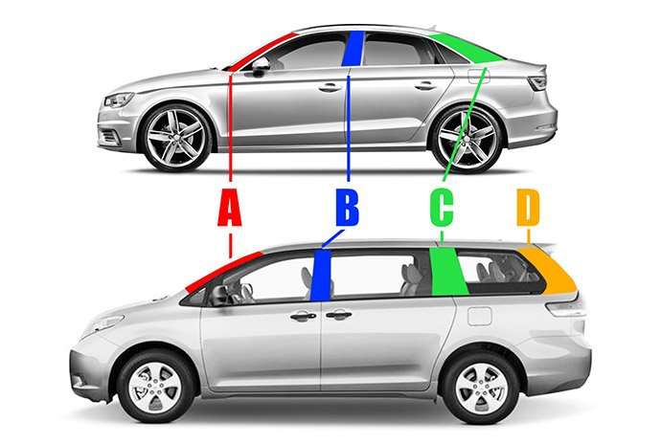
Figure 2: Location of the “B Pillar” on a 4 door sedan.
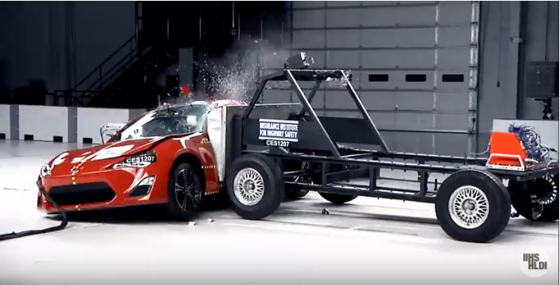
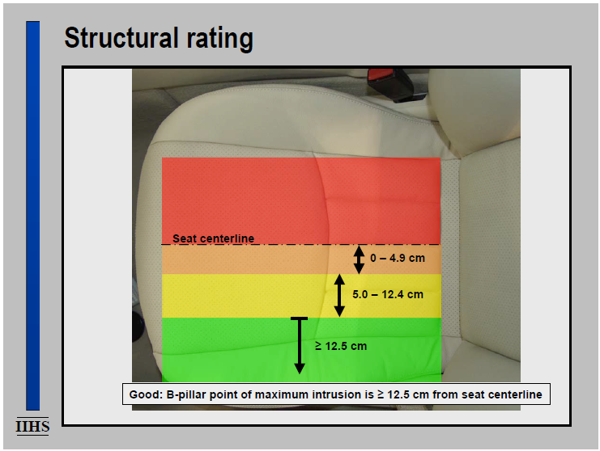
Figure 3: The IIHS crash test and ratings system. The test is shown on YouTube: www.youtube.com/watch?v=_WurTOejrhI. IIHS expresses the test results as good, acceptable, marginal, or poor. For the side crash, a B Pillar that only bent into the “green” zone would be good, while one that bent more than halfway across the driver’s seat into the “red” zone would be poor. (Used by permission of IIHS.)

- BEAM DESIGN: SHAPE AND MATERIAL PARAMETERS
As in the hollow bird bone example, engineers reduce the mass of the B Pillar by optimizing the shape of the part and by choosing stiff materials to make it. Typical B Pillars are made of layers of steel, and the thickness of the layers varies just like the bird bone shape varied. Figure 4 shows an example of a B Pillar designed to be as lightweight as possible while meeting the safety requirements.
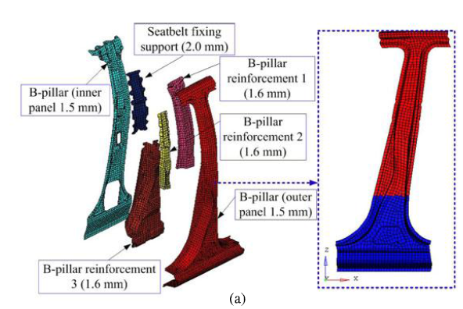
Figure 4: An example of a low mass B Pillar comprised of 6 layers of steel that are welded and glued together. The thinnest area of the stacked assembly is the very top of the green inner panel, at 1.5 mm, which is about the same thickness as 15 sheets of copy paper. Near the center of the pillar, at the point where IIHS rates the deformation, the stacked assembly is about 8.2 mm thick, or about 82 sheets of copy paper. In addition to varying the thickness of the steel sheets, the strength level of the steel can also be varied between the layers by changing the chemistry of the steel and how it is processed.

We needed to adapt the B Pillar design concept to a practical classroom activity, both in terms of the math needed to optimize the beam design and in the lab work to make and test the beams. The equations to predict the deflection of a beam have two categories of variables: shape and material. By choosing simple shapes like rectangles or cylinders, the deflections can be predicted from algebra rather than calculus. There are also algebraic formulas to predict deflection for hollow rectangular beams and for round tubes. The “shape” variables are the beam length (L), and the “Moment of Inertia” (I) which relates to the cross section of the beam. Formulas for Moments of Inertia are readily available online. Figure 5 shows four moments of inertia which should be most useful for the labs.
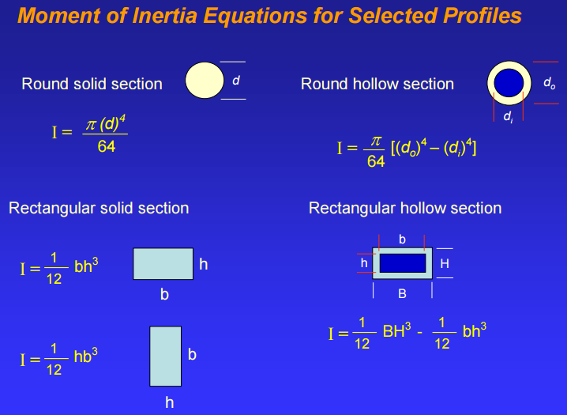
Figure 5: Moments of inertia for solid and hollow rectangular and round beams.

Let’s consider how we can predict the deflection of a diving board as a person stands on it using the equation in Figure 6. This is a classic “cantilever beam” problem in physics. We know from experience that the heavier the person, the more the diving board sags down. We also know that it sags more as you move farther away from the support end of the diving board. These effects can be identified in the structure of the equation used to predict the deflection of the diving board with respect to force applied (F, the person’s weight) and the unsupported length of the board (L). As these two variables increase, the diving board should deflect farther. We see that the equation has the Force and Length in the numerator, so when they increase, the deflection increases.
Using similar reasoning, we observe that as we make the beam thicker and wider, the deflection is reduced for the same unsupported length and applied force. These shape variables are in the denominator so when they increase, the predicted deflection is reduced. Students can use the equation to guide their engineering design strategy – increasing the beam height will reduce deflection more effectively than increasing the width (B). The only factor related to what the beam is made from, E, shows that stiffer materials will result in a beam that deflects less.
A very simple classroom exercise to help kinesthetic learners tackle the equations is to place a meter stick, rulerso it overhangs the desk like a diving board. Press gently on the end of the stick and observe the force to deflect it downward a few centimeters. Next, shorten the unsupported length by about half and observe the increase in force needed to achieve the same deflection. Finally, turn the stick 90* so the “height” is much greater than the “base” and try to push the end of the stick down a few cm. This should be very difficult.
The effects of shape on beam deflection can also be investigated using wooden dowel rods of different cross sectional areas clamped to a table. A cup or bottle can be hung from the end of the rod, and the mass of water, sand, washers etc. needed to deflect the rod a fixed distance can be measured. Round and square dowel rods if different sizes are readily available at hardware stores.

- Overview of the Labs

We devised four labs. Lab 1 focuses on the concept of shape effects on beam stiffness, and bridges the concept of a layered sheet metal B Pillar to the simplified beam shapes in the other labs. We copy “cut and fold” instructions onto cardstock. Students fold the cardstock into two beam shapes, one tall and thin and one short and wide. The length is kept constant, and the beams are made from identical materials. We determine how much mass is needed to collapse the two different shapes, and think about how to represent the side crash test in how we support our beams when loading them. Since both beams have the same mass, the beam that supports the most mass becomes the winner on the basis of mass supported per mass of beam. Lab 1 takes approximately 1 class period to perform, and students can discuss the results the following day.

shape
material
F
L
k = F/Y = E * 3 (I/L³)

Y

Rearrange the equation to solve for Y:
Y = F x L x L x L
3 x E x I

Replace I with I= (1/12) x B x H x H x H from Figure 5.
Y = 4 x F x L x L x L__
E x B x H x H x H

Figure 6: The formula for deflection of a solid rectangular cross section beam, like a diving board, has variables related to the material used to make the beam (Young’s Modulus, E) and the beam shape (I, L). The force applied to press the end of the board down is shown as “F”. We can rearrange the formula and substitute the equation for “I” for the solid rectangular beam to create a formula that predicts the downward deflection of a beam from the beam width (B) and height (H), the unsupported length (L), and the stiffness of the material from which it is made (E).
Lab 2 focuses on the effect of material choice on the beam stiffness. We used two different densities of polystyrene foam insulation board from the hardware store to make the solid, rectangular cross section beams. By incrementally increasing the mass hanging from the end of a beam clamped to a table and recording the deflection, students can measure the stiffness of the material (E) needed to calculate the deflection for future beam designs using these same materials. By dividing the mass needed to deflect the beam a fixed amount by the mass of the beam, the structural efficiency of the beams can be compared. Other materials can be used to make beams of the same shape. Suggested alternatives are in the Lab 2 writeup. If the teacher pre-cuts the foam beams, Lab 2 can be completed in a single class period. If students fabricate the beams, 1.5-2 class periods should be allotted. For a one minute video of the Lab 2 in progress, please visit the ASM Master Teachers Website: https://sites.google.com/site/asmmasterteacherwiki/project-definition/ps-beam-and-tape

Labs 3 and 4 combine the concepts of shape and material choice to create the most mass efficient beam. Lab 3 is based on stressed skin composites found in aircraft wings. Another example of a stressed skin composite is a banana – when we begin peeling a banana the force we apply to the skin is carried by the skin until the skin tears open. Our starting point for Lab 3 is the foam beams from Lab 2, combined with tape such as duct tape or package tape. Students are asked to place the tape so it provides the maximum increase in stiffness with minimum additional weight. The same cantilever beam test used in Lab 2 is used in Labs 3 and 4. The winning beam is the lightest beam that deflects no more than a required limit under a fixed force (or crash energy). The cost of the tape can also be included to bring a more real world engineering constraint to the class. If you don’t have an easy way to cut insulation foam board, the stressed skin composite lab works with uncooked lasagna noodles.

Lab 4 invites students to design, make, and test the most structurally efficient beam. You will need to work with the class to agree on constraints such as the materials to be used and the amounts. Students starting with the foam insulation board beams can carve foam away, add reinforcements such as bamboo skewers or pencils, or add tape. Some of them will use the equation to think about the base and height of the beam they want to make, and others will focus on the materials of construction. It is possible to tape two rectangular beams together and drill a hole where they meet. If you flip them over to drill the other side, you end up with something like an I Beam which is very mass efficient. Plan on 2 class periods for Lab 4. Students will create the beam in the first period and test it in the second period.

Labs 2-4 assume that a cantilever beam set up will be used to determine the mass that can be supported by the various beams without deflecting more than a set amount. The maximum allowable deflection relates back to the IIHS crash test rating with respect to the B Pillar intrusion across the driver’s seat. Students will want to crash test their beams. Three practical ways to crash test beams with fixed or variable energy are described in the final section of the lab write-ups.

Section 6

LAB 1
Shape Effects on Beam Strength

Version A: Weights stacked on top of beam

Version B: Weights suspended below beam

Materials:
2 Card Stock Templates
Scissors
Meter stick
Scale for weighing beams and pennies or washers
Ruler (to help fold with straight lines)
Washers or Pennies for weights
2 Books – same thickness, at least 10 inches tall, to support the beams

Goal:
We are going to make beams with two different widths and heights, but the same length. We will determine which shape can support the most mass without collapsing. Which beam shape would you predict will be stiffer based on your experience with the meter stick tests? (Circle it.)
F

F

F

Procedure:
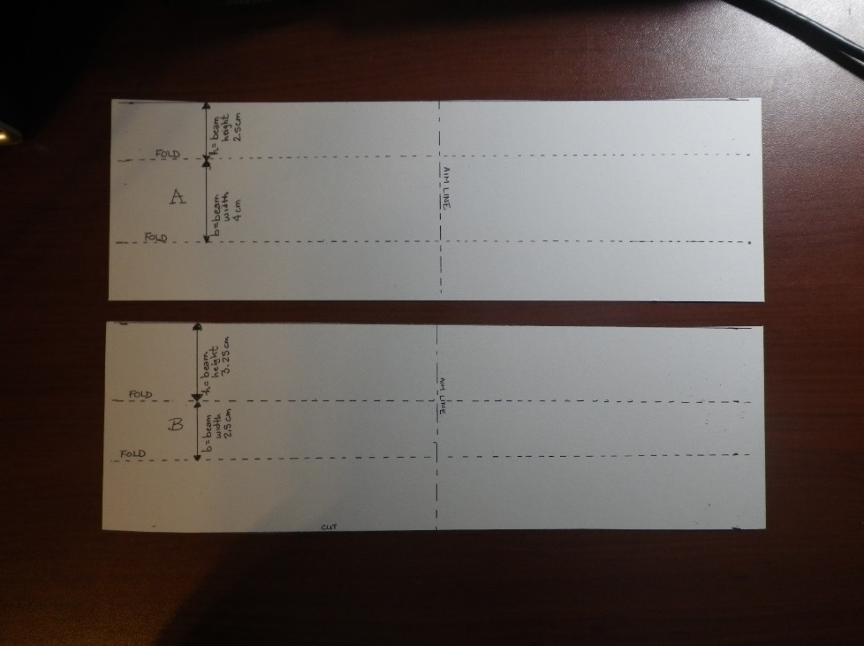
- Cut the card stock into two pieces that are 28 cm long x 9 cm wide. Label the pieces A and B. Mark the center of the length with an “aim” line across each piece. This line will be 14 cm from the end.

- Fold piece A to create an open U shape that is 28 cm long. The bottom of the “U” should be 4 cm wide, and the legs of the U should be 2.5 cm tall. The line marking the center of the length dimension should be on the bottom side of the “U” so you can see it if you flip the U over and stand it on its legs. Use the edge of a ruler to help get straight folds. Record the mass of beam A: _________ grams

- Fold piece B to create a taller U shape that is 28 cm long. The bottom of the “U” should be 2.5 cm wide, and the legs should be 3.25 cm tall. Record the mass of beam B: _______grams

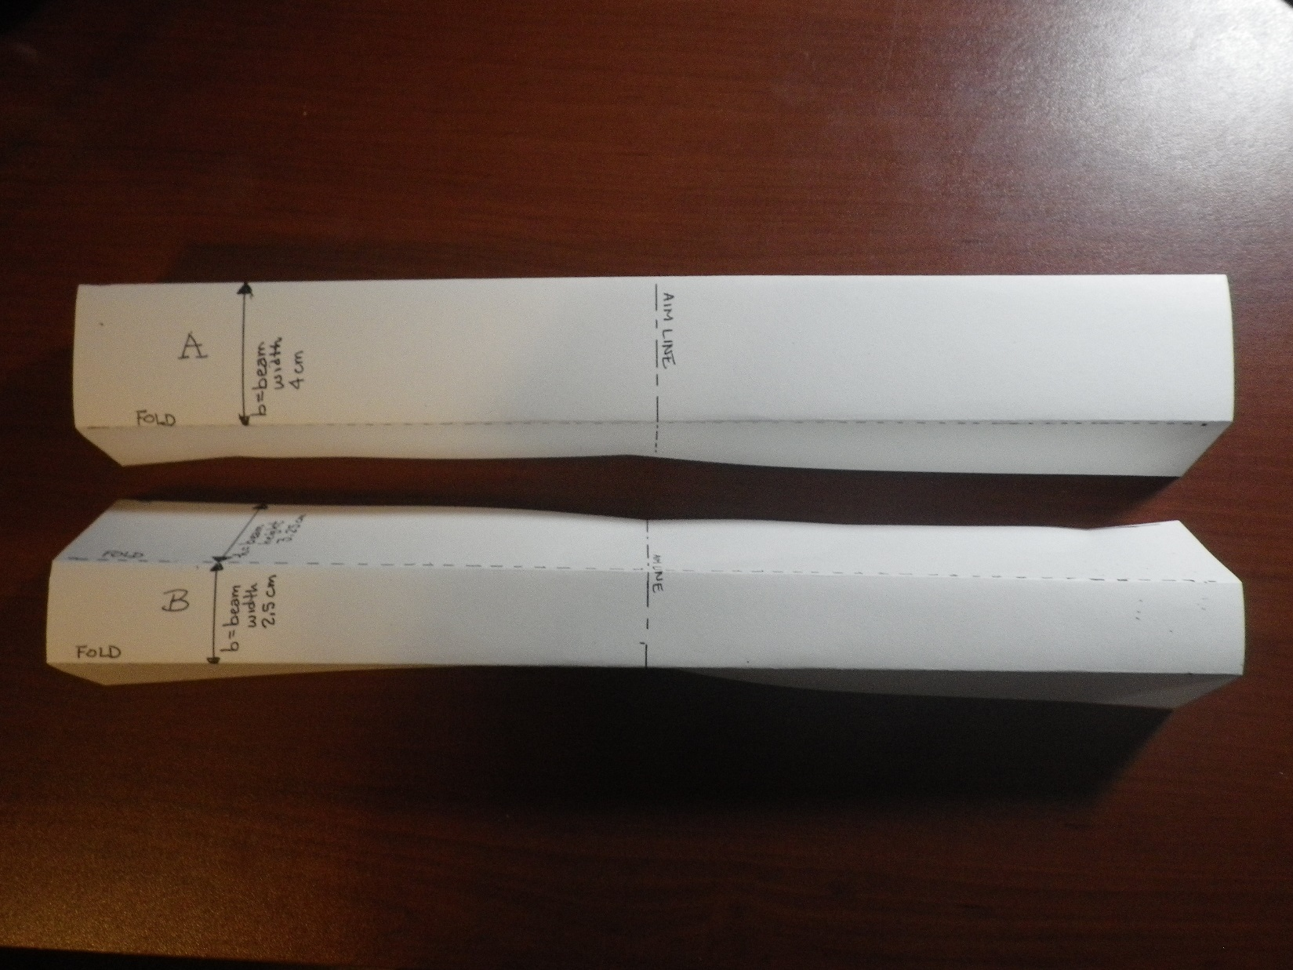

- Stand both U channels on their legs so the bottom of the U faces up and you can see the centerline mark.
- Mass 5 washers or pennies and calculate the average mass per washer or penny:
1 | 2 | 3 | 4 | 5 | Sum of 1-5 | Average Mass (=sum/5)

- Stack the washers or pennies on the centerline of the beam and record the mass the beam can support.
  - Channel A ___________grams

  - Channel B ___________grams

- Observe how your beam failed. Did both beams fail the same way?

- Did your prediction match your observation?

- The “Structural Efficiency” of the beam is a way to determine which beam design supported the most mass for a given mass of the beam structure. Calculate the structural efficiency here:
Beam | Mass Supported (g)  (Step 6) | Mass of Beam (g)  (Steps 2 and 3) | Structural Efficiency (g/g)  =Mass Supported/  Mass of Beam
A

B

- If we are trying to relate this beam test to the stiffness of the metal between the driver and passenger doors in a car during a side impact crash, how should we change the test method to better represent the car crash test? Draw, diagram, or describe your proposed test method.

- In the crash test video we watched, the doors were closed when the car was impacted. Make 2 new beams and mass them. Place your beams between two heavy books to act like the doors on the sides of the beam. Load the center line of your beams again and record the mass at which they failed, and how they failed. (If your tower of pennies or washers is too tall, make two towers, one on each side of the center line, and add the weights equally to each tower.)

Channel A:
Mass of beam:
Mass of pennies or washers that caused it to fail: ________ grams
Mass supported divided by Mass of Beam: _________ gram/gram
Failure description or diagram:

Channel B:
Mass of beam:
Mass of pennies or washers that caused it to fail: ________ grams
Mass supported divided by Mass of Beam: _________ gram/gram
Failure description or diagram:

- Determine the structural efficiency here:
Beam | Mass Supported (g)  (Step 6) | Mass of Beam (g)  (Steps 2 and 3) | Structural Efficiency (g/g)  =Mass Supported/  Mass of Beam
A

B

- What effect did providing side support have on the beam failure?
  - The mass supported for the same shape?
Adding side support (increased or decreased) the mass the beam could support.
  - The structural efficiency of the same shape?
Adding side support (increased or decreased) the efficiency.
  - The ranking of structural efficiency comparing A to B with and without support?
Without support (A or B) had the highest structural efficiency
With side support (A or B) had the highest structural efficiency
(A or B) is the most mass efficient (highest collapse mass per mass of beam) shape.

Test Set Up for Side Supported Beam with Stacked Weights

(It’s easier to stack the weights if your supports are the same height as the beam, or slightly shorter.)
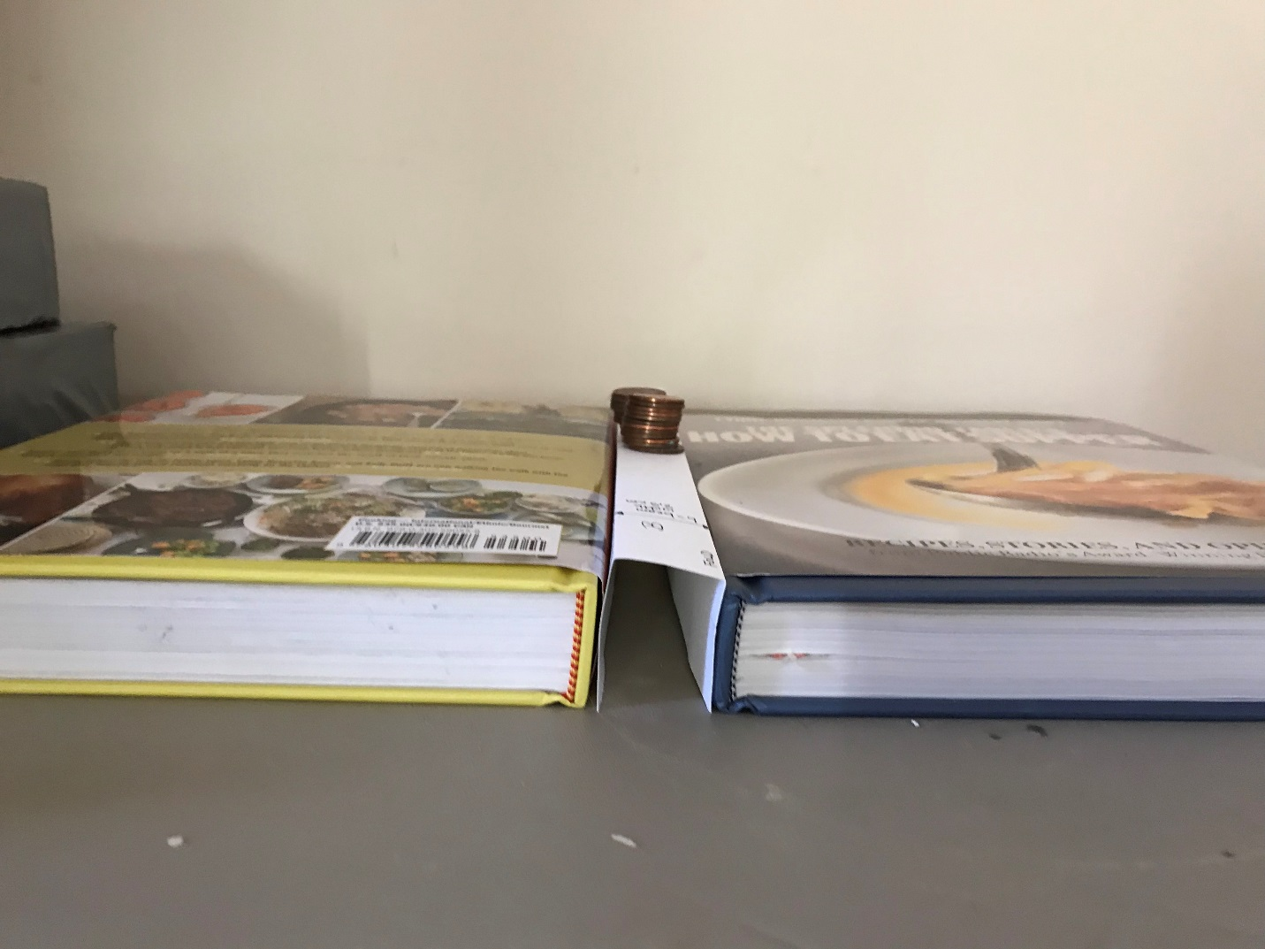


OPTIONAL: Crash test your beams using a pendulum impact

Teacher Instructions:
Equipment:
Ring stand
8 oz. water bottle with cap
String
Small cardboard box, 6-8” long
Scissors
C or Flat Clamp
2 Rulers
Masking tape
Graph Paper
Heavy books or a gallon jug of water to brace the box against

Note: The support for the beams is moved from the sides to the ends to open up a space for the pendulum to impact the beam. The fundamental effects of the beam shape on the deflection created by an impact should carry over from the stacked weight experiment.

Remind students that in the crash test video, the car hit with a fixed impact energy. After impact, the deflection of the B Pillar was measured. This lab can be run with fixed or variable impact energies by changing the mass of the impactor (water bottle) or by varying the height from which the bottle is released. To provide the best match to the crash test video, this procedure is written based on a fixed energy with the deflection resulting from the impact being the dependent variable.

Set Up:
      - Place a ring stand on a table, near the edge.
      - Hang a small (e.g. 8 oz) water bottle with a cap from the ring stand. Adjust the string length so the water bottle hits the center of the beam length. You will need to do some preliminary testing to determine how much water to put in the bottle. Mass the water bottle, water, and string: M = ____grams.
      - Make slits in a cardboard box approximately 6-8” long (or wood box ). The slits should be long enough to slide the card stock beam legs into the slits so the wide part of the beam is in contact with the edge of the box. The slits should be centered along the box width. The slits should be 2.5 cm and 4 cm apart. The beams need to overhang the ends of the boxes, or they will slip out of the slits when impacted. (See Figure 1.)
      - Cut a portion of one side of the box away to create a “window” to view the impacted beams. (See Figure 2.)
      - Clamp the box and ring stand to the table. I didn’t have a suitable clamp to fit inside the box, so I used a paint stir stick to do the best I could, then braced the back of the box against a jug of water so it didn’t move. I found that placing the box opening just behind the ring stand so that one end of the beam was in contact with the ring stand worked well. In a sense, having the support of the ring stand on the end of the beam is like having the B pillar attached to the roof of the car.
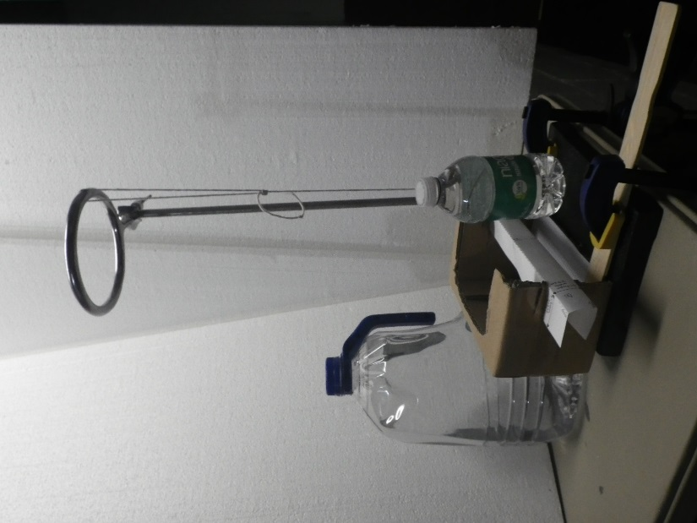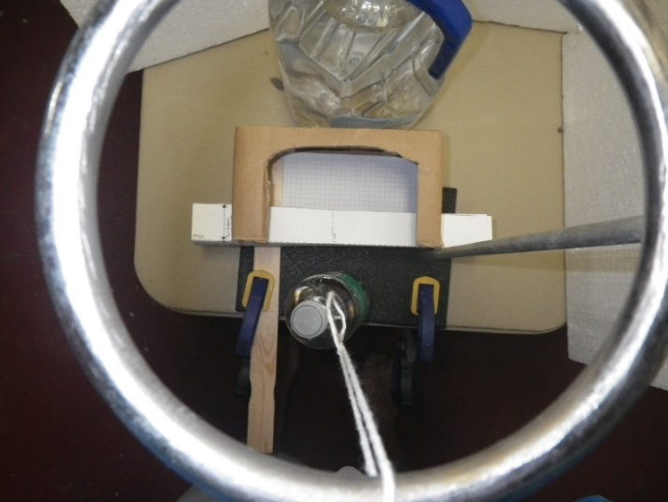
Figure 1: Side and top views of impact test setup using a pendulum anchored with a ring stand. One end of the beam is placed against the ring stand post, and graph paper inside the box to provide a measure of deflection. The gallon jug of water is simply bracing the box so it doesn’t move when the beam is impacted.
      - Put a line of masking tape on the ring stand straight out from the center of the beam as a guide for the pendulum path – you want to get a direct hit, without angular variation. You may also want to put a piece of tape on the ring to help align the string for the impact.

      - (Optional) Place a ruler at the end of the tape to measure the height of the water bottle at the top of the pendulum swing. You want to impact the beams with a consistent potential energy. I just lifted the bottle to a visually determined 90°, even with the top of the ring stand
A. Determine the height for the students to use: ___ cm.
B. Calculate the potential energy for your test: PE = mgh = ___ Joules
m = mass of bottle and string, in kg
g = Gravitational constant, 9.8 m/s² on the Earth’s surface
h = height from which the bottle is dropped, in meters

      - Have a second ruler available to measure the maximum beam deflection after impact, while the beam is still in the shoebox fixture, or tape a piece of graph paper in the box to use as a measure of maximum deflection. To accelerate testing, you could mark “good/pass/fail” deflection zones on the graph paper, similar to the system used by the IHSS crash tests.

Test Procedure:
            - Prepare new “Channel A” and “Channel B” samples. Reusing samples that collapsed under the weight bearing test may cause poor results in the impact test.
            - Mass the samples and record the mass:
  - Channel A ___________grams

  - Channel B ___________grams

- Slide the 4 cm wide Channel A into the slits in the test fixture.
- With the string fully extended, raise the water bottle to a height of __ cm. Use the masking tape line to align the bottle with the center of the beam.
- Smoothly release the bottle, without trying to throw or push it toward the beam.
- Measure the maximum deflection of your beam from its starting position using the edge of the box as “zero”. Y = ___ cm
- Determine your Channel A score:
  - Divide the maximum deflection by the mass: S =Y/m =
  - Lowest score wins.
- Repeat the test for Channel B, using the slots that are closer together to hold the skinnier beam.
  - Maximum deflection, Y= ___
  - Channel B Score, S = Y/m = ____
- Which beam had a better score, A or B?
- Who had the best score in the class and how much different were the scores within each beam shape?

Example of a failed beam:
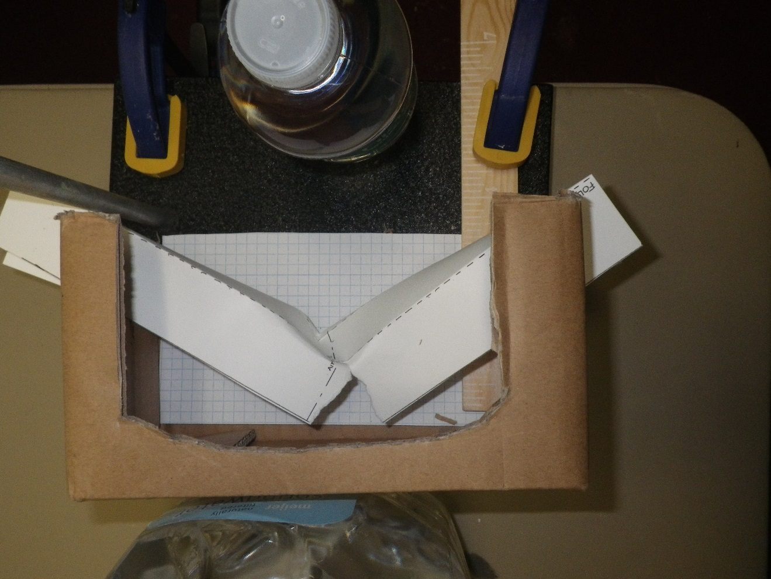
Figure 3: This beam tore after impact with a full 8oz water bottle raised to the top of the ring stand.

BACKGROUND FOR TEACHERS
The stiffness of a beam is related to its shape and the materials used to make it. The purpose of this lab is to highlight the effects of shape on stiffness. In this case, stiffness is the resistance to deflection under a force.

Please begin the lab with a quick warm up activity using a meter stick, ruler, or paint stir stick to provide students with a tangible experience of the effect of geometry on the ease of deflecting the beam.
The stiffness of a rectangular beam depends on the shape variables of length, height, and width. For a solid meter stick, the formula to predict how much the beam should deflect is:
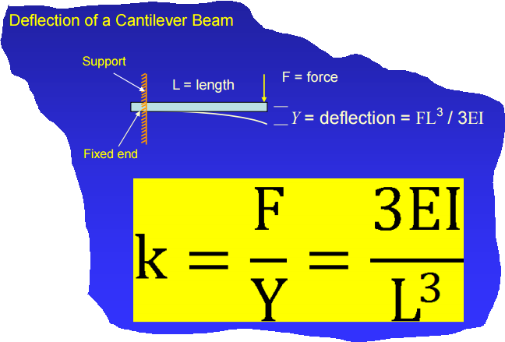
Y = FL³/4Ebh³
Y= deflection of the center or end of the beam
F = applied force
L = beam length
E = Young’s modulus (stiffness) of the beam material
b = width of beam
h = height of beam

Look at the formula and do a thought experiment with the meter stick in 3 positions:
- Lay the meter stick on the table so the wide side is against the table and the numbers are facing up to the ceiling. Put the edge of the table at the 50 cm mark so half the stick is hanging off the table.
- Starting from the position “A”, move the meter stick so the 75 cm mark is at the end of the table and 25 cm of the stick is hanging off the table.
- Turn the meter stick so the numbers face to the side and the thin side is against the table. Move it so the 50 cm mark is at the edge of the table and half the stick is hanging off the table.
Looking at the formula, which meter stick position would you predict to be the hardest to deflect of the 3 positions described?
A. _______ 50 cm/wide side down
B. ______ 25 cm/wide side down
C. ______ 50 cm/thin side down

Let’s test your hypothesis by placing the meter stick as described in A, B, and C and gently pressing on the end of the meter stick hanging off the table to move it down about 1 cm.

Which position of the meter stick was hardest to move? A._______ 50 cm/wide side down
B. ______ 25 cm/wide side down
C. ______ 50 cm/thin side down

This experiment with the meter sticks should be followed by making and testing simple open “U” shaped beams with different shapes. The student’s lab instructions will begin with a hypothesis about which beam shape should be able to support more load without collapsing based on their experience with the meter stick.
Here’s the beginning of the students’ lab instructions:

We are going to make some beams with two different widths and heights, but the same length. We will determine which shape can support the most mass without collapsing. Which beam shape would you predict will be stiffer based on the formula and your experience with the meter stick tests? (Circle it.)
F

F

F

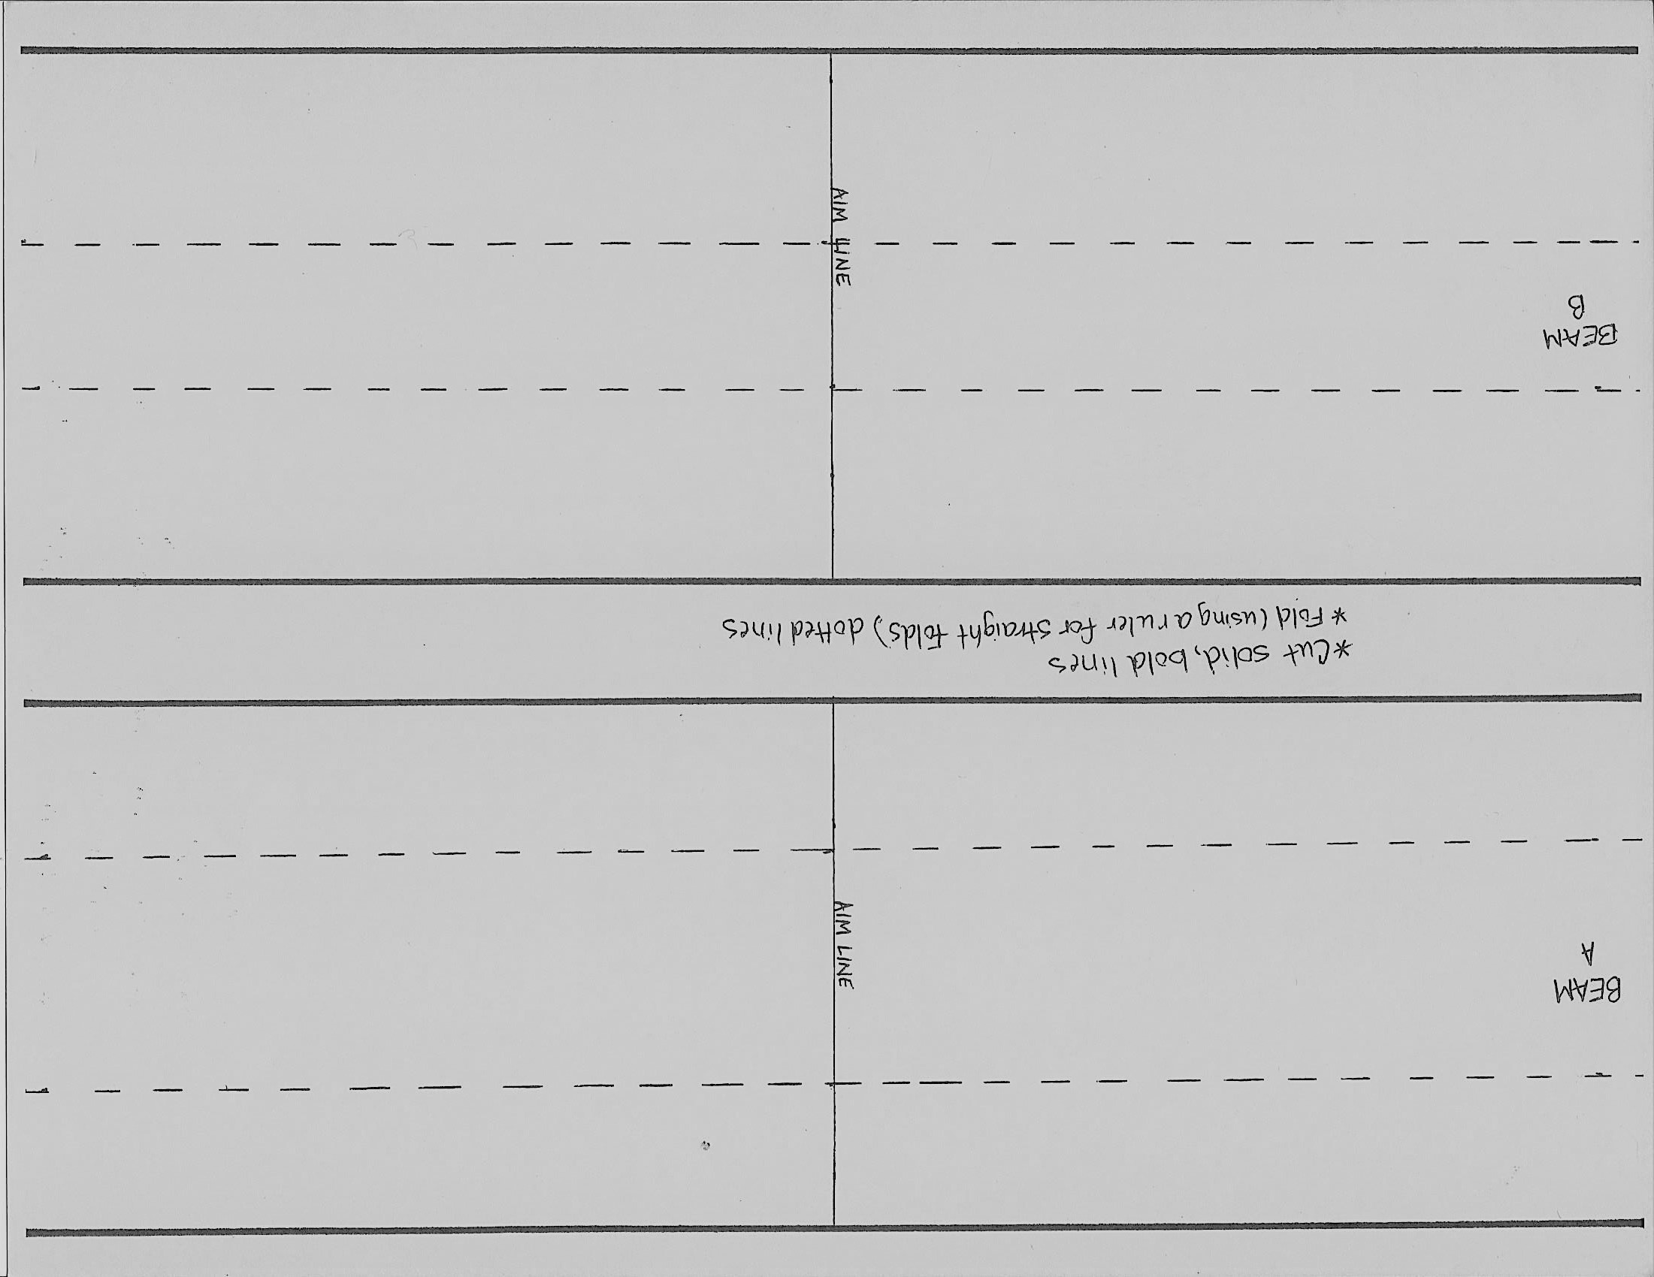

Materials:
2 Card Stock Templates
Scissors
Scale for weighing beams
Meter stick
Ruler (to help fold with straight lines)
1 paper clips (to make a hook to hang the water bottle)
2 Books – same thickness,at least 10 inches tall, to support the beams
1 Water bottle per station
1 Washer to spread load
String or wire to connect bottle to paper clip
Graduated cylinder

Goal:
We are going to make some beams with two different widths and heights, but the same length. We will determine which shape can support the most mass without collapsing. Which beam shape would you predict will be stiffer based on your experience with the meter stick tests? (Circle it.)
F

F

F

Procedure:
- Cut the card stock into two pieces that are 28 cm long x 9 cm wide. Label the pieces A and B. Mark the center of the length with an “aim” line across each piece. This line will be 14 cm from the end.
- Fold piece A to create an open U shape that is 28 cm long. The bottom of the “U” should be 4 cm wide, and the legs of the U should be 2.5 cm tall. The line marking the center of the length dimension should be on the bottom side of the “U” so you can see it if you flip the U over and stand it on its legs. Use the edge of a ruler to help get straight folds.

- Fold piece B to create a taller U shape that is 28 cm long. The bottom of the “U” should be 2.5 cm wide, and the legs should be 3.25 cm tall.

- Stand both U channels on their legs so the bottom of the U faces up and you can see the centerline mark. Open the paper clip so you get a hook. Poke the straight end of the hook through the center of the beam’s width at the centerline of the length. Put a washer on the straight end of the hook, and bend the paper clip to hold the washer flat against the top surface of the beam.

- Tie a string or wire around the top of the water bottle and make a loop so you can hang it from the paper clip hook below the beam.

- Put the beams between two desks or tables placed __ cm apart. Hang the water bottle below the beam.

- Using the graduated cylinder, slowly pour water into the bottle and record how many ml of water were in the bottle when the beams collapsed. Record the mass the beam can support, remembering that 1 ml of water has a mass of 1 gram.

  - Channel A ___________grams

  - Channel B ___________grams
- Observe how your beam failed. Did both beams fail the same way?

- Did your prediction match your observation?

- The “Structural Efficiency” of the beam is a way to determine which beam design supported the most mass for a given mass of the beam structure. Calculate the structural efficiency here:
Beam | Mass Supported (g)  (Step 6) | Mass of Beam (g)  (Steps 2 and 3) | Structural Efficiency (g/g)  =Mass Supported/  Mass of Beam
A

B

- If we are trying to relate this beam test to the stiffness of the metal between the driver and passenger doors in a car during a side impact crash, how should we change the test method to better represent the car crash test? Draw, diagram, or describe your proposed test method.

- In the crash test video we watched, the doors were closed when the car was impacted. Make two new beams and mass them. Place your beams between two heavy books to act like the doors on the sides of the beam. Load the center line of your beams again and record the mass at which they failed, and how they failed. Record these masses in the table.
Beam | Mass Supported (g)  (Step 6) | Mass of Beam (g)  (Steps 2 and 3) | Structural Efficiency (g/g)  =Mass Supported/  Mass of Beam | Failure Description
A

B

Sketch the failure mode:

- What effect did providing side support have on the beam failure?
  - The mass supported for the same shape?
Adding side support (increased or decreased) the mass the beam could support.
  - The structural efficiency of the same shape?
Adding side support (increased or decreased) the efficiency.
  - The ranking of structural efficiency comparing A to B with and without support?
Without support (A or B) had the highest structural efficiency
With side support (A or B) had the highest structural efficiency
(A or B) is the most mass efficient (highest collapse mass per mass of beam) shape.

Test Set Up for Side Supported Beam with Suspended Weights

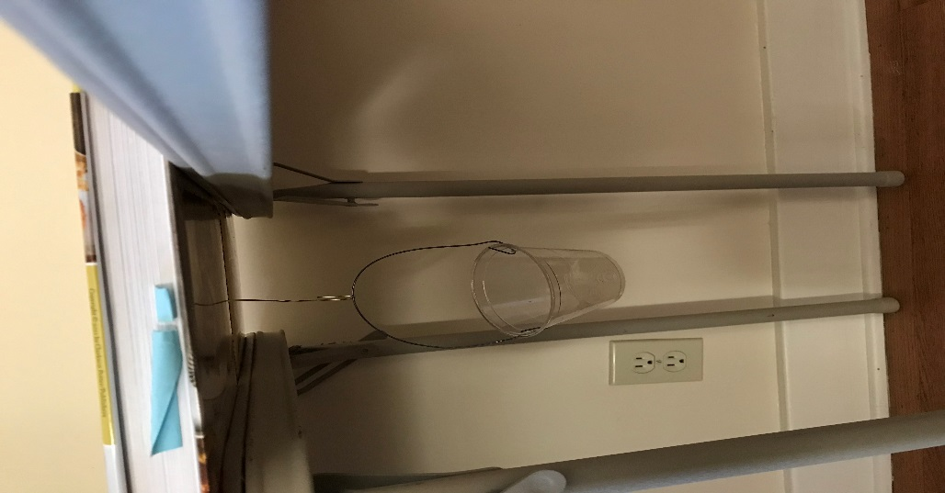

Straighten one end of a paper clip and poke it through the center of the beam. Bend the upper part of the clip 90* so it will sit flat against the top of the beam. Place a washer over the wire to spread the load evenly over the beam surface – the wire should hold the washer against the beam surface when weight is added to the cup or bottle suspended below the beam. Place the beam between two desks or tables like a bridge, and support the beam sides with books or bricks. Add weight to the cup or water bottle hanging from the paper clip. Don’t forget to include the mass of the clip, washer, and container in the mass required to cause the beam to collapse.

OPTIONAL: Crash test your beams using a pendulum impact

Teacher instructions:
Equipment:
Ring stand
8 oz. water bottle with cap
String
Small cardboard box, 6-8” long
Scissors
C or Flat Clamp
2 Rulers
Masking tape
Graph Paper
Heavy books or a gallon jug of water to brace the box against

Note: The support for the beams is moved from the sides to the ends to open up a space for the pendulum to impact the beam. The fundamental effects of the beam shape on the deflection created by an impact should carry over from the stacked weight experiment.

Remind students that in the crash test video, the car hit with a fixed impact energy. After impact, the deflection of the B Pillar was measured. This lab can be run with fixed or variable impact energies by changing the mass of the impactor (water bottle) or by varying the height from which the bottle is released. To provide the best match to the crash test video, this procedure is written based on a fixed energy with the deflection resulting from the impact being the dependent variable.

Set Up:
      - Place a ring stand on a table, near the edge.
      - Hang a small (e.g. 8 oz) water bottle with a cap from the ring stand. Adjust the string length so the water bottle hits the center of the beam length. You will need to do some preliminary testing to determine how much water to put in the bottle. Mass the water bottle, water, and string: M = ____grams.
      - Make slits in a cardboard box approximately 6-8” long (or wood box ). The slits should be long enough to slide the card stock beam legs into the slits so the wide part of the beam is in contact with the edge of the box. The slits should be centered along the box width. The slits should be 2.5 cm and 4 cm apart. The beams need to overhang the ends of the boxes, or they will slip out of the slits when impacted. (See Figure 1.)
      - Cut a portion of one side of the box away to create a “window” to view the impacted beams. (See Figure 2.)
      - Clamp the box and ring stand to the table. I didn’t have a suitable clamp to fit inside the box, so I used a paint stir stick to do the best I could, then braced the back of the box against a jug of water so it didn’t move. I found that placing the box opening just behind the ring stand so that one end of the beam was in contact with the ring stand worked well. In a sense, having the support of the ring stand on the end of the beam is like having the B pillar attached to the roof of the car.
Figure 1: Side and top views of impact test setup using a pendulum anchored with a ring stand. One end of the beam is placed against the ring stand post, and graph paper inside the box to provide a measure of deflection. The gallon jug of water is simply bracing the box so it doesn’t move when the beam is impacted.

      - Put a line of masking tape on the ring stand straight out from the center of the beam as a guide for the pendulum path – you want to get a direct hit, without angular variation. You may also want to put a piece of tape on the ring to help align the string for the impact.
      - (Optional) Place a ruler at the end of the tape to measure the height of the water bottle at the top of the pendulum swing. You want to impact the beams with a consistent potential energy. I just lifted the bottle to a visually determined 90°, even with the top of the ring stand
A. Determine the height for the students to use: ___ cm.
B. Calculate the potential energy for your test: PE = mgh = ___ Joules
m = mass of bottle and string, in kg
g = Gravitational constant, 9.8 m/s² on the Earth’s surface
h = height from which the bottle is dropped, in meters
      - Have a second ruler available to measure the maximum beam deflection after impact, while the beam is still in the shoebox fixture, or tape a piece of graph paper in the box to use as a measure of maximum deflection. To accelerate testing, you could mark “good/pass/fail” deflection zones on the graph paper, similar to the system used by the IHSS crash tests.

Test Procedure:
            - Prepare new “Channel A” and “Channel B” samples. Reusing samples that collapsed under the weight bearing test may cause poor results in the impact test.
            - Mass the samples and record the mass:
  - Channel A ___________grams

  - Channel B ___________grams

- Slide the 4 cm wide Channel A into the slits in the test fixture.
- With the string fully extended, raise the water bottle to a height of __ cm. Use the masking tape line to align the bottle with the center of the beam.
- Smoothly release the bottle, without trying to throw or push it toward the beam.
- Measure the maximum deflection of your beam from its starting position using the edge of the box as “zero”. Y = ___ cm
- Determine your Channel A score:
  - Divide the maximum deflection by the mass: S =Y/m =
  - Lowest score wins.
- Repeat the test for Channel B, using the slots that are closer together to hold the skinnier beam.
  - Maximum deflection, Y= ___
  - Channel B Score, S = Y/m = ____
- Which beam had a better score, A or B?
- Who had the best score in the class and how much different were the scores within each beam shape?

Example of a failed beam:
Figure 3: This beam tore after impact with a full 8oz water bottle raised to the top of the ring stand.
BACKGROUND FOR TEACHERS
The stiffness of a beam is related to its shape and the materials used to make it. The purpose of this lab is to highlight the effects of shape on stiffness. In this case, stiffness is the resistance to deflection under a force.
Please begin the lab with a quick warm up activity using a meter stick, ruler, or paint stir stick to provide students with a tangible experience of the effect of geometry on the ease of deflecting the beam.
The stiffness of a rectangular beam depends on the shape variables of length, height, and width. For a solid meter stick, the formula to predict how much the beam should deflect is:
Y = FL³/4Ebh³
Y= deflection of the center or end of the beam
F = applied force
L = beam length
E = Young’s modulus (stiffness) of the beam material
b = width of beam
h = height of beam

Look at the formula and do a thought experiment with the meter stick in 3 positions:
- Lay the meter stick on the table so the wide side is against the table and the numbers are facing up to the ceiling. Put the edge of the table at the 50 cm mark so half the stick is hanging off the table.
- Starting from the position “A”, move the meter stick so the 75 cm mark is at the end of the table and 25 cm of the stick is hanging off the table.
- Turn the meter stick so the numbers face to the side and the thin side is against the table. Move it so the 50 cm mark is at the edge of the table and half the stick is hanging off the table.
Looking at the formula, which meter stick position would you predict to be the hardest to deflect of the 3 positions described?
A. _______ 50 cm/wide side down
B. ______ 25 cm/wide side down
C. ______ 50 cm/thin side down

Let’s test your hypothesis by placing the meter stick as described in A, B, and C and gently pressing on the end of the meter stick hanging off the table to move it down about 1 cm.
Which position of the meter stick was hardest to move? A._______ 50 cm/wide side down
B. ______ 25 cm/wide side down
C. ______ 50 cm/thin side down

This experiment with the meter sticks should be followed by making and testing simple open “U” shaped beams with different shapes. The student’s lab instructions will begin with a hypothesis about which beam shape should be able to support more load without collapsing based on their experience with the meter stick.
Here’s the beginning of the students’ lab instructions:

We are going to make some beams with two different widths and heights, but the same length. We will determine which shape can support the most mass without collapsing. Which beam shape would you predict will be stiffer based on the formula and your experience with the meter stick tests? (Circle it.)
F

F

F

SECTION 7

LAB 2
Material Effects on Beam Stiffness

Version A: Solid Beams Made From Insulation Board

Version B: Filled Folded Cardstock U Channels From Lab 1

Materials:
Two types of insulation foam board of the same thickness. (Owens Corning Foamular (pink) and expanded polystyrene foam (white). 0.75 - 1” thick work well. Do NOT choose laminated boards.)
Band saw, hack saw, utility knife, or wire saw to cut the boards into beam
Scale
C clamp or bar clamp
Small piece of plastic or wood (e.g. paint stir stick) to spread the clamp load across the specimen.
Meter stick
Permanent Marker
Wire or large paperclip
Flat washer
Wide mouthed water bottle, cup, or bucket that can be filled with mass to load the beam
A weighting material – e.g. water, sand, nuts….
(Alternative: Prefill water bottles with different masses, cap them, and mark the mass on the bottle.)

Background:
The deflection of a beam depends on the shape of the beam and on the material from which it is made. In this lab we will compare the stiffness of beams made from two different materials. Both beams will have the same shape. The measurements of the beam stiffness you’ll make in this lab can be used to predict the deflection of beams with different shapes. Engineers call the material property of “stiffness” the Elastic Modulus, and we use the symbol “E” in equations using the Elastic Modulus.

When engineers create a new design, they need the object to be strong enough to perform the required functions. In many cases it is also important to make the object as light as possible. We can divide the strength or stiffness of a component by how much it weighs to rate designs. When we divide strength or stiffness by the mass of the object, the ratio is called “Specific Strength” or “Specific Stiffness”. Using these “specific” ratings allows us to compare different design concepts, just as you can compare the fuel efficiency of a car based on miles per gallon. In addition to determining the stiffness of the beams, we will also determine which beam material provides the greatest stiffness per unit mass.

Procedure:
- If your teacher hasn’t pre-cut the beams, cut 1 beam from each kind of insulation foam so they are as close to the same size as possible. If you are using extruded insulation, all the beams need to be cut in the same direction, because the extrusion process creates differences in strength depending on whether the beam is parallel or perpendicular to the extrusion direction. Target dimensions of 25 cm long x 4 cm wide x 1.8 or 2.5 cm tall worked well. Record the dimensions of your beams and the mass of your beams in Table 1.

Table 1: Beam data.
Beam Identification | Length  (L, cm) | Width  (B, cm) | Height  (H, cm) | Mass (grams) | Slope of the Deflection vs. Mass Curve (“F/Y”, grams/cm)

- Mark a point 3 cm from the end of each beam, and try to center it across the width of the beam. Open the paper clip to make a hook. Push the straight end of the paperclip through the beam at the mark 3 cm from the end. Sandwich the washer between the hook part of the paperclip and the top surface of the beam, then pull the paperclip down so the hook is pushed back into the beam. (The washer will spread the force over a bigger area so the paperclip doesn’t come out during the testing.) Bend the straight end of the paperclip to make a hook below the beam. The weights will be hung from this hook during the test.

- Clamp your beam to the table using a thin flat piece of plastic or wood such as a paint stir stick between your beam and the clamp to spread the clamp load over the clamped area. Don’t crush you sample by clamping too hard. Figure 1 shows an example of a beam ready to test. It is important to keep the length of the beam hanging off the table the same so we can compare results. Please try to have the end of your beam 18 cm from the edge of the table.

- Mass the empty weighting system and wire to be used to attach it to the beam: Mo = ___________grams_

- Attach the weighting system near the end of your beam.
  - Measure the length between the edge of the table and where you attached the weighting system to your beam. This will be your unsupported length to use in calculating the beam deflection. Try to get Lu ~ 15 cm so we can compare the results without having an extra variable.

Beam 1 Lu = ____ cm Beam 2 Lu = ____ cm

- Hold the meter stick so you can see when the beam bends 1-2 cm as you apply the load.

- Working as a team, have one person slowly add mass to the weight system. Have a second person measure the beam deflection after each weight addition. Record the total mass and deflection after each addition using Table 2. Stop adding mass when your beam deflected more than 2 cm.

Table 2: Force-Deflection data.
Beam 1  Mass Added (g) | Beam 1  Deflection (cm) | Beam 2  Mass Added (g) | Beam 2  Deflection (cm)
Weight of cup or bottle and string:

First addition to cup or bottle:

Second addition to cup or bottle:

Etc.

- Graph the force (weight) vs. deflection data for your beam on Figure 2, then calculate the slope of the straight part of the force-deflection curve. We are going to use this value to estimate the “Modulus” (E) of the beam:

Slope (rise over run) = Y/F = ________ cm/_______grams

We need to take the inverse of this value for beam design: 1/Slope = F/Y

Inverse Slope for my beam = F/Y = ___________ (grams)/___________cm = ___________g/cm
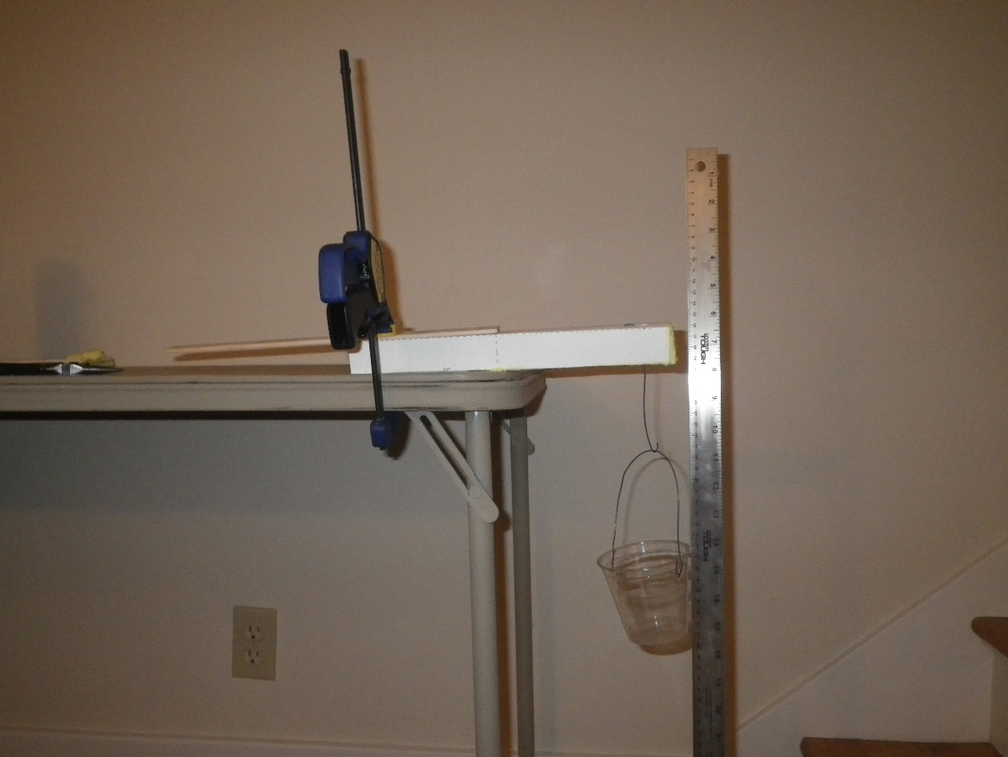
Table Top
Beam
String to Bottle or Cup
Paper Clip
L_{u}, try to make this 15 cm
CLAMP PROTECTOR
CLAMP
CLAMP
WASHER
Paper Clip
3 cm

Figure 1: Experimental setup. You can try looping the wire connecting to the bottle or cup over the beam, or you can make a wire hook that pierces the beam. If you use the wire, be careful not to stab your hand when you are pushing the wire through the foam. After pushing the straight end of the wire through the beam, use pliers to bend it back toward the beam to make a small second “hook”, and poke that hook back into the center of the beam to help the wire stay in place.

- Estimate the Modulus (“E”) of your beam: (F/Y is the inverse slope from step 8.)

$E=\frac{\left[(4×L_{u}×L_{u}×L_{u}×\left(\frac{F}{Y}\right)\right]}{BxHxHxH}$ = (4 x ____x ____x____) x ( )_ = g/cm²
x x x

- Determine your Structural Efficiency score:
Beam | Force to deflect beam  1 cm (grams) | Mass of Beam  (grams) | Structural Efficiency:  Deflection load/Mass of beam (g/g)
1

2

- Repeat Steps 2-11 for Beam 2.

- Which beam was stiffest? ______ Beam 1 ____ Beam 2

- How did you decide which beam was the stiffest? (Most force to get equal deflection, highest modulus, highest slope of the force-deflection plot, other….)

- Which beam had the highest structural efficiency? ______ Beam 1 ____ Beam 2

- Did the beam with the highest structural efficiency have the highest stiffness?

__ Y ___N

- Using the modulus of elasticity you measured, along with your beam A dimensions, predict the mass required to deflect your beam A 1 cm, and plot your prediction on the graph in Figure 2.

Beam deflection formula for a solid rectangle: $Y=(Fx{L_{u}}^{3})/(4xExBxH^{3})$

Solving for F: $F=\frac{4xYxExBxHxHxH}{L_{u}xL_{u}xL_{u}}=$

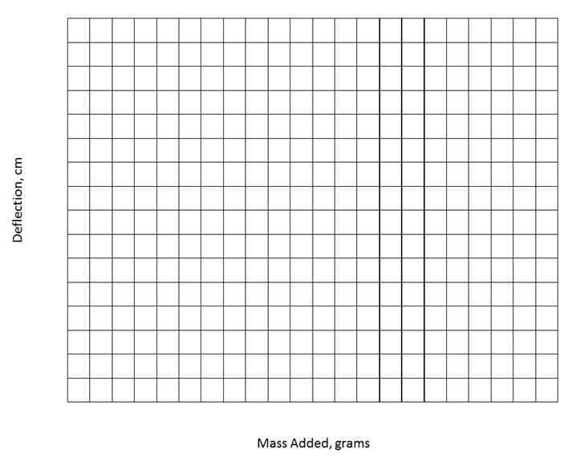
DEFLECTION (cm)
FORCE (grams)

Figure 2: Load-Deflection data for my beams, and predicted load to deflect Beam A 1 cm.
(Take the slope for the straightest part of your data where the deflection and force are low. Slope is rise divided by run. You will need to use the inverse of the slope, or run divided by rise, for design calculations.)

SLOPE: $\frac{RISE}{RUN}= cm/g$

INVERSE SLOPE = $\frac{1}{SLOPE}$ = g/cm

Inverse slope is also how much force is needed to deflect the beam 1 cm

Teachers Notes:
The goal of this lab is to begin to introduce the material variable in the stiffness of a beam, while keeping the shape variables the same. The material variable appears in the beam stiffness equations as “Young’s Modulus”.
Y = FL³/4EBH³
Y= deflection of the center or end of the beam
F = applied force
L = beam length
E = Young’s modulus (stiffness) of the beam material
B = width of beam
H = height of beam

As long as students use consistent shapes, the material variables should be observable.
We found that insulation board from the hardware store works well for this lab, in particular a pink or blue colored extruded polystyrene which was denser and stiffer than an expanded polystyrene bead board. Do not purchase a board with a paper or foil skin on it. Try to purchase two kinds of insulation board that are the same thickness. Thicknesses in the range of 0.75-1” were successfully tested.
The easiest way to cut the boards into beams is to use a band saw. It is also possible to cut them with a utility knife, hacksaw, or wire saw. A “hot wire” using a wire heated by electrical resistance also works, but generates an odor.
We discovered a hidden variable when we were developing this lab: the orientation of the beam samples compared to the extrusion direction from making the more rigid foam board. There is a strength difference between samples taken parallel to the long axis of the board (the extrusion direction) compared to perpendicular to the long axis. If you purchase a 4x8’ board, keep the long dimension of the beam consistently oriented, either parallel to or perpendicular to the original rectangle.
To add a crash test option to this lab, we recommend a drop weight impact test. Set the beam to span an opening between two supports (such as text books of equal thickness or bricks). Center a weight over the middle of the beam and drop it onto the beam from a fixed height. The energy of the impact test results from the potential energy of the weight being converted to kinetic energy:
P.E. = m x g x h
Where P.E. is the potential energy, m is the mass of the weight being dropped on the beam (kg), g is the gravitational constant (9.8 m/s² on Earth’s surface), and h is the height from which the weight is dropped (m).
You may want to have the students look up values of the Young’s (or “Flexural”) Modulus and density for various beam materials and compare these data to their measured values. The expanded polystyrene can be found in a range of densities, and the modulus depends on the process by which the polystyrene is shaped into the boards. Here are a few examples:
Type of Foam | Density (lb/ft³) | Modulus (psi) | Source
Expanded polystyrene | 0.70 | 130 | http://www.universalconstructionfoam.com  Expanded Polystyrene Data Sheet
Expanded polystyrene | 1.80 | 480 | “
Extruded polystyrene | 1.80 | 1600 | http://msdssearch.dow.com  for Styrofoam Panel Core 30

Solid beams can also be made from Crisp Rice cereal bars. To create a difference in stiffness, replace the marshmallow-butter binder with a sugar syrup cooked to a soft crack or hard crack candy stage (~300F). Try a ratio of 2C white sugar, 1 cup water, and ½ cup light corn syrup. The sugar syrup may result in a brittle beam that doesn’t bend under load, but can still be “crash tested”.

Materials:
Card Stock
Scissors or paper cutter for card stock
Popsicle sticks etc. for smoothing beam materials into place
Scale
C clamp
Small piece of plastic or wood (e.g. paint stir stick) to spread the clamp load across the specimen.
Meter stick
Permanent Marker
Wire
Duct tape
Wide mouthed water bottle, cup, or bucket that can be filled with mass to load the beam
A weighting material – e.g. water, sand, nuts….
(Alternative: Prefill water bottles with different masses, cap them, and mark the mass on the bottle.)

Student’s choice of materials used in prior labs or readily available and approved by instructor prior to use: urethane foam, Portland cement, styrene beads, cardboard, bubble wrap, ….

Background:
In many mass sensitive designs, like airplanes and structures that protect you in an automobile crash, mass can be reduced by using a thin walled tube or honeycomb shell and filling it with a reinforcing material. In the prior lab, “U Channel Beams”, we observed the effects of geometry on beam stiffness by folding card stock into two shapes. In this lab we will try to improve the stiffness of one beam geometry by filling one of those shapes with the reinforcing material of your choice (subject to my pre-approval). We will determine which design and material concept produces the best stiffness for the least weight (has the highest structural efficiency).
Sketch and describe your design concept and strategy here:

Procedure:
- Use the Beam B geometry on the card stock template. Fold the card stock to create an open U shape that is 28 cm long. The bottom of the “U” should be 4 cm wide, and the legs of the U should be 2.5 cm tall. The line marking the center of the length dimension should be on the bottom side of the “U” so you can see it if you flip the U over and stand it on its legs. Use a ruler to help you fold the sides as straight as possible. Put duct tape over the ends and wrap the duct tape about 1 cm along the sides and bottom of the channel to hold your filler material in place.

- Fill the U channel with the material of your choice. Think ahead if you choose a material that takes time to cure (cement) or crosslink (urethane foam, glue). Try to pick something that will be easy to cut away or file if it expands and overfills the channel.

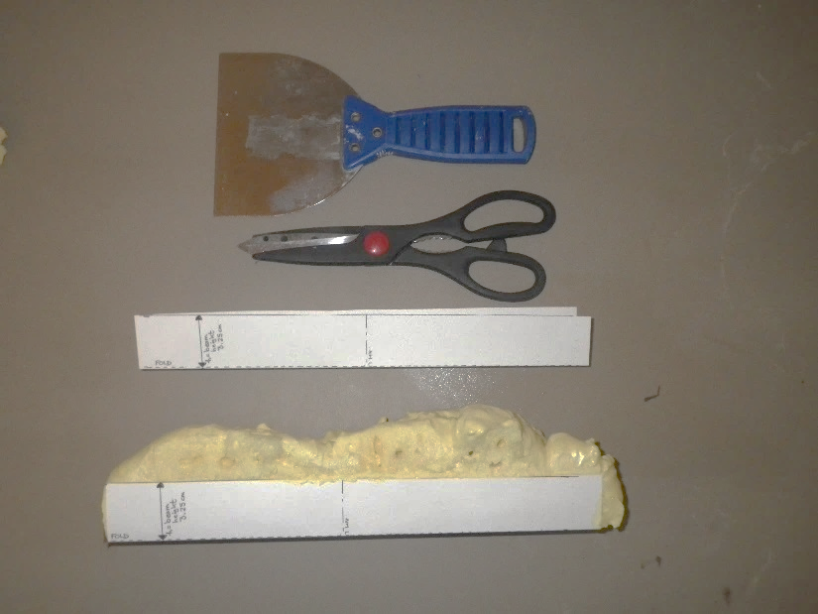
Figure 1: Example of empty U channel, and the U channel filled with “Great Stuff” window and door insulating foam. The foam could be cut with scissors, a coping saw, or a utility knife blade to get a fairly uniform beam for testing. The spatula was helpful in prying apart channels that had been filled with foam while next to each other in a box.

- When your beam is ready to test, record the mass and the beam dimensions in Table 1:
Table 1: Beam dimensions, mass, and failure load and deflection
Length  (L, cm) | Width  (B, cm) | Height  (H, cm) | Mass  (g) | Slope of Force vs. Deflection Curve (g/cm) | Modulus (g/cm²)

- Mark a point 3 cm from the end of each beam, and try to center it across the width of the beam. Open the paper clip to make a hook. Push the straight end of the paperclip through the beam at the mark 3 cm from the end. Sandwich the washer between the hook part of the paperclip and the top surface of the beam, then pull the paperclip down so the hook is pushed back into the beam. (The washer will spread the force over a bigger area so the paperclip doesn’t come out during the testing.) Bend the straight end of the paperclip to make a hook below the beam. The weights will be hung from this hook during the test.

- Clamp your beam to the table using a thin flat piece of plastic or wood such as a paint stir stick between your beam and the clamp to spread the clamp load over the clamped area. Put the beam in the clamp so the card stock faces up. Don’t crush you sample by clamping too hard. Figure 2 shows an example of a beam ready to test. It is important to keep the length of the beam hanging off the table the same so we can compare results. Please try to have the end of your beam 23 cm from the edge of the table.

- Mass the empty weighting system and wire to be used to attach it to the beam: Mo = ___________grams_

- Attach the weighting system near the end of your beam using the hook.
  - Measure the length between the edge of the table and where you attached the weight system to your beam. This will be your unsupported length to use in calculating the beam deflection. Try to get Lu ~ 20 cm so we can compare the results without having an extra variable.

Beam 1 Lu = ____ cm

- Hold the meter stick so you can see when the beam bends 1 cm as you apply the load.

- Working as a team, have one person slowly add mass to the weight system. Record the total mass and deflection after each addition using Table 2. Stop adding mass when your beam deflected more than 1 cm.

- Graph the load vs. deflection data for your beam on Figure 3.

Table Top
Beam
String to Bottle or Cup
Paper Clip
L_{u}, try to make this 20 cm
CLAMP PROTECTOR
CLAMP
CLAMP
WASHER
Paper Clip
3 cm

Figure 2: Experimental setup. You can try looping the wire connecting to the bottle or cup over the beam, or you can make a wire hook that pierces the beam. If you use the wire, be careful not to stab your hand when you are pushing the wire through the foam. After pushing the straight end of the wire through the beam, use pliers to bend it back toward the beam to make a small second “hook”, and poke that hook back into the center of the beam to help the wire stay in place.
Table 2: Force-Deflection data.
Beam 1  Mass Added (g) | Beam 1  Deflection (cm)
Weight of cup or bottle and string:

First addition to cup or bottle:

Second addition to cup or bottle:

Etc.

- Estimate the Modulus (“E”) of your beam:

$E=\frac{\left[(4×L_{u}×L_{u}×L_{u}×\left(\frac{F}{Y}\right)\right]}{BxHxHxH}$ = (4 x ____x ____x____) x ( )_ = g/cm²
x x x

- Determine your Structural Efficiency score:
Beam Identification | Load to deflect beam 1 cm (grams) | Mass of Beam  (grams) | Structural Efficiency:  1 cm Deflection load/Mass of beam (g/g)

- If your beam failed before it deflected 1 cm., observe how your beam failed. Did the card stock rip before your reinforcement broke? Did it break in one place or in many places?
- If you could change something about your design concept to improve your beam, what would you change and why?

- As a class, determine who had the best score for the mass efficiency of the beam based on the force it took to deflect the beam 1 cm divided by the mass of the beam. Discuss their design strategy. How did their strategy differ from the beams with that had the worst scores for mass/deflection at failure
DEFLECTION (cm)
FORCE (grams)

Figure 2: Load-Deflection data for my beam.

Teachers Notes:

The goal of this lab is to begin to introduce the material variable in the stiffness of a beam, while keeping the shape variables the same. The material variable appears in the beam stiffness equations as “Young’s Modulus”.

Y = FL³/4EBH³
Y= deflection of the center or end of the beam
F = applied force
L = beam length
E = Young’s modulus (stiffness) of the beam material
B = width of beam
H = height of beam
Figure 1: Equation describing the deflection of a solid rectangular beam under cantilever loading.

We based this lab on the wider open beam “B” in the “U Channel Beam” lab. You may want to have half the students make the beam A geometry if your groups can handle both geometric and multiple materials variables, or you may want to try a different mold idea such as those described below. As long as students use consistent shapes, the material variables should be observable.

This lab will take two class periods, one to make the beams and one to test them in cantilever bending.

Materials Options For Open Cardstock Beam Molds:

The open cardstock beams work well with spray-in foam insulation, such as the “Great Stuff” door and window sealer pictured above. Different foam insulations have different stiffnesses, and the stiffness and density of the foam can be increased by stirring it to collapse the bubbles after the channels are filled. The downside is that it can be hard to keep the beam shapes rectilinear, and the foam spray tubes plug after about 10 minutes. We also tried making this with the two part urethane foam resins (e.g. “Eurocast”, available from Tesco-Iasco).

If you decide to use very rigid materials such as cement or Eurocast resins, you will need to mold the paper clip for hanging the weight into the beam when you make it. Put a piece of tape across the beam mold opening to hold the paper clip hook system. Straighten one end of the paper clip, then put a 90* bend in it so there’s about a cm of paper clip that will sit flat against the bottom of the mold. This will make it harder for the paper clip to simply pull out of the beam when loaded. Jab the straightened end of the paper clip through the center of the tape, position the bent end against the base of the mold, and leave the hook above the tape.

Rice cereal treats can be made in a disposable foil pan and then cut to fairly uniform sizes. You can change the stiffness of the rice krispy treats by eliminating the butter and replacing the marshmallows with an 2C water, 1C white sugar and ½ C light corn syrup boiled to a hard crack candy stage (about 300F). This syrup can increase the rigidity of the rice krispy treats to the point where it can be hard to cut them into samples.

Wood glue mixed with sawdust could also be a filler candidate – the mass ratio of glue to sawdust could be a variable assigned to different lab groups.

Expanded polystyrene beads can used to create “light weight” Portland cement composites. To make the beads, simply toss unexpanded polystyrene beads into boiling water, then drain the water through a fine sieve to retrieve the beads. (You can also try breaking up packing material, but this is more difficult and will give you a coarser particle size distribution.) The easiest way to mix them with the cement is to put them in a clean peanut butter jar or wide mouthed bottle, add water with a few drops of dish soap to aid wetting, then add the cement and shake vigorously. As in the case of the sawdust and glue beams, the amount of polystyrene can be varied from lab group to lab group. You may need to put tape across the beam opening in several places to provide adequate support for the heavier cement samples.

Mold Options:

Silicone ice cube trays for making long cubes for water bottles can also be used to produce uniform shape beams from different materials. Use mold release spray on the silicone molds before using them with rapid set cement or Eurocast resins. The disadvantage of the silicone ice cube trays is that the beams will be fairly short (4”) and may be difficult to test with reasonable weights for stronger materials.

You may be able to buy plastic “J Channel” or corner protectors at the hardware store. Two of these can be taped together to create a longer beam mold. Spray the inside with mold release if you plan to use them for cast resins or wipe them with a thin coating of petroleum jelly if you want to try them with cement. The spray in foam had different densities when we filled a tall plastic mold vertically – the mass of the foam collapsed some of the bubbles on the bottom of the sample. Pry the samples out of the molds when they are cured. We soak the plastic molds in hot soapy water and scrub any cement off so they are reusable.

Paper towel rolls can also be used as molds. If you use them for cement you may want to rubber band or tape several tubes together, or stand them in an empty coffee can to provide support. Make sure you tape the bottom end of the tube shut with duct tape before pouring the cement in!

Testing Alternatives:

If your beams are very stiff, such as cement beams or Eurocast resin, you may have difficulty deflecting them with the cantilever beam set up. We have tested stiff beams in a 3 point bend tester constructed from 2x4” lumber. This wood frame allows us to apply higher loads, but it does not work well for polymer foams because they deflect too much and the unsupported length of the beam varies significantly as you take data.

You may want to have the students look up values of the Young’s Modulus for various beam materials instead of trying to measure them with the cantilever beam setup. In this case, you could skip the cantilever lab entirely and move straight to an impact test to determine which beam material provided the best structural efficiency in terms of deflecting the least under a fixed energy emulating the IIHS crash test. The foam beams will fail the crash test at lower energies than a resin or cement beam, but they will be much more mass efficient. The “winner” is the beam that passes the crash test requirement with the lowest mass.

Research Ideas:
Advanced students may find it interesting to investigate foam filled structures to improve crashworthiness. Dow Automotive markets a polyurethane foam, “Betafoam”, specifically for this purpose. B Pillars have been reinforced with foam to improve the roof crush performance with minimal impact on mass. This short article by the American Chemistry Council has some highlights of the B Pillars with foam reinforcements: https://plastics-car.com/plasticfoams. Compared with using more sheet metal, adding foam to meet the greater roof crush strength requirements saved 45% of the mass, and the potential to use a smaller steel structure to achieve the same strength with foam fill is also mentioned. A more detailed case study on the advantages of foam filled B pillars, originally published by ASM in 1998, is attached.

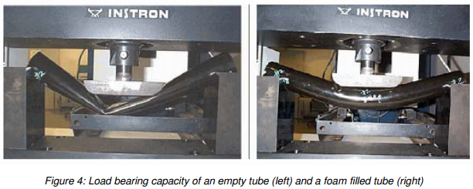
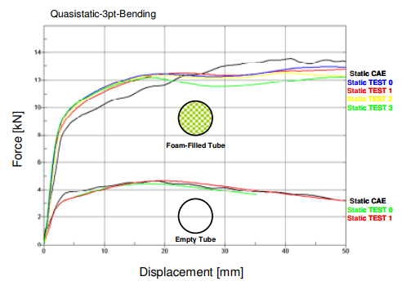
Figure 1: Adding polyurethane foam to a steel tube increased the energy absorbed by 300%. Top left: empty steel tube in 3 point bending. Top right: Foam filled tube in 3 point bending. Bottom: Force-displacement curves for the empty and filled steel tubes tested in 3 point bending. (https://www.dynamore.de/en/downloads/papers/07-forum/forum07/crash/crash-performance-increase-with-structural)

JMEPEG (1998) 7:511-514 ©ASM International

Roof-Crush Strength Improvement Using Rigid Polyurethane Foam
K. Lilley and A. Mani
(Submitted 28 August 1997; in revised form 5 May 1998)
Recent bending tests show the effectiveness of rigid, polyurethane foam in improving the strength of automotive body structures. By using foam, it is possible to reduce pillar sections, and to reduce thicknesses or eliminate reinforcements inside the pillars, and thereby offset the mass increase due to the foam filling. Further tests showed that utilizing the foam filling in a B-pillar to reduce section size can save ~20 mm that could be utilized to add energy absorbing structures in order to meet the new interior head impact requirements specified by the federal motor vehicle safety standards (FMVSS) 201 Head Impact Protection upgrade.

Keywords automotive, optimize, rigid foam, safety, structure

Introduction

Polyurethane foam is the end product in the exothermic chemical reaction of two components, a formulated resin and an isocyanate. The two components react quickly to form a rigid, closed-cell foam. The foam expands in situ to seal cavities (Fig. 1). Low-density foam is currently being used for noise, vibration, and harshness improvement in many automobiles. The improvement is typically achieved by injecting the foam into the hollow cavities of the body sections such as the pillars, cowl, and rocker panels. With the foam-in-place process, the foam seals the cavities, thereby blocking the transmission and amplification of the wind, engine, and road noise. Other foam-sealing capabilities include sealing water and dust leaks, and reducing air leakage to optimize the heating, ventilation, and air-conditioning operation.
Higher-strength foam can provide additional benefits. In ad- dition to blocking the noise, air, and water paths, the higher- strength rigid foam (generally referred to as structural foam) can provide stiffness to hollow body sections and joints. The in- creased joint stiffness improves vehicle dynamics and gives the vehicle a solid, integrated feel. The Auto/Steel Partnership, through the Ford High Strength Steel (HSS) Industry Resource Group (IRG), studied the ability of polyurethane structural foam to improve joint stiffness.
For baseline and correlation data, a production B-pillar to rocker section was tested quasi-statically. Three cases were tested: baseline (no foam), foam filled with 5 pounds per cubic foot (pcf) density, and foam filled with 30 pcf density. The 5 pcf foam improved the fore/aft stiffness by 25%, the inboard/out- board stiffness by 75%, and the torsional stiffness by 250%. The 30 pcf foam improved the fore/aft stiffness by 100%, the inboard/outboard stiffness by 200%, and the torsional stiffness by 500%. Using finite element modeling, the study optimized the section for joint stiffness, weight, and cost, by varying the metal type and gauge, and the location, quantity, and density of the foam.

In production, a vehicle uses a 25 pcf density foam applied to the B-pillar to rocker area. Four-corner post shaker testing of the vehicle revealed that the metal in this area was fatiguing and cracking after 10% of 1 lifetime cycle. The addition of the foam allowed the vehicle to achieve 110% of 1 lifetime cycle without metal failure because of the increased joint stiffness and load distribution.

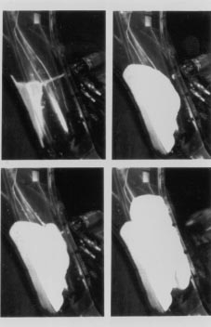
K. Lilley, Foamseal Urethane Technology—ITW; and A. Mani, EASi
Engineering, Bingham Farms, Michigan, USA. Fig. 1 In situ application and expansion of foam

Rigid Polyurethane Foam Application Process

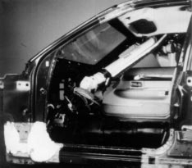
The application of polyurethane foam in automotive vehi- cles is proven technology. The foam-in-place process has been in production since 1982 and over 2 million North American cars and trucks per year use low-density and high-density foam for various purposes. Both low-density and high-density foam can be applied to the vehicle in the same application area at the assembly plant. During vehicle assembly, the foam-in-place process is performed between the paint and trim operations. The injected foam has excellent adhesion properties when applied to electrocoated or painted surfaces. Foam assumes the shape of the cavity and remains intact over the life of the vehicle. No corrosive effects or foam degradation are evident in durability testing or in production vehicles.
The foam process is safe and environmentally sound. It is typically applied by operators wearing safety glasses and gloves in a downdraft-ventilation booth. The foam chemicals do not contain ozone-depleting chemicals or heavy metals. The foam is also environmentally safe for landfill disposal and it has no adverse affect on vehicle steel recycling.
The foam chemicals are available in drums, returnable liq- uid bins, or tank trucks. Specialized equipment is necessary to heat, meter, and dispense the 1:1 volume ratio foam compo- nents. An ergonomic hand-held gun is used to mix and dispense the foam into the cavities. The injection gun is self-cleaning, re- quires no solvent flush, and is long-lasting. Typically, more than 250,000 shots are dispensed before gun service is required.
Presently all applications are done manually on an assembly line. Robotic application of foam is in development (Fig. 2). The end-of-arm tooling holds the material supply hoses and the injection gun (Fig. 3). This gun is the same as the ergonomic hand-held gun except the handle is removed for attachment to the robot arm.

Rigid Polyurethane Foam for Roof-Crush Strength
The industry is becoming aware of the potential of structural foam fillers as viable alternatives to conventional methods to improve the strength of the body structure. Structural compos- ites based on epoxies, ceramics, and glass micro-bubbles are very effective, but they are not economical nor easily process- ed.

Fig. 2 Current applications are performed manually using a light-weight gun with Foamseal’s patented mix chamber. Robotic application is being developed and tested.
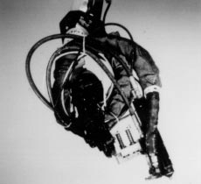
Fig. 3 Robotic end-of-arm tooling with dispense gun
Rigid, polyurethane foam, however, can be cost-competi- tive in comparison to conventional alternatives, such as steel reinforcements. In an extensive study to reduce roof crush in controlled rollover crash tests, structural foam filling was util- ized. Structural foam was added to the A-pillars and B-pillars in a recent production vehicle, to preserve the strength of the roof, add rigidity, and absorb noise and vibration, without adding significant weight. The density of the foam material is a critical parameter for strength applications, as higher density implies higher strength. However, because the mass penalty can be high as well, it is important to: a) select a suitable density range; and b) apply foam in the critical areas of deformation only. Four-point bending tests of foam-filled tubes and nonlinear finite element simulations were first performed to select a suit- able density range of foam filling.

Bending Tests of Foam-Filled Tubes

Under roof-crush loading, the predominant mode of defor- mation is the bending of the pillars. Therefore, four-point bend- ing tests were performed to evaluate the improvement in bending strength. An unfilled steel tube was first tested to es- tablish its load capacity. The rectangular section steel tubes were filled with 3 pcf, 6 pcf, and 18 pcf density of polyurethane foam and the tests repeated (Fig. 4 to 6).
The deformed shapes of the end section of the unfilled tube and a filled tube (3 pcf) show that there is severe section

collapse in the unfilled tube (Fig. 7). The deformed shapes of all the filled tubes show indentations at the point of load appli- cation. These indentations are caused by the foam compression locally and they should not be mistaken for section collapse. The end sections far away from the loading points show severe collapse in the unfilled tube due to panel buckling, whereas the end sections are preserved in the filled tubes.
Although the foam is brittle and fractures beyond a certain tensile load, it is still functional, as it is entrapped within the closed section of the steel tube. This “entrapment” is a key to the maintenance or increase of the load-carrying capacity of the filled tube. The unfilled tubes show a significant reduction in the load capacity after the peak load is reached. In an open section structure, foam filling is not likely to be as effective be- yond certain loading because the fractured foam would not be entrapped and would dislodge. It is also seen that the peak load of the unfilled tube is much lower than the filled tubes with various densities. The results of the tests also show that the in- dentations in the filled tubes do not result in a load reduction.

Numerical Simulation of the Bending Tests

Numerical simulations of the bending tests were also carried out, primarily to provide appropriate characterization of the material properties of the rigid foam material. The bending test was simulated using the transient, nonlinear code LS- DYNA3D (LS-DYNA3D Users Manual; Livermore Software Technology Corporation). Solid elements were used to model the foam, and a polyurethane foam (Material Number 57) ma- terial model was utilized. The compressive strength charac- teristics parallel to the direction of rise was utilized as the foam, after injection into the tube, is likely to rise along the axis of the tube, which is also the bending axis. The tensile modulus was assumed to be the same as that of the compressive modulus. An elongation limit of 5% was also assumed. The mode of defor- mation and load capacities computed in the simulations com- pared well with those obtained from the tests. A plot of the bending strength of these tubes against the density of foam shows that even a low-density foam (3 pcf) provides significant improvement, with nearly twice the bending strength of the un- filled tube. The bending stiffness of these filled tubes was plot- ted as a function of the density by calculating the slopes of the force-deflection curves in the bending tests at about 1 mm de- flection. Again, the increase in stiffness is nearly linear with in- creasing density.
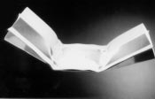
Fig. 4 Bending test, deformed shape of tube filled with 3 pcf density of polyurethane foam

Evaluation of Roof-Crush Strength with Foam Filling
Full-scale roof-crush tests are expensive and time-consum- ing, so numerical simulations of the roof crush were carried out, to evaluate the effectiveness of foam, and to identify the critical areas of foam application. A finite element model of a pick-up truck cab was used to simulate the roof-crush test per federal motor vehicle safety standard (FMVSS) 216. The bending tests demonstrated that polyurethane foam can improve the density. Several simulations were carried out to evaluate foams of various densities, and to identify critical areas of foam application for roof-crush loading.
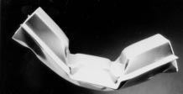
Fig. 5 Bending test, deformed shape of tube filled with 6 pcf density of polyurethane foam
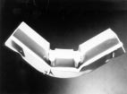
Fig. 6 Bending test, deformed shape of tube filled with 18 pcf density of polyurethane foam
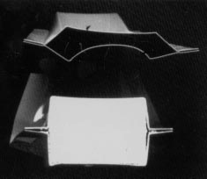
Fig. 7 Deformation of the end sections of the tubes from bending tests.

The undeformed and deformed shapes of the unfilled structure show substantial bending about the belt-line level. Filling the B-pillar ring, the B-pillars, and the rear roof header with foam raised the strength of the roof by 72%. Having established the potential of foam filling to raise the roof-crush strength, additional studies were performed using lower densities of foam in selected regions.
The next two configurations used a much lower density of foam: the A-pillar filled with 5 pcf foam, and only the upper B- pillar filled with 5 pcf foam. Since most of the deformation of the B-pillar structure happened above the belt line, it was felt that filling the upper B-pillar would be effective in improving strength. Filling the A-pillar provided a strength improvement of only 2%. This is attributed to the fact that the B-pillar, with its considerably larger section, carries most of the load. In comparison, filling only the upper portion of the B-pillars resulted in a substantial (14%) strength improvement.
Next, a simulation was carried out with a smaller B-pillar section filled with foam, with the objective of obtaining the same strength as the original unfilled B-pillar. The aim was to offset the strength reduction of the reduced section by foam filling. This section was 20 mm narrower than the original section. First, a 5 pcf filling was used in the reduced section. The resulting strength was lower (by 5%) than that of the original unfilled B-pillar. Therefore, a higher-density foam (9 pcf) was used for the filling. This configuration resulted in nearly the same strength as the original unfilled B-pillar. Thus, it is seen that foam filling can help reduce the section sizes in the B-pillars without appreciable loss of strength or increase in mass.

Head Impact Considerations in Designing Foam-Filled Pillars
A new design concept for the B-pillar section shows that the space saved by using the foam can be used to add energy-absorbing (EA) trim or foam to help meet the proposed FMVSS 201 Head Injury Criterion (HIC) requirements for head impacts against the interior upper vehicle structure. Such space-saving is significant because thick padding of the interior upper roof structure could result in reduced interior room and reduce the driver’s field of view as well. In a study that evaluated various families of foams for head impact protection, it was shown that adding a 12.5 mm to 25.0 mm thick EA foam layer reduces the HIC values by nearly 20% in many locations.

8. Conclusions
Based on this study, the following conclusions can be drawn:
- Foam filling with rigid, polyurethane foam can improve the strength of the thin-walled, hollow structures such as the B-pillars. Numerical simulations of the bending tests also replicate this improvement.
- The higher the density of polyurethane foam, the higher the strength and stiffness provided to such structures. The foam density and the areas of application can be optimized for a given application based on weight, cost, strength, and stiffness improvement requirements.
- Filling the A-pillar with 5 pcf polyurethane foam did not result in an appreciable improvement of the roof crush strength for the light truck studied.
- The upper portion of the B-pillars has been identified as a critical region for foam filling for roof crush. Also, 5 pcf density rigid polyurethane foam provides a roof crush strength improvement of 14% with a mass penalty of 1.24 kg per vehicle.
- A polyurethane foam-filled B-pillar design concept has evolved. Although the section is 20 mm narrower, it provides the same roof-crush strength due to the added strength provided by the foam filling.
- The 20 mm space gained could be utilized to add EA structures, such as extended ribs under the trim, foam padding, or additional steel structures, to meet the recently issued head impact requirements (FMVSS 201 upgrade). This concept of foam-filled and padded hollow members could be extended to other members, such as headers and roof rails.

Selected References
  - K. Fischer, Focus on Safety Engineering: Occupant Restraint Analysis Time Reduced by New Graphical Processor, Inside Automotives Int., April/May 1997, p 32-34
  - L. Kempfer, Ed., Crimping Tool to Market Faster, Computer- Aided Engineering, January 1996, p 10
  - S. Roush, EASi-Crash Offers New Crash-Test Technology, Tech Center News, Dec 11, 1995, Vol 3 (No. 48)
  - V. Shankar, Software Helps Designers Seal Up Part Quality,
Automotive & Transportation Interiors, Nov 1996, p 49

SECTION 8

LAB 3
Stressed Skin Composites
(Combined effects of material choice and placement of the reinforcing tape)

Version A: Solid Foam Insulation Board Beams + Tape

(See “teachers notes” at the end of the lab for alternative materials suggestions such as uncooked lasagna noodles or wooden dowel rods instead of the insulation foam beams.)

Materials:
Styrofoam or insulating foam from hardware store
Packing tape, duct tape, or other tape
Band saw, hack saw, serrated or utility knife to cut the foam (or hot wire cutter)
Scissors to cut the tape
Meter stick
Permanent Marker
C clamp or bar clamp
Small piece of plastic or wood (e.g. paint stir stick) to spread the clamp load across the specimen.
Wire
Wide mouthed water bottle, cup, or bucket that can be filled with mass to load the beam
A weighting material – e.g. water, sand, nuts….
(Alternative: Prefill water bottles with different masses, cap them, and mark the mass on the bottle.)

Background:
The stiffness of a beam is related to its geometry and what the beam is made from. We are going to determine if there are ways to significantly improve the stiffness of the beam without adding much mass by making a “stressed skin composite”. A low mass foam material will be used for the main part of the beam, and tape will be added to reinforce it. A simple example of a stressed skin composite is a banana – the skin adds a lot of resistance to deformation to the fruit. The key to creating the stiffest beam per gram of beam mass is in where you put the tape, and what kind of tape you use.

Our test is related to the “B Pillar”, which is the metal beam between the driver and passenger doors on a car (Figure 1). This beam needs to deflect as little as possible if you are hit from the side. In real life the “B Pillars” are made of layers of different materials sandwiched together so that the areas that are most critical to protecting the passenger in a crash have the stiffest geometry and material. Away from the critical areas you might notice that there is less material. Figure 2 shows an example of how using a different shape and a stronger steel made a B Pillar that did a better job protecting the passengers and weighed less:
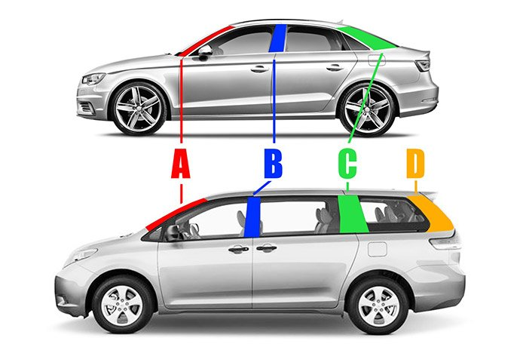
Figure 1: The A, B, and C Pillars on a car. (www.edmunds.com)
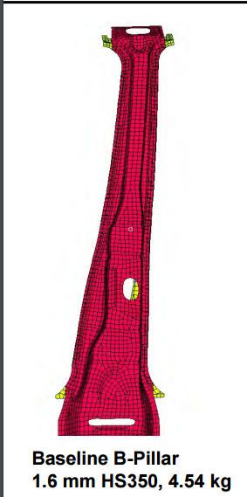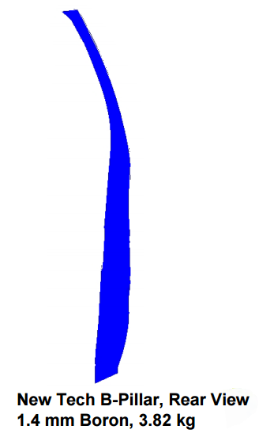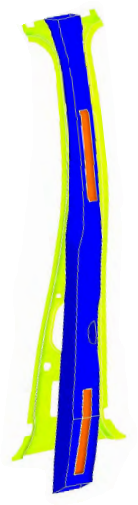
Figure 2: Optimizing the geometry and using a stronger steel produced a B Pillar design that was thinner, 16% lighter, and stiffer than the original design (red) when the new design (blue) was glued to the inner part of the support (yellow). The glued areas are shown in orange. (reference: T. Vikstrom, P. McKune, K. Palanisamy, R. Kozak, “Highly Engineered Structural Solutions for the 21st Century Auto Body”, presented at Great Designs in Steel, and posted at www.steel.org)

Procedure:
- Using the example beam as a template, cut the foam into three pieces that are 25 cm long. Try to cut as straight a line as possible, and try not to crush the foam as you cut it. All 3 pieces should be 4 cm wide. The height of the beams will depend on how thick your foam is. Label the pieces A, B, and C. Mark the center of the beam at 3 cm from one end of the beam. Beam A will be the control sample.

- Select the kind of tape you want to test. You may use no more than 3 meters of tape total for the entire experiment. Remember that every cm of tape you use adds weight to your beam.

- Put one layer of tape over the wide surface of Beam B, as shown in Figure 3.
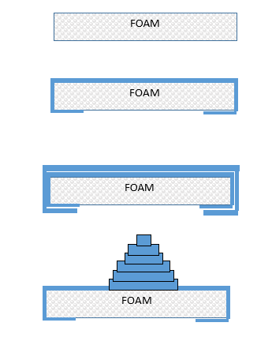
Figure 3: Apply the tape (dark blue) to the wide top surface of Beam B. It does not need to extend down the sides or around the ends.
,
- Beam C will get the same first layer of tape as Beam B. After that you can decide where you want to apply more tape to give you the most benefit in stiffness, and how much more tape you want to use. Do not use more than 3 meters of tape total on Beams B and C combined. You may also want to carve off some of the foam to reduce the mass. Sketch your design and describe your reinforcement and mass reduction strategy here:

Mass Beams A, B, and C and record the mass in Table 1.

Table 1: Beam mass, failure load and deflection
Beam Name | Mass  (g) | Mass for 1 cm deflection (g) | Failure Load  (g) | Failure Deflection (Y, cm) | Slope of Straight Part of Load-Deflection Plot (g/cm)
A (control, no tape)

B (1 layer of tape)

C (my design)

- Open the paper clip to make a hook. Push the straight end of the paperclip through the beam at the mark 3 cm from the end. Sandwich the washer between the hook part of the paperclip and the top surface of the beam, then pull the paperclip down so the hook is pushed back into the beam. (The washer will spread the force over a bigger area so the paperclip doesn’t come out during the testing.) Bend the straight end of the paperclip to make a hook below the beam. The weights will be hung from this hook during the test.

- Clamp your beam to the table using a thin flat piece of plastic or wood such as a paint stir stick between your beam and the clamp to spread the clamp load over the clamped area. Put the beam in the clamp so the tape faces up. Don’t crush you sample by clamping too hard. Figure 4 shows an example of a beam ready to test.

- Mass the empty weighting system and wire to be used to attach it to the beam: Mo = ___________grams_

- Attach the weighting system near the end of your beam.
  - Measure the length between the edge of the table and where you attached the weight system to your beam. This will be your unsupported length to use in calculating the beam deflection. Try to get Lu ~ 15 cm so we can compare the results without having an extra variable.

Beam A Lu = ____ cm Beam B Lu = ____ cm Beam C Lu - _____ cm

- Hold the meter stick so you can see when the beam bends 1 cm as you apply the load.

- Working as a team, have one person slowly add mass to the weight system. Record the total mass and deflection after each addition using Table 2.

- Stop adding mass when your beam deflected more than 1 cm and record the mass in Table 1.

- Resume adding mass and record the mass at which your beam breaks.

- Repeat steps 7-13 for Beams B and C.

- Graph the load vs. deflection data for both beams on Figure 2.

- Calculate the slope of the straight part of the force-deflection curve (rise over run) and then take the inverse of that slope. We are going to use this inverse slope to estimate the “Modulus” (E) of the beam:

Inverse Slope for my beam = F/Y = ___________ (grams)/___________cm = ___________g/cm

- Estimate the Modulus (“E”) of your beam:

$E=\frac{\left[(4×L_{u}×L_{u}×L_{u}×\left(\frac{F}{Y}\right)\right]}{BxHxHxH}$ = (4 x ____x ____x____) x ( )_ = g/cm²
x x x

- Determine your Structural Efficiency scores:
Beam | Load to deflect beam 1 cm (grams) | Mass of Beam  (grams) | Structural Efficiency:  1 cm Deflection load/Mass of beam (g/g)
A

B

C

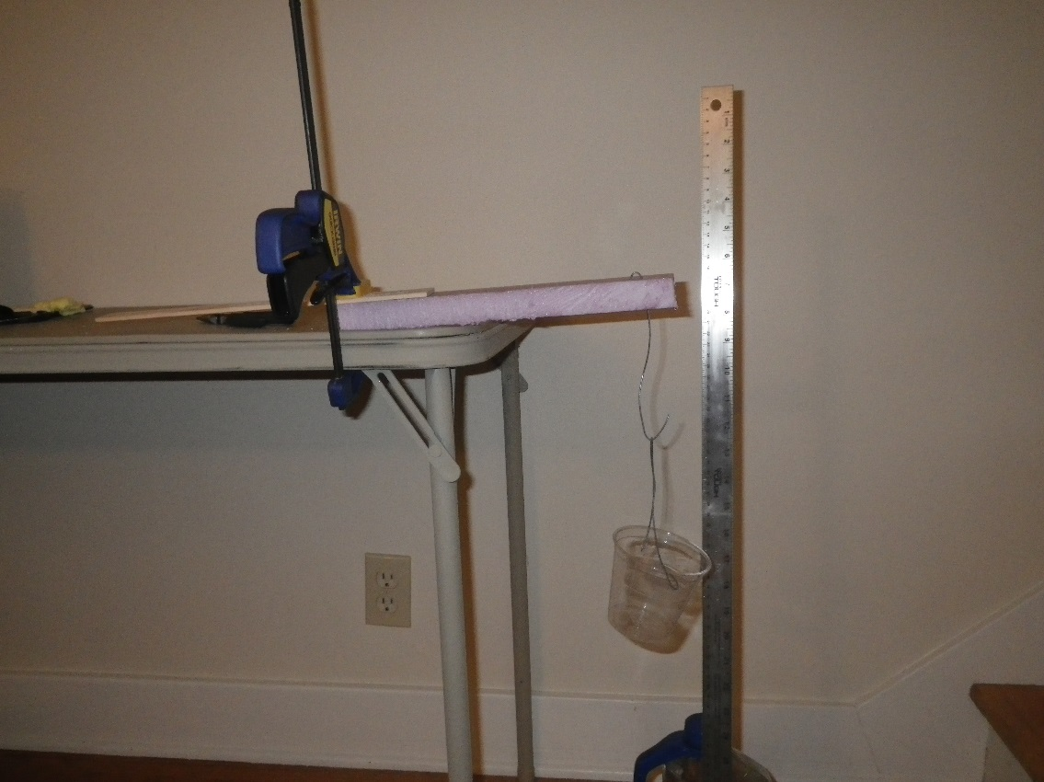
Table Top
Beam
String to Bottle or Cup
Paper Clip
L_{u}, try to make this 15 cm
CLAMP PROTECTOR
CLAMP
CLAMP
WASHER
Paper Clip
3 cm

Figure 4: Experimental setup schematic and example. You can try looping the wire connecting to the bottle or cup over the beam, or you can make a wire hook that pierces the beam. If you use the wire, be careful not to stab your hand when you are pushing the wire through the foam. After pushing the straight end of the wire through the beam, use pliers to bend it back toward the beam to make a small second “hook”, and poke that hook back into the center of the beam to help the wire stay in place.

Table 2: Load-Deflection Data Sheet
Load Event | BEAM A  Deflection (cm) | BEAM A  Load  (g) | BEAM B  Deflection (cm) | BEAM B  Load  (g) | BEAM C  Deflection (cm) | BEAM C  Load  (g)
0
1
2
3
4
5
6
7
8
9
10
11
12
13
14
15
16
17
18
19
20
21
22
23
24
25
26
27
28
29
30

DEFLECTION (cm)
FORCE (g)

Figure 5: Load-Deflection data for my beams, and predicted loads for a deflection of 1 cm.
(Take the slope for the straightest part of your data where the deflection and force are low. Slope is rise divided by run. You will need to use the inverse of the slope, or run divided by rise, for design calculations.)

SLOPE: $\frac{RISE}{RUN}= cm/g$

INVERSE SLOPE = $\frac{1}{SLOPE}$ = g/cm

Inverse slope is also how much force is needed to deflect the beam 1 cm
- Using the modulus of elasticity you measured, along with your beam A dimensions, predict the mass required to deflect your beam A 1 cm, and plot your prediction on the graph in Figure 2.

Beam deflection formula for a solid rectangle: $Y=(Fx{L_{u}}^{3})/(4xExBxH^{3})$

Solving for F: $F=\frac{4xYxExBxHxHxH}{L_{u}xL_{u}xL_{u}}=$

- If you could change something about your design concept to improve your beam, what would you change and why?

- As a class, determine who had the best score for the structural efficiency of the beam based on the force it took to deflect the beam 1 cm divided by the mass of the beam. Discuss their design strategy. How did their strategy differ from the beams with that had the worst scores for mass/deflection at failure?

- Optional: Engineers also have to factor the cost of their design ideas into their decisions. Calculate the cost of the tape used for the top 3 most structurally efficient designs and determine which design is the best in terms of both mass and cost. This can be done by dividing the structural efficiency of the design by the cost of the tape added to the foam.

Teachers Notes:

      - If you purchase the insulating foam in a 1” thickness, the 4 cm wide beams will almost exactly match the Beam “B” geometry from the folded card stock “U Channel” lab 1. This lab uses 25 cm long beams vs. the 27 cm long beams made from 8.5x11” card stock.

      - “Topological design” and “biomimicry” describe lightweight design methods that follow Nature’s example of only putting mass where it is required to meet functional requirements. In addition to the hollow bird bones with internal reinforcements, diatoms provide another great example of Nature optimizing designs. These tiny single cell animals need to be light enough to float in seawater, but they are protected by silica cell walls. The silica is only deposited where it is necessary. There are over 100,000 kinds of diatoms, each with unique geometry of the silica. Engineers are studying these forms and applying Nature’s lessons in two main ways. First, computer programs have been created to design shapes by starting with an empty volume, then adding mass only where it is needed to support the required forces. Second, additive manufacturing methods such as 3D printing, are making it possible to bring these design concepts to life.

      - Depending on your budget, we found that some very strong tape, like high temperature muffler tape, produced surprisingly good increases in beam stiffness. It might be interesting to have one lab group use a significantly stronger tape that costs more to better illustrate the engineering tradeoffs between cost, mass, and performance.

      - If you don’t want to make foam beams, you can do a simple version of this lab with uncooked lasagna noodles, or by cutting wood dowel rods (which come in square and circle shapes of different thicknesses) into short sections. If you use the lasagna noodle approach, impact test the samples with the tape on the bottom side of the sample.

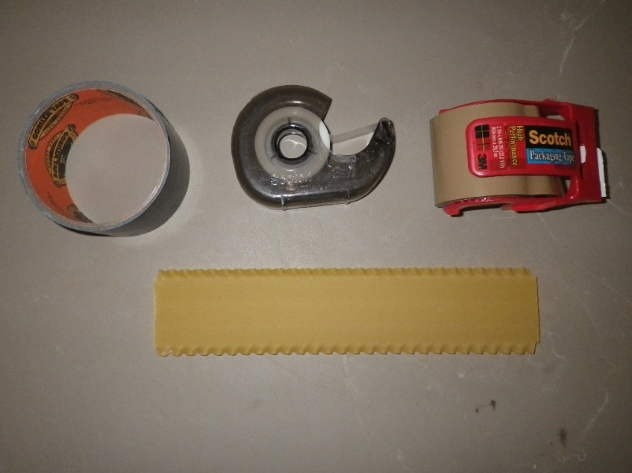

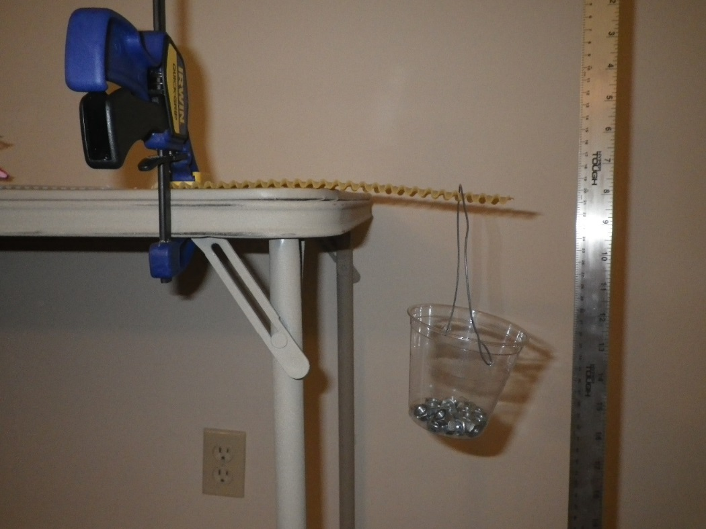
Figure 6: An uncooked lasagna noodle with 1 layer of duct tape can support a surprising amount of weight. Loop the handle of the cup over the noodle instead of trying to pierce the noodle with a paper clip.

SECTION 9

LAB 4
“Freestyle” – Students optimize beam geometry and material choices

Version A: Solid Foam Insulation Board Beams + Tape + Reinforcements

Materials: (actual materials may vary from this list)
Expanded or extruded polystyrene insulation foam boards from hardware store
Packing tape, duct tape, or other tape
Hot wire, hacksaw, serrated or utility knife to cut the foam
Scissors to cut the tape
Popsicle sticks or sticks from outdoors
Urethane foam resins to make high and low density foams
Portland cement
Meter stick
Permanent Marker
C clamp or bar clamp
Small piece of plastic or wood (e.g. paint stir stick) to spread the clamp load across the specimen.
Wire
Wide mouthed water bottle, cup, or bucket that can be filled with mass to load the beam. (Some beams may be so strong that you need a 1 gallon water or milk jug, or even a 5 gal. Bucket with a handle.)
A weighting material – e.g. water, sand, nuts….
(Alternative: Prefill water bottles with different masses, cap them, and mark the mass on the bottle.)
Scale to weigh the beams and the weighting material.

Background:
The stiffness of a beam is related to its geometry and what the beam is made from. We are going to determine if there are ways to significantly improve the stiffness of the beam without adding much mass using the insights about geometry and materials effects on beam behavior from our prior labs. Our test is related to the “B Pillar”, which is the metal beam between the driver and passenger doors on a car (Figure 1).
Figure 1: The A, B, and C Pillars on a car. (www.edmunds.com)
This beam needs to deflect as little as possible if you are hit from the side. In real life the “B Pillars” are made of layers of different materials sandwiched together so that the areas that are most critical to protecting the passenger in a crash have the stiffest geometry and material. Away from the critical areas you might notice that there is less material. Figure 2 shows an example of how using a different shape and a stronger steel made a B Pillar that did a better job protecting the passengers and weighed less:
Figure 2: Optimizing the geometry and using a stronger steel produced a B Pillar design that was thinner, 16% lighter, and stiffer than the original design (red) when the new design (blue) was glued to the inner part of the support (yellow). The glued areas are shown in orange. (reference: T. Vikstrom, P. McKune, K. Palanisamy, R. Kozak, “Highly Engineered Structural Solutions for the 21st Century Auto Body”, presented at Great Designs in Steel, and posted at www.steel.org)

Procedure:
- Sketch your design and describe your reinforcement and mass reduction strategy here:

- In consultation with your teacher, create a beam that is 25 cm long, 4 cm wide, and 2.5 cm tall.
- Mass your beam and record the mass in Table 1.

Table 1: Beam mass, failure load and deflection
Beam Name | Mass  (g) | Mass for 1 cm deflection (g) | Failure Load  (g or kg) | Failure Deflection (Y, cm) | Slope of Straight Part of Load-Deflection Plot (g/cm)

- Clamp your beam to the table using a thin flat piece of plastic or wood such as a paint stir stick between your beam and the clamp to spread the clamp load over the clamped area. Decide which side of your beam you want on the top for the test. Don’t crush you sample by clamping too hard. Figure 3 shows an example of a beam ready to test.

- Mass the empty weighting system and wire to be used to attach it to the beam: Mo = ___________grams

- Attach the weighting system near the end of your beam. Try to put it about 3 cm from the end of the beam away from the table.
  - You may need to use tape to hold the wire in place. When you remove the weight system, mass the tape you used: Mt = ___________grams.
  - Measure the length between the edge of the table and where you attached the weight system to your beam. This will be your unsupported length to use in calculating the beam deflection. Try to get Lu ~ 15 cm so we can compare the results without having an extra variable.

Beam Lu = ____ cm

- Hold the meter stick so you can see when the beam bends 1 cm as you apply the load.

- Working as a team, have one person slowly add mass to the weight system. Record the total mass and deflection after each addition using Table 2.

- Stop adding mass when your beam deflected more than 1 cm and record the mass in Table 1.

- Resume adding mass and record the mass at which your beam breaks.

- Graph the load vs. deflection data for your beam on Figure 4.

- Calculate the slope of the straight part of the force-deflection curve. We are going to use this value to estimate the “Modulus” (E) of the beam:

Slope for my beam = F/Y = ___________ (grams)/___________cm = ___________g/cm

- Estimate the Modulus (“E”) of your beam:

E = (4 x L x L x L) x F/Y = (4 x ____ x ____x____x___ ) x ( )_ = g/cm²

B x H x H x H ____x____x____x____

- Determine your mass efficiency scores:
Beam Identification | Load to deflect beam 1 cm (grams) | Mass of Beam  (grams) | Mass Efficiency:  Deflection load/Mass of beam (g/g)

- If you could change something about your design concept to improve your beam, what would you change and why?

- As a class, determine who had the best score for the mass efficiency of the beam based on the force it took to deflect the beam 1 cm divided by the mass of the beam. Discuss their design strategy. How did their strategy differ from the beams with that had the worst scores for mass/deflection at failure?

3 cm
Table Top
Beam
String to Bottle or Cup
Wire
TAPE
L_{u}, try to make this 15 cm
CLAMP PROTECTOR
CLAMP
CLAMP

Figure 3: Experimental setup schematic and example. You can try looping the wire connecting to the bottle or cup over the beam, or you can make a wire hook that pierces the beam. If you use the wire, be careful not to stab your hand when you are pushing the wire through the beam. After pushing the straight end of the wire through the beam, use pliers to bend it back toward the beam to make a small second “hook”, and poke that hook back into the center of the beam to help the wire stay in place.

Table 2: Load-Deflection Data Sheet
(If your beam is very stiff, you may need to change the measurement units to mm and kg.)
Load Event | BEAM A  Deflection (cm) | BEAM A  Load  (g)
0
1
2
3
4
5
6
7
8
9
10
11
12
13
14
15
16
17
18
19
20
21
22
23
24
25
26
27
28
29
30

DEFLECTION (cm)
FORCE (grams)

Figure 4: Load-Deflection data for my beam.

Teachers Notes:

      - The intention of this lab is to allow your students to experience the creative pleasure of engineering design, taking advantage of what they learned from more structured labs about the impacts of geometry, materials choices, and composites.
      - The materials list is based on materials used in a typical 1 semester materials science elective based on the ASM Materials Camp for Teachers ® syllabus. The list is a guideline and can be modified to suit what you have on hand.
      - Popsicle sticks duct taped to an insulating foam beam required a 1 gallon milk jug to hold enough mass to create significant deflection.
      - Mrs. Laura Moore’s Materials Science classes at Hartland High School in Hartland, MI tested this procedure in June 2017. They found that they needed to agree on the amounts of raw materials (reinforcements, tape) that could be used, and they started from a standard sized beam cut from insulation foam. Many of them carved the foam, then added reinforcements. Example beams included:

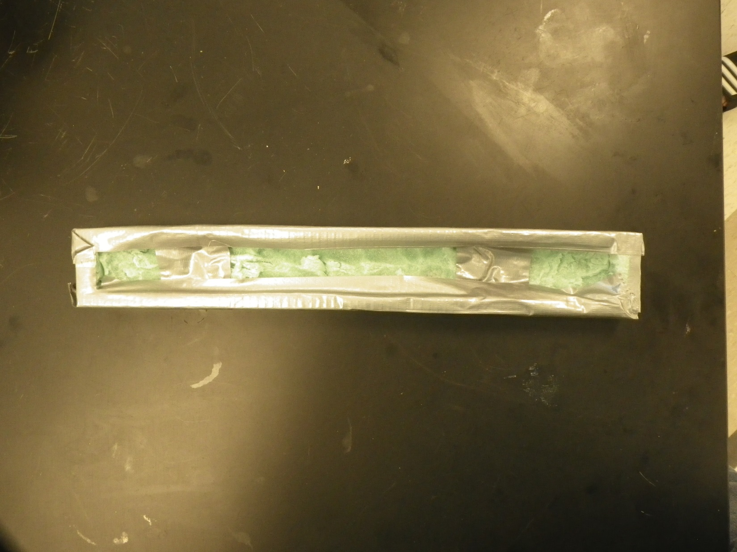
Hollowed out and wrapped with duct tape

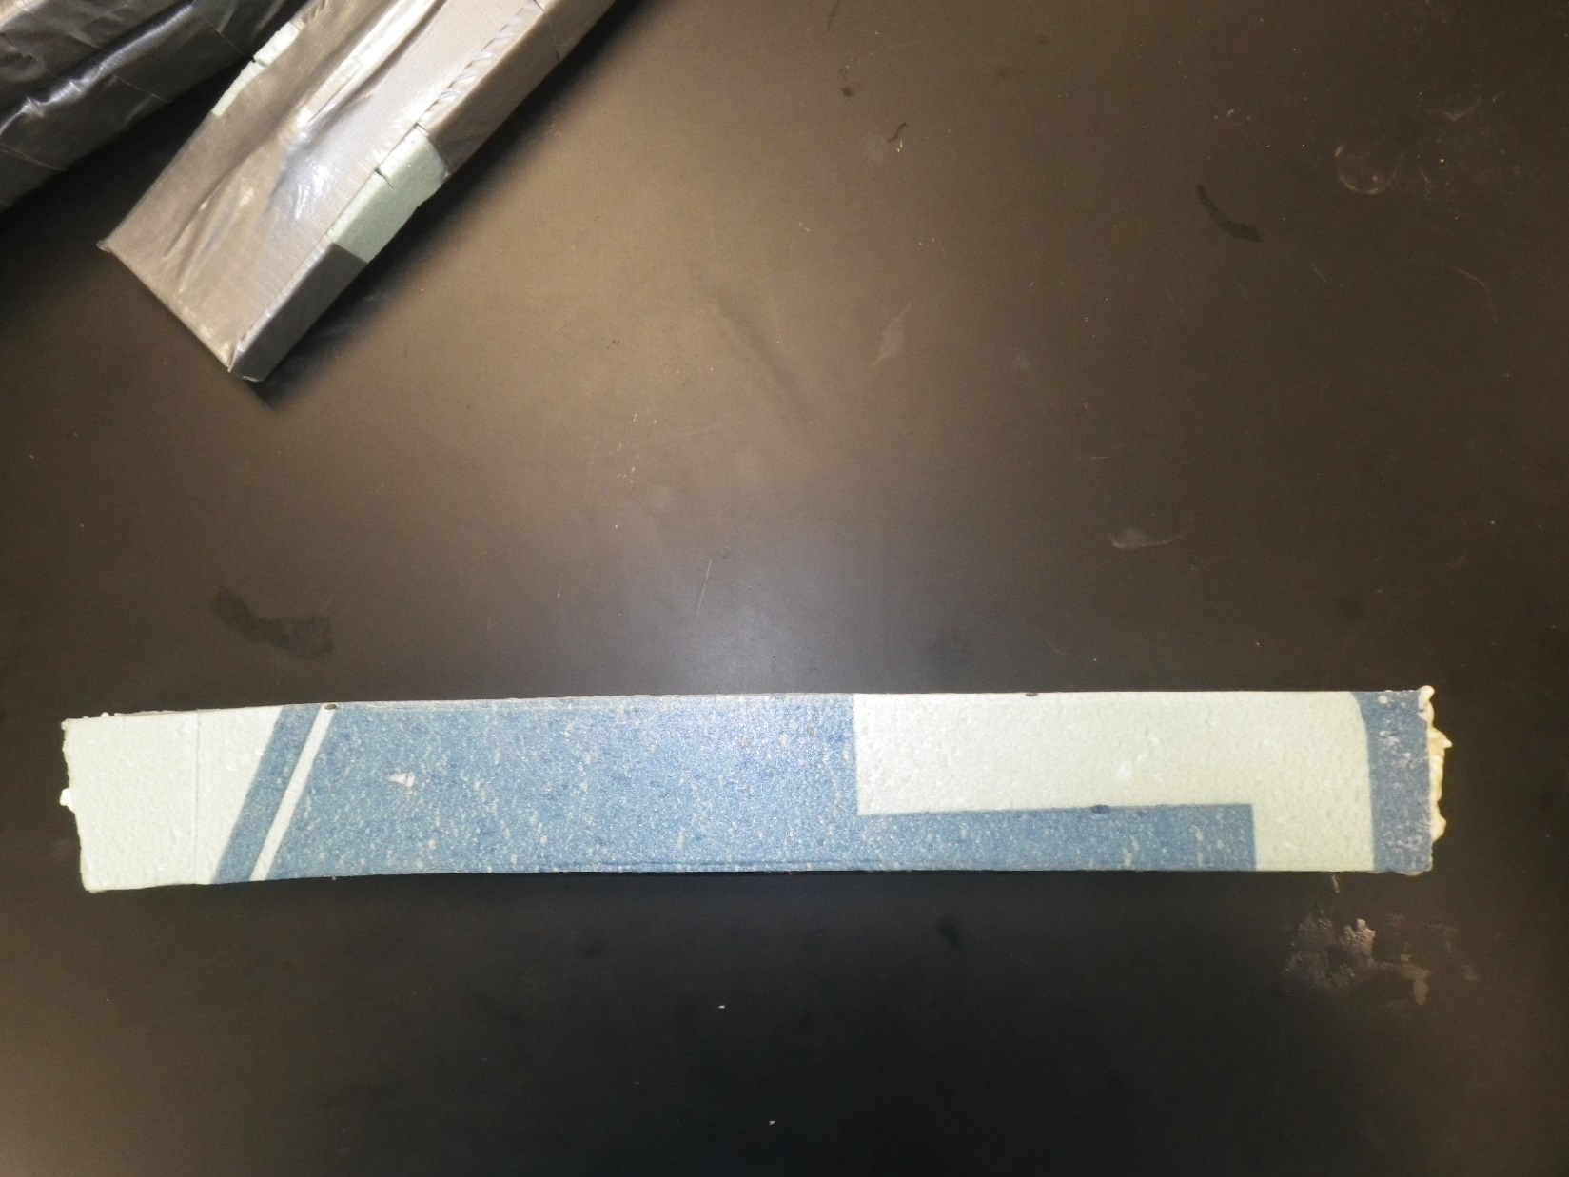

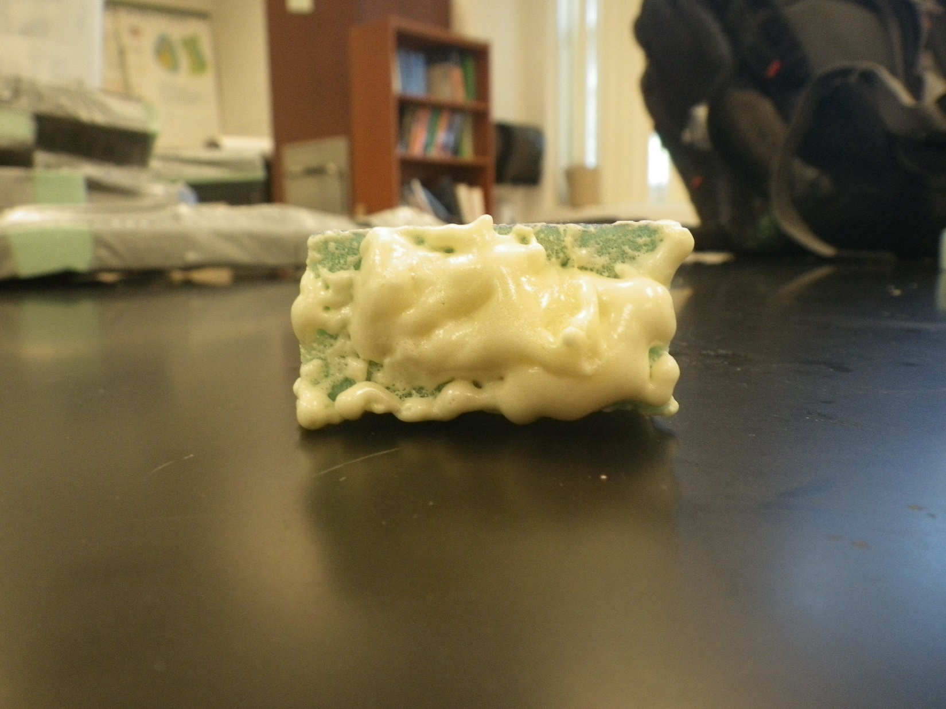

Hollowed out and filled with spray in insulating foam

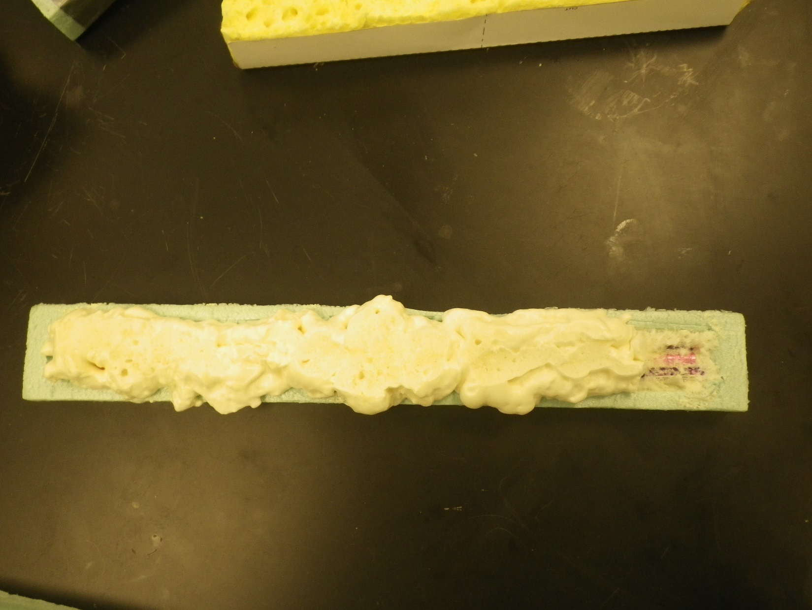
Hollowed out, reinforced with pencils (Pink and purple), and spray in foam insulation.

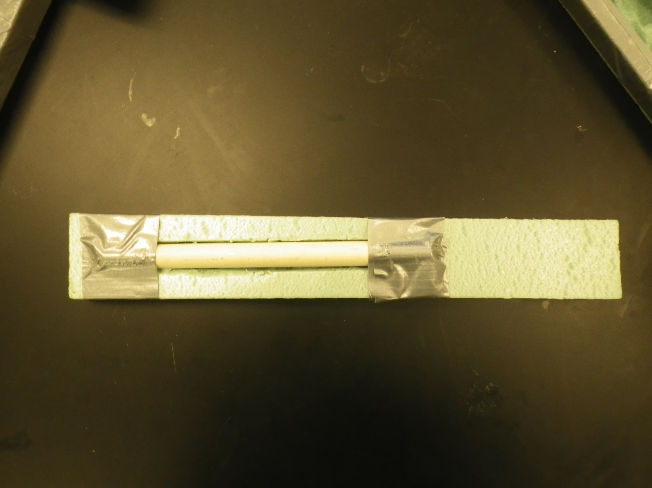
Partially hollowed out, reinforced with PVC pipe held in place with duct tape.

      - You can introduce I- Beams and have students discuss why railroad rails are shaped somewhat like I-Beams as part of the design process.

10. Classroom Crash Test Methods

When we piloted these labs with Laura Moore’s students, it was clear that they were not going to be satisfied until they had their own version of the IIHS crash test. Adding a crash test works with all four of the labs. The safety of your students is paramount. Safety glasses or goggles must be worn. One of our key considerations was designing test methods which keep your students away from the impact event and any flying pieces of the beams. Because of the many options for making beams, we cannot predict the energy needed to do the crash test. This conundrum is actually an opportunity for an engineering exercise to bound the problem of defining a crash test that will be relevant for the beams your students made.

The amount of energy can be scaled to suit your student’s designs, and all three of our proposed methods can be conducted with a fixed impact energy (like the IIHS side crash test) or with a variable energy if you have beams with widely differing stiffnesses.

There are two simple ways to vary the crash energy: change the mass of the impacting object, or change the height from which it is dropped onto the beam. You may recall the relationship between potential energy of an object raised to a height and its kinetic energy once it falls:

Potential energy = Mass*Gravitational Constant*Height
Kinetic energy = ½ (Mass)(Velocity)²
Where m = mass (kg), v=velocity (m/sec), g=gravitational constant (9.8 m/sec² ), h=height (meters)

It may be easiest to agree on a fixed energy and a single failure criterion. For example, if you support the beam on books 3 cm. above the floor and drop a 100 gram weight on the center of the beam from a height of 50 cm, the fixed energy would be:

Energy = (0.100 kg) x (9.8 m/s²) x 0.5 m = 0.49 kgm²/s² = 0.49 Joules

The failure criterion, to make the testing faster for a large group, would be that the beam touches the floor after the impact. This would be like the B pillar deflecting past a certain point on the driver’s seat in the IIHS crash test.

The class “winner” would the lightest beam that survives the impact without touching the floor. The “score” would be based on energy divided by the mass of the beam – a “Specific crash energy” rating, in joules of energy that can be absorbed per gram of beam.

If you choose to vary the energy, the winner would become the lightest beam that required the most energy to touch the floor after impact. The same “specific crash energy” calculation would be made. There may be a cumulative damage process if you raise the weight higher after each test and impact the same area. Students can record the “condition” of their beam after each test to watch for this, and the energy tolerated in the test prior to the beam touching the floor could be used as the maximum tolerable energy to create the final specific crash test energy rating.

Our three crash test methods are:
- Pendulum impact using a ring stand
- Drop impact test using a ladder
- Drop impact test using a PVC pipe

The pendulum impact test shown in Figure 1 is well suited for testing delicate beams, such as the folded card stock in Lab 1. The required materials are a cardboard box, a ring stand, a string, something to use as a weight, a meter stick, a scale, a clamp to hold the ring stand in place, and something to brace the box against. Detailed instructions are below.

The drop impact test using a ladder was conceived to isolate the student’s feet from the impact zone. We can suspend a mass from a string using a household ladder. The beam can be placed across two bricks or heavy books to raise it off the floor. Line up the center of the beam under the weight, then raise the weight to a selected height and release the string. Photos of two examples using a foam filled card stock beam struck with a 2 lb. hand weight (0.93 kg), and lasagna noodles with and without duct tape on the underside being struck by a golf ball follow.

One way to bound the problem of the crash test energy would be to impact sample beams with a variety of balls of various masses dropped from the same height: ping pong ball, marble, baseball, soft ball, or a basketball. The balls could be placed in a mesh bag (e.g. a lingerie bag or mesh from a bag of oranges) which can be tied to the string to reduce variation in the impact angle and strike location compared to dropping the balls freehand. The golf ball example in Figure 2 illustrates this concept.

The students can define the criteria for “passing” the crash test – least deflection for a given impact energy would be one criterion – measure the deflection with the weight still on the beam. The deflection scores could be multiplied by the mass of the beam to bring in the concept of light weight design. The lowest product of deflection and mass would win.
The third impact test is also a mass dropped from a fixed or variable height. It is based on a test devised by ASM Master Teacher Scott Spohler, and can be used to test cement pucks as well as for this lab. Scott drilled holes along the length of a PVC pipe. A bolt or pin is placed in one of the holes, and a weight is dropped down the pipe until it stops against the bolt. The beam sample is placed below the pipe, and the bolt is pulled out of the drilled hole to release the weight. The impact zone is confined to the area immediately below the pipe, and the weight trajectory is predictable. There are photos showing this below.

Pendulum Impact Test Details:
Equipment:
Ring stand
8 oz. water bottle with cap
String
Small cardboard box, 6-8” long
Scissors
C or Flat Clamp
2 Rulers
Masking tape
Graph Paper
(Optional – build a simple wooden box, or put slits in a clear plastic box of suitable size instead of using the shoe boxes.)

Note: The support for the beams is moved from the sides to the ends to open up a space for the pendulum to impact the beam. The fundamental effects of the beam shape on the deflection created by an impact should carry over from the stacked weight experiment.

Remind students that in the crash test video, the car hit with a fixed impact energy. After impact, the deflection of the B Pillar was measured. This lab can be run with fixed or variable impact energies by changing the mass of the impactor (water bottle) or by varying the height from which the bottle is released. To provide the best match to the crash test video, this procedure is written based on a fixed energy with the deflection resulting from the impact being the dependent variable.

Set Up:
      - Place a ring stand on a table, near the edge.
      - Hang a small (e.g. 8 oz) water bottle with a cap from the ring stand. Adjust the string length so the water bottle hits the center of the beam length. You will need to do some preliminary testing to determine how much water to put in the bottle. Mass the water bottle, water, and string: M = ____grams.
      - Make slits in a cardboard box approximately 6-8” long (or wood box ). The slits should be long enough to slide the card stock beam legs into the slits so the wide part of the beam is in contact with the edge of the box. The slits should be centered along the box width, and should be 2.5 cm and 4 cm apart. The beams need to overhang the ends of the boxes, or they will slip out of the slits when impacted. (See Figure 1.)
      - Cut a portion of one side of the box away to create a “window” to view the impacted beams. (See Figure 1.)
      - Clamp the box and ring stand to the table. I didn’t have a suitable clamp to fit inside the box, so I used a paint stir stick to do the best I could, then braced the back of the box against a jug of water so it didn’t move. I found that placing the box opening just behind the ring stand so that one end of the beam was in contact with the ring stand worked well. In a sense, having the support of the ring stand on the end of the beam is like having the B pillar attached to the roof of the car.
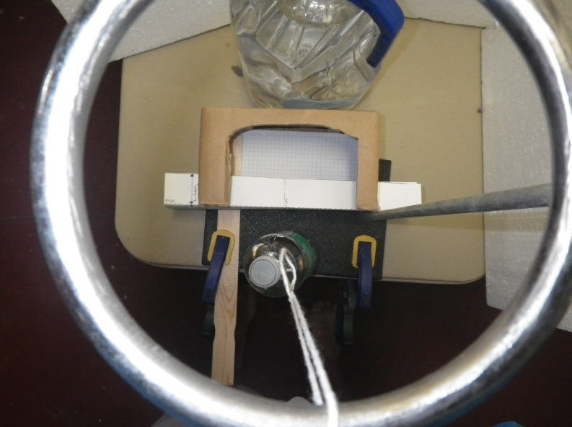
Figure 1: Side and top view of the pendulum impact test. Quadrille paper inside the cardboard box can be used to measure final deflection, or to provide a background for a cell phone video of the impact event.

      - Put a line of masking tape on the ring stand straight out from the center of the beam as a guide for the pendulum path – you want to get a direct hit, without angular variation. You may also want to put a piece of tape on the ring to help align the string for the impact.

      - (Optional) Place a ruler at the end of the tape to measure the height of the water bottle at the top of the pendulum swing. You want to impact the beams with a consistent potential energy. I just lifted the bottle to a visually determined 90°, even with the top of the ring stand
A. Determine the height for the students to use: ___ cm.
B. Calculate the potential energy for your test: PE = mgh = ___ Joules

      - Have a second ruler available to measure the maximum beam deflection after impact, while the beam is still in the shoebox fixture, or tape a piece of graph paper in the box to use as a measure of maximum deflection. To accelerate testing, you could mark “good/pass/fail” deflection zones on the graph paper, similar to the system used by the IHSS crash tests.

Test Procedure (for folded cardstock beams in Lab 1):
            - Prepare new “Channel A” and “Channel B” samples. Reusing samples that collapsed under the weight bearing test may cause poor results in the impact test.
            - Mass the samples and record the mass:
  - Channel A ___________grams

  - Channel B ___________grams
- Slide the 4 cm wide Channel A into the slits in the test fixture.
- With the string fully extended, raise the water bottle to a height of __ cm. Use the masking tape line to align the bottle with the center of the beam.
- Smoothly release the bottle, without trying to throw or push it toward the beam.
- Measure the maximum deflection of your beam from its starting position using the edge of the box as “zero”. Y = ___ cm
- Determine your Channel A score:
  - Divide the maximum deflection by the mass: S =Y/m =
  - Lowest score wins.
- Repeat the test for Channel B, using the slots that are closer together to hold the skinnier beam.
  - Maximum deflection, Y= ___
  - Channel B Score, S = Y/m = ____
- Which beam had a better score, A or B?
- Who had the best score in the class and how much different were the scores within each beam shape?

Ladder Impact Drop Test:

This test is quite straightforward. Tie a weight to a string and place books or bricks under the ladder. The test energy is determined by the mass of the weight and the height from which it is dropped. The string can be either inserted through a hole in the top of the ladder or simply hung over a step, and the steps can make convenient visual references for fairly consistent starting heights. Figure 2 shows an example using a 2 lb. handweight, and Figure 3 shows a golf ball used as the weight for more delicate beams, such as the lasagna noodle with duct tape in Lab 3.

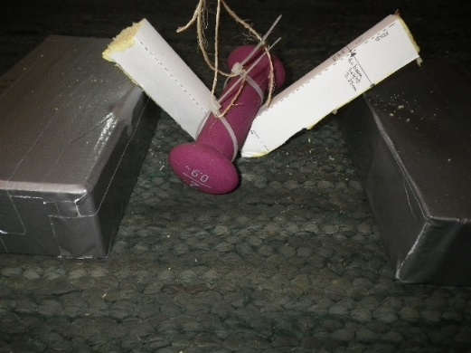
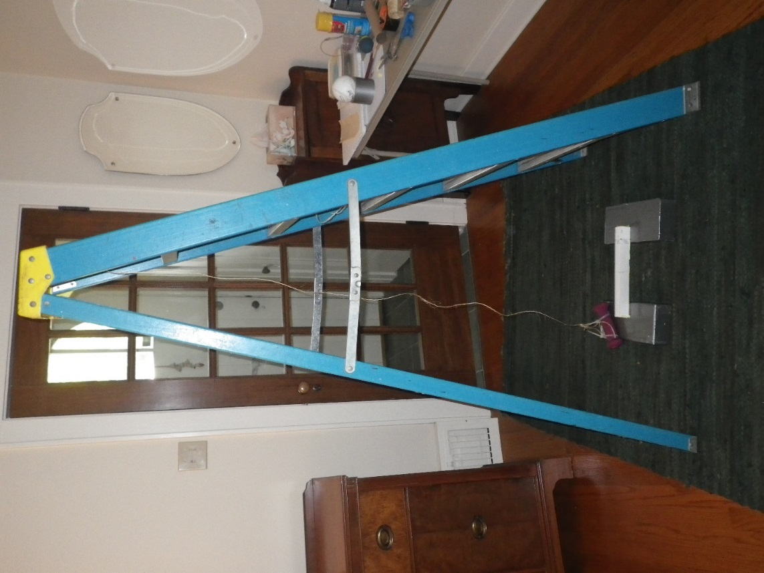
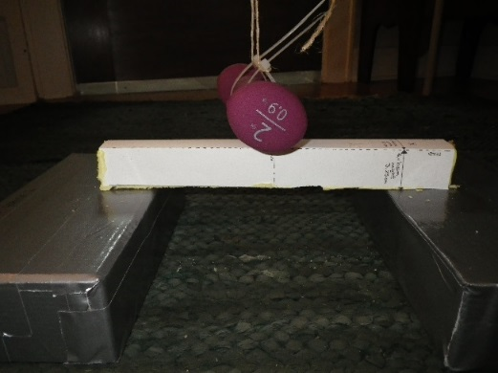
Figure 2: Crash test using a household ladder, string, a hand weight, and a beam placed across two duct tape wrapped bricks.

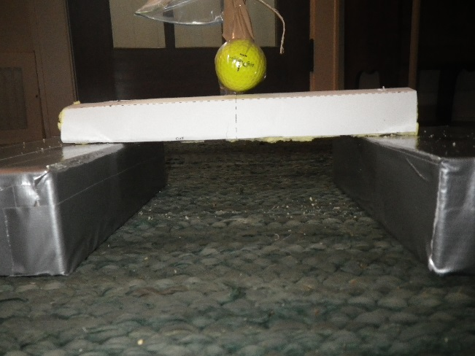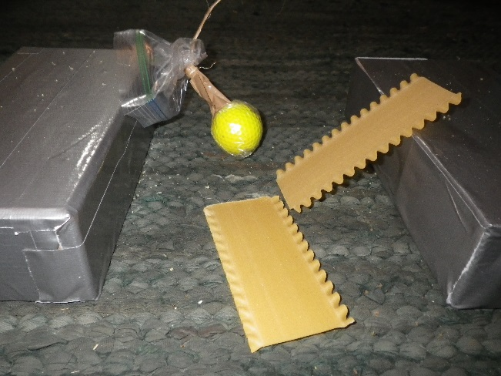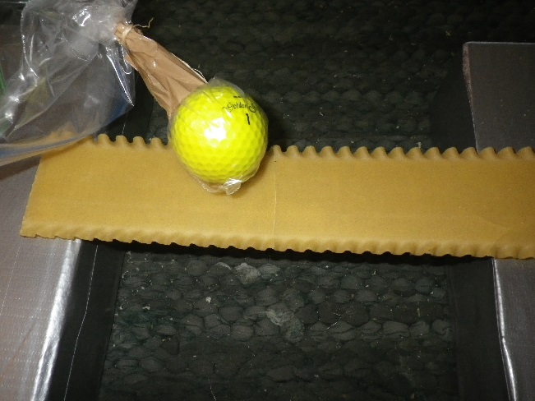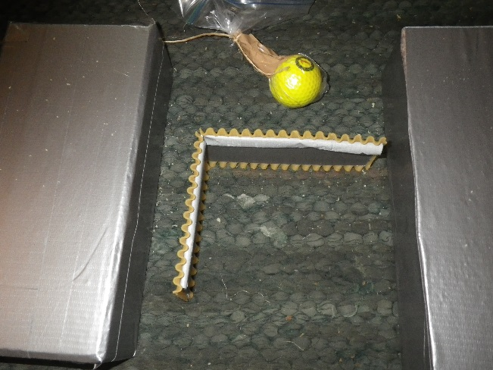
Figure 3: This is the same set up with a golf ball in a plastic bag as the weight for weaker beams. The unreinforced lasagna noodle broke when the weight was dropped from a height even with the first step of the ladder. The ball bounced off the reinforced noodle and a foam filled beam when dropped from the same height. Dropping the ball from the 3rd step of the ladder produced no damage to the foam filled beam, but the duct taped noodle cracked completely across the width and through the thickness (black arrow). The noodle beam remained intact and undeflected despite the crack because the duct tape on the underside provided reinforcement, but bent easily when picked up from the bricks.

PVC Pipe Drop Weight Impact Test

This method was contributed by ASM Master Teacher Scott Spohler.

Materials & Equipment
1 ¼” diameter PVC pipe, 5 feet long.
An old brass weight, a large ball bearing, a piece of 1” diameter steel bar etc. as the weight to be dropped.
1 long bolt or clevis pin, about ¼” diameter and 4” long.
3/8” drill bit and an electric drill or drill press.
Meter stick or tape measure
Permanent marker
String
Zip ties or wire
Optional: A PVC pipe connector if you want to cut the pipe into shorter lengths for easier storage.

Method
- Mark the hole locations at 2” intervals along the length of the pipe.
- Using a drill slightly larger than the bolt or clevis pin (3/8”in this case), and keeping the drill perpendicular to the PVC, drill a hole through the pipe. A drill press is a big help here. If you do it by hand, have a partner hold the pipe and with a nail, punch a starter point to help keep the drill steady. Or, drill a small pilot hole first.
- Attach the PVC pipe to something that will keep it vertical using the zip ties or wire. The bottom of the pipe should be just above where you will place the beams supported by books or bricks to elevate them from the floor.
- Tie a string to the clevis pin, insert it in the hole, then set the mass on it. Pull the pin!

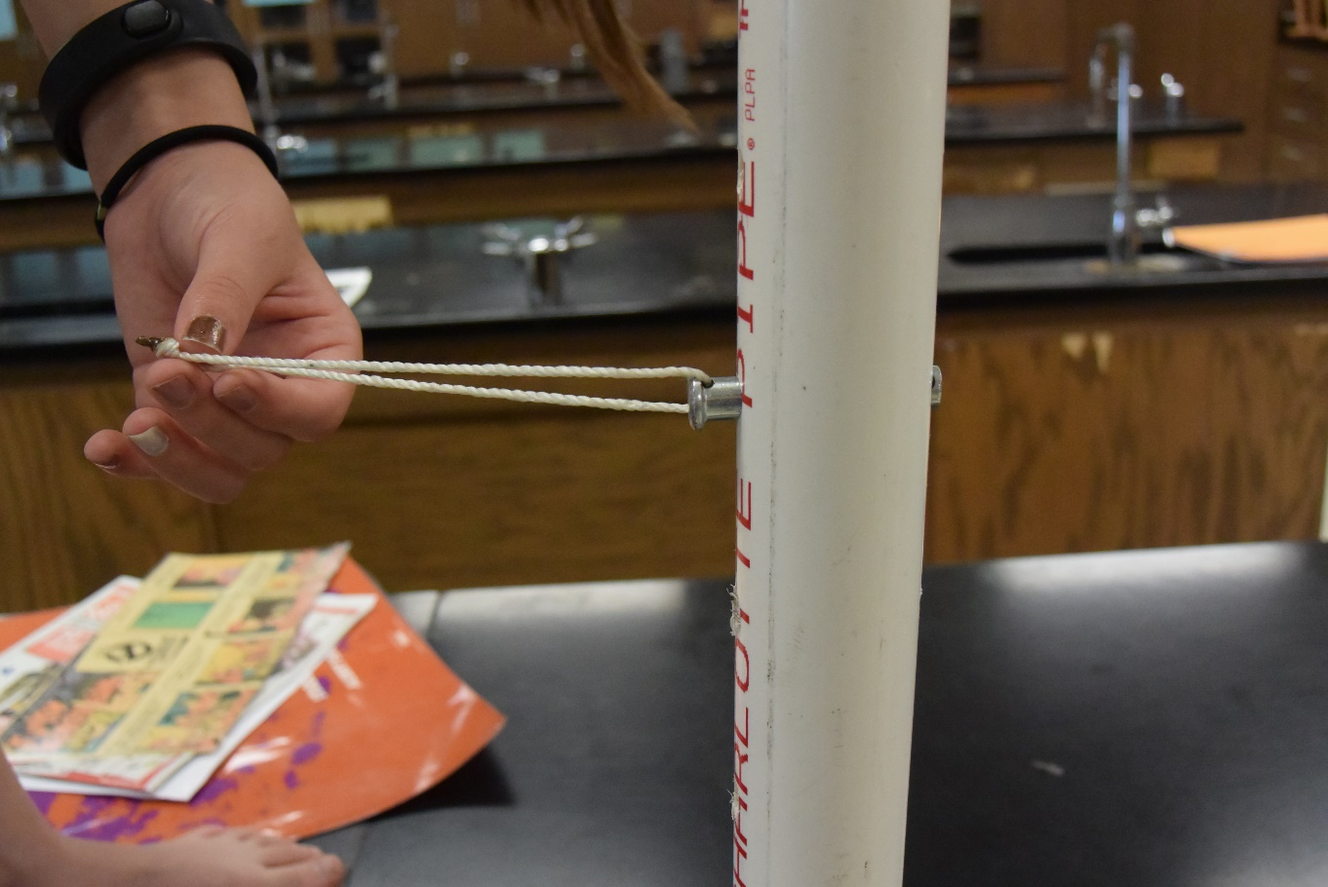
Figure 4: Clevis pin in PVC pipe.

- Classroom Video Discussion Starters

We prepared three short videos to serve as classroom discussion starters, originally intended to focus on the topic of lightweight design. In the end, they touch on a number of materials engineering aspects of a lower leg prosthetic used by a young athletic woman. Nicole Ver Kuilen lost her leg to childhood bone cancer. A year later, her parents signed her up for soccer and she is an inspiration. We thought it would be interesting to understand how the mass of the prosthetic leg affected what Nicole can do, and we were thrilled to be able to talk with the person who made her leg about the engineering and manufacturing processes that were required. Each video is 3-4 minutes long.

In Video 1 we meet Nicole Ver Kuilen and hear how she came to be an amputee. She describes some of the limits of her prosthetic leg, specifically corrosion problems caused by exposure to water when she was backpacking in the Pacific Northwest and had to cross many rivers. She also talks about a campaign to raise awareness of the barriers patients face in accessing prostheses – she does many sports but has only one leg for them. In Video 2, we take a closer look at some of the materials science issues in Nicole’s prosthetic. The locking system that attaches it and some of the steel bolts critical to her safety rust when they get wet. Her foot is made of carbon fiber composite, which is prone to delamination and wear when you are training for half marathons. That’s a problem because her foot costs $5,000 to replace (in 2017). She has a special sock made from ultrahigh molecular weight polyethylene to protect the carbon fiber from wear. Our final video stars Natalie Harold, a resident in Prosthetics, who made Nichol’s current leg. She describes how the materials used to construct the leg are selected. The heavier and more active the patient, the denser the metal components need to be to have adequate strength. Then, we have a behind the scenes look at some of the processes involved in creating these one of a kind prostheses for each patient. These include white light scanning to create 3D geometry of the residual limb, computer aided design and machining, making a thermoplastic test socket from PET plastic before creating the final socket from vacuum molded carbon fiber composites.

We hope you’ll find these suggested discussion questions for each video helpful.

Episode 1: Intro to Nicole.

What would it be like to be an amputee?
How would the mass of the prosthetic affect what you can do?
What other properties or characteristics of materials engineering besides mass influence the function of a prosthetic limb?
(Stiffness, fatigue strength, thermal conductivity, corrosion, resistance to UV light, antimicrobial features, hydrophilic/hydrophobic….)
How do these characteristics and properties relate to the type of material used?
What kinds of materials do you think are used in prosthetic limbs, and why would you pick a certain material for a certain part of the prosthetic?
How many different types of materials do you think are used to make Nicole’s leg?

Episode 2: Materials Engineering Topics with Nicole
Why would corrosion be important to Nicole?

(She had to carry an extra leg with her on hikes in Costa Rica so she didn’t get her good leg wet. The spare leg weighs about 1.5 kg. If the pin lock system corrodes she can get stuck in her leg. Corrosion on the bolts might make them weaker.)

What if she only had one leg that wasn’t waterproof – could she be as adventurous?

What other every day activities would this affect? (Balancing in shower, getting caught in the rain, swimming, kayaking/canoeing.)

Where did you see examples of corrosion in the video? (Bolts, pin)

How many different kinds of materials (e.g. metals, composites, polymers…)did you see when Nicole showed you her prostheses?
There are examples of all 3, and you can discuss whether the carbon fiber in the carbon fiber composite should be classified as a ceramic or a polymer.

Career information: Materials engineers have to understand how different materials break or fail to function. Corrosion in the iron parts can cause the pin lock system to get stuck so Nicole can’t get her leg off. Materials engineers can specialize in understanding how to prevent and control corrosion. The separation in the carbon fiber composite foot is also an example of a failure mechanism. Understanding how to keep the layers of the composite bonded together under repeated flexing is part of materials engineering. Another career within the field of materials science and engineering is “Tribology”, the study of wear. Nicole had problems with the carbon fiber composite wearing when she got a hole in her special sock and the carbon fiber rubbed against the polymer foot shell. A tribologist might study how a coating could be added to the carbon fiber foot to protect it. Students can research career opportunities in Tribology and Corrosion Engineering.

Additional examples of wear related issues: the socket in a hip replacement, and the effects of any small particles from wear of implants which can react badly with the body.

Polymers: The polymer fiber used in the socks is ultrahigh molecular weight polyethylene. It is also used to make the tethers for astronauts on space walks, cut resistant body armor, and dental floss. In addition to protecting the carbon fiber foot from rubbing and wearing, it also prevents squeaks that occur when the carbon fiber composite rubs against the foot shell. (Nicole’s friend’s nicknamed her “Squeaky” for awhile.) The noise absorbing and transmitting properties of materials are a factor when materials are chosen. Examples are polymer gears to eliminate noise, and special sound absorbing decals used in automotive structures.

Episode 3: Natalie – behind the scenes look at prosthetic design and production

A lot of the structural parts of the prosthetic were made from metal. What metals were mentioned, and how did Natalie decide which metal was needed when she was picking from that list for a particular patient?
(Al, Ti, Stainless Steel….weight and activity level of the patient)

How many different kinds of materials were mentioned or shown – metals, polymers, ceramics….?
They may miss ceramics – used in the plaster casts. Metals – pylons, shown in pictures of the “ankle”. Polymers – test sockets made from PET “pop bottle plastic”, the foam blocks that are machined by CNC from the white light scans, resin for the carbon fiber composite, foot shell.

Where did you see a thermoplastic polymer? (Test socket – PET, easy to shape)
Where did you see a thermoset polymer (Carbon fiber composite socket – once it’s made, it’s done.)

Why would they do a white light scan then CNC machine a big block of polymer foam to make the mold for the test socket instead of 3D printing?

Carbon fiber composite used in two places for different reasons – the foot has to flex (fatigue) and be light weight, and the socket has to be stiff and lightweight. Where else would you see a fatigue limited application of a carbon fiber composite?
787 airplane wings, wind turbine blades.

- Further Information

Please visit the Teachers Resources area at the ASM International Materials Education Foundation to access more lab ideas, learn about the ASM Teachers Materials Camp® program, http://www.asmfoundation.org/who-we-impact/teachers/educator-resources/

The classroom discussion starter videos will be posted on You Tube, and also within the teacher resources area of the ASM Website. Location TBD – need help from Ginny.

Our sponsoring organization, Lightweighting Innovations For Tomorrow, also has an extensive and growing library of teacher resources related to materials science and manufacturing processes. You can access their materials and videos at http://liftlearninghub.com/learninghub

Private communication, Katya Kritsuk, Oct. 30, 2017 based on her research published in http://www.sciencedirect.com/science/article/pii/S1751616117303065#
F. Xu, G. Sun, G. Li, Q. Li, “Crashworthiness design of multi-component tailor-welded blank (TWB) structures”, Struct. Multidisc. Optim. V. 48, pp. 653-667, 2013.
http://engineering.sjsu.edu/e10/wp-content/uploads/Structure_Stiffness_S13.pdf
https://www.dynamore.se/en/resources/papers/07-forum/crash/crash-performance-increase-with-structural

