**Teacher Notes on Classroom Crash Test Methods**

When we piloted these labs with Laura Moore’s students, it was clear that they were not going to be satisfied until they had their own version of the IIHS crash test. Adding a crash test works with all four of the labs. The safety of your students is paramount. Safety glasses or goggles must be worn. One of our key considerations was designing test methods which keep your students away from the impact event and any flying pieces of the beams. Because of the many options for making beams, we cannot predict the energy needed to do the crash test. This conundrum is actually an opportunity for an engineering exercise to bound the problem of defining a crash test that will be relevant for the beams your students made.

The amount of energy can be scaled to suit your student’s designs, and all three of our proposed methods can be conducted with a fixed impact energy (like the IIHS side crash test) or with a variable energy if you have beams with widely differing stiffnesses.

There are two simple ways to vary the crash energy: change the mass of the impacting object, or change the height from which it is dropped onto the beam. You may recall the relationship between potential energy of an object raised to a height and its kinetic energy once it falls:

Potential energy = Mass*Gravitational Constant*Height

Kinetic energy = ½ (Mass)(Velocity)2

Where m = mass (kg), v=velocity (m/sec), g=gravitational constant (9.8 m/sec2 ), h=height (meters)

It may be easiest to agree on a fixed energy and a single failure criterion. For example, if you support the beam on books 3 cm. above the floor and drop a 100 gram weight on the center of the beam from a height of 50 cm, the fixed energy would be:

Energy = (0.100 kg) x (9.8 m/s2) x 0.5 m = 0.49 kgm2/s2 = 0.49 Joules

The failure criterion, to make the testing faster for a large group, would be that the beam touches the floor after the impact. This would be like the B pillar deflecting past a certain point on the driver’s seat in the IIHS crash test.

The class “winner” would the lightest beam that survives the impact without touching the floor. The “score” would be based on energy divided by the mass of the beam – a “Specific crash energy” rating, in joules of energy that can be absorbed per gram of beam.

If you choose to vary the energy, the winner would become the lightest beam that required the most energy to touch the floor after impact. The same “specific crash energy” calculation would be made. There may be a cumulative damage process if you raise the weight higher after each test and impact the same area. Students can record the “condition” of their beam after each test to watch for this, and the energy tolerated in the test prior to the beam touching the floor could be used as the maximum tolerable energy to create the final specific crash test energy rating.

Our three crash test methods are:

1. Pendulum impact using a ring stand
2. Drop impact test using a ladder
3. Drop impact test using a PVC pipe

The pendulum impact test shown in Figure 1 is well suited for testing delicate beams, such as the folded card stock in Lab 1. The required materials are a cardboard box, a ring stand, a string, something to use as a weight, a meter stick, a scale, a clamp to hold the ring stand in place, and something to brace the box against. Detailed instructions are below.

The drop impact test using a ladder was conceived to isolate the student’s feet from the impact zone. We can suspend a mass from a string using a household ladder. The beam can be placed across two bricks or heavy books to raise it off the floor. Line up the center of the beam under the weight, then raise the weight to a selected height and release the string. Photos of two examples using a foam filled card stock beam struck with a 2 lb. hand weight (0.93 kg), and lasagna noodles with and without duct tape on the underside being struck by a golf ball follow.

One way to bound the problem of the crash test energy would be to impact sample beams with a variety of balls of various masses dropped from the same height: ping pong ball, marble, baseball, soft ball, or a basketball. The balls could be placed in a mesh bag (e.g. a lingerie bag or mesh from a bag of oranges) which can be tied to the string to reduce variation in the impact angle and strike location compared to dropping the balls freehand. The golf ball example in Figure 2 illustrates this concept.

The students can define the criteria for “passing” the crash test – least deflection for a given impact energy would be one criterion – measure the deflection with the weight still on the beam. The deflection scores could be multiplied by the mass of the beam to bring in the concept of light weight design. The lowest product of deflection and mass would win.

The third impact test is also a mass dropped from a fixed or variable height. It is based on a test devised by ASM Master Teacher Scott Spohler, and can be used to test cement pucks as well as for this lab. Scott drilled holes along the length of a PVC pipe. A bolt or pin is placed in one of the holes, and a weight is dropped down the pipe until it stops against the bolt. The beam sample is placed below the pipe, and the bolt is pulled out of the drilled hole to release the weight. The impact zone is confined to the area immediately below the pipe, and the weight trajectory is predictable. There are photos showing this below.

**Pendulum Impact Test Details:**

Equipment:

Ring stand

8 oz. water bottle with cap

String

Small cardboard box, 6-8” long

Scissors

C or Flat Clamp

2 Rulers

Masking tape

Graph Paper

(Optional – build a simple wooden box, or put slits in a clear plastic box of suitable size instead of using the shoe boxes.)

Note: The support for the beams is moved from the sides to the ends to open up a space for the pendulum to impact the beam. The fundamental effects of the beam shape on the deflection created by an impact should carry over from the stacked weight experiment.

Remind students that in the crash test video, the car hit with a fixed impact energy. After impact, the deflection of the B Pillar was measured. This lab can be run with fixed or variable impact energies by changing the mass of the impactor (water bottle) or by varying the height from which the bottle is released. To provide the best match to the crash test video, this procedure is written based on a fixed energy with the deflection resulting from the impact being the dependent variable.

Set Up:

* + - 1. Place a ring stand on a table, near the edge.
      2. Hang a small (e.g. 8 oz) water bottle with a cap from the ring stand. Adjust the string length so the water bottle hits the center of the beam length. You will need to do some preliminary testing to determine how much water to put in the bottle. Mass the water bottle, water, and string: M = ____grams.
      3. Make slits in a cardboard box approximately 6-8” long (or wood box ). The slits should be long enough to slide the card stock beam legs into the slits so the wide part of the beam is in contact with the edge of the box. The slits should be centered along the box width, and should be 2.5 cm and 4 cm apart. The beams need to overhang the ends of the boxes, or they will slip out of the slits when impacted. (See Figure 1.)
      4. Cut a portion of one side of the box away to create a “window” to view the impacted beams. (See Figure 1.)
      5. Clamp the box and ring stand to the table. I didn’t have a suitable clamp to fit inside the box, so I used a paint stir stick to do the best I could, then braced the back of the box against a jug of water so it didn’t move. I found that placing the box opening just behind the ring stand so that one end of the beam was in contact with the ring stand worked well. In a sense, having the support of the ring stand on the end of the beam is like having the B pillar attached to the roof of the car.

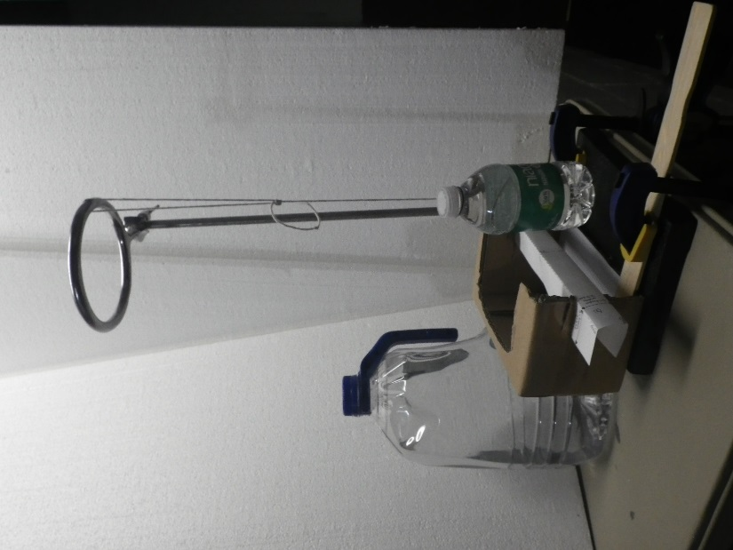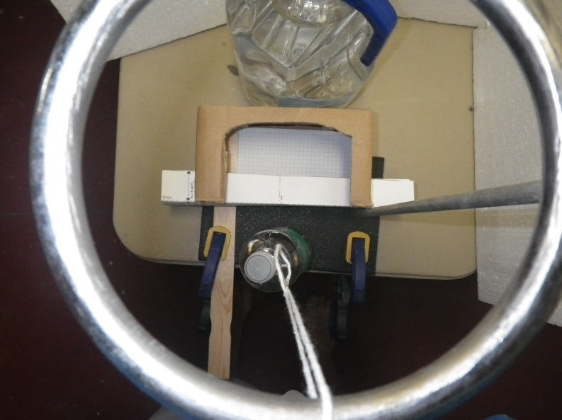

Figure 1: Side and top view of the pendulum impact test. Quadrille paper inside the cardboard box can be used to measure final deflection, or to provide a background for a cell phone video of the impact event.

* + - 1. Put a line of masking tape on the ring stand straight out from the center of the beam as a guide for the pendulum path – you want to get a direct hit, without angular variation. You may also want to put a piece of tape on the ring to help align the string for the impact.
      2. (Optional) Place a ruler at the end of the tape to measure the height of the water bottle at the top of the pendulum swing. You want to impact the beams with a consistent potential energy. I just lifted the bottle to a visually determined 90°, even with the top of the ring stand

A. Determine the height for the students to use: ___ cm.

B. Calculate the potential energy for your test: PE = mgh = ___ Joules

* + - 1. Have a second ruler available to measure the maximum beam deflection after impact, while the beam is still in the shoebox fixture, or tape a piece of graph paper in the box to use as a measure of maximum deflection. To accelerate testing, you could mark “good/pass/fail” deflection zones on the graph paper, similar to the system used by the IHSS crash tests.

Test Procedure (for folded cardstock beams in Lab 1):

Prepare new “Channel A” and “Channel B” samples. Reusing samples that collapsed under the weight bearing test may cause poor results in the impact test.

Mass the samples and record the mass:

* 1. Channel A ___________grams
  2. Channel B ___________grams

1. Slide the 4 cm wide Channel A into the slits in the test fixture.
2. With the string fully extended, raise the water bottle to a height of __ cm. Use the masking tape line to align the bottle with the center of the beam.
3. Smoothly release the bottle, without trying to throw or push it toward the beam.
4. Measure the maximum deflection of your beam from its starting position using the edge of the box as “zero”. Y = ___ cm
5. Determine your Channel A score:
   1. Divide the maximum deflection by the mass: S =Y/m =
   2. Lowest score wins.
6. Repeat the test for Channel B, using the slots that are closer together to hold the skinnier beam.
   1. Maximum deflection, Y= ___
   2. Channel B Score, S = Y/m = ____
7. Which beam had a better score, A or B?
8. Who had the best score in the class and how much different were the scores within each beam shape?

**Ladder Impact Drop Test:**

This test is quite straightforward. Tie a weight to a string and place books or bricks under the ladder. The test energy is determined by the mass of the weight and the height from which it is dropped. The string can be either inserted through a hole in the top of the ladder or simply hung over a step, and the steps can make convenient visual references for fairly consistent starting heights. Figure 2 shows an example using a 2 lb. handweight, and Figure 3 shows a golf ball used as the weight for more delicate beams, such as the lasagna noodle with duct tape in Lab 3.

Figure 2: Crash test using a household ladder, string, a hand weight, and a beam placed across two duct tape wrapped bricks.

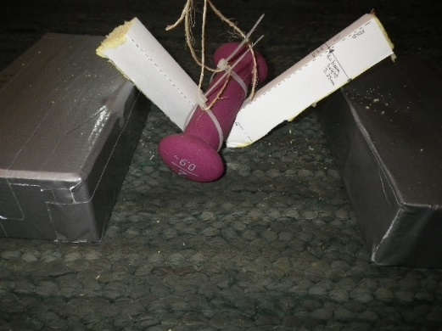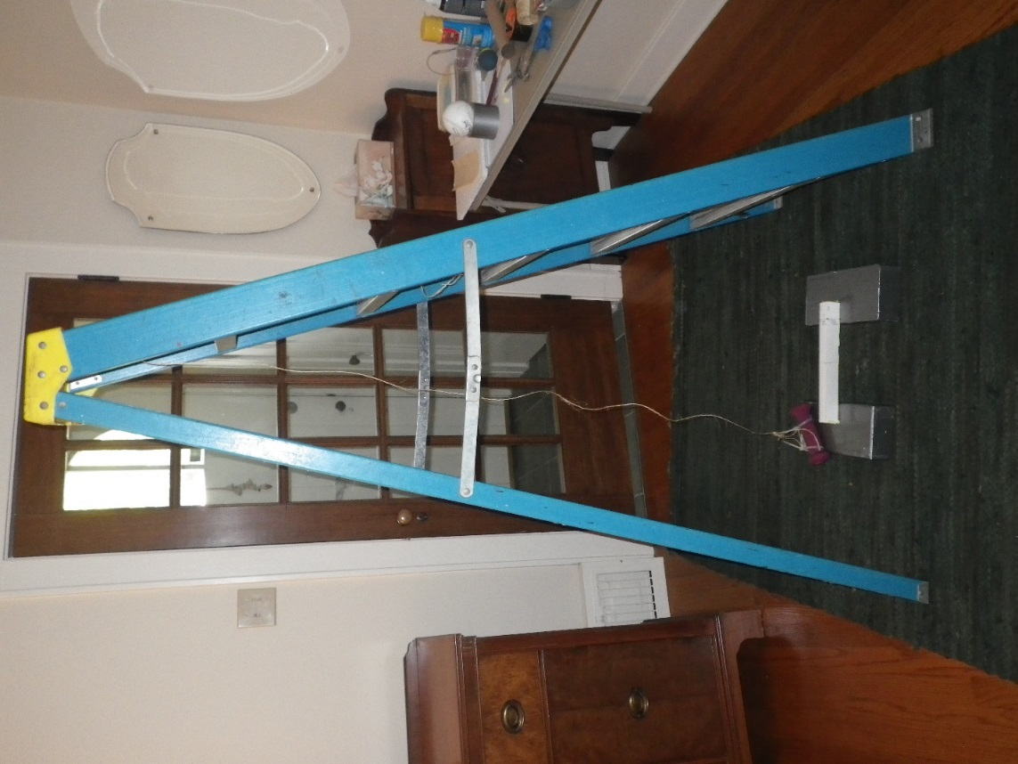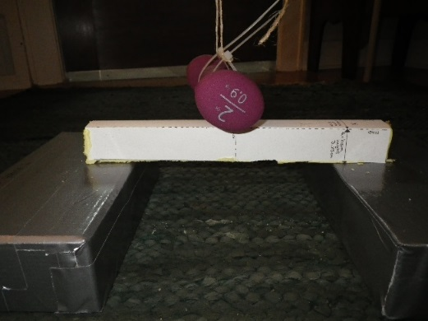

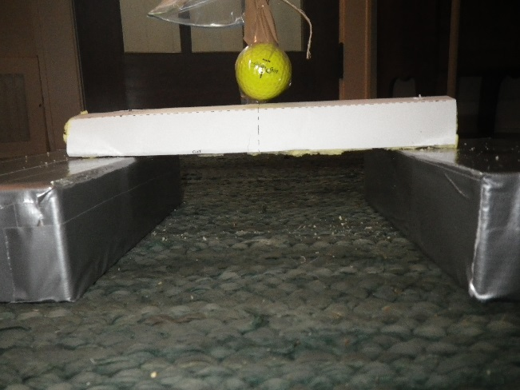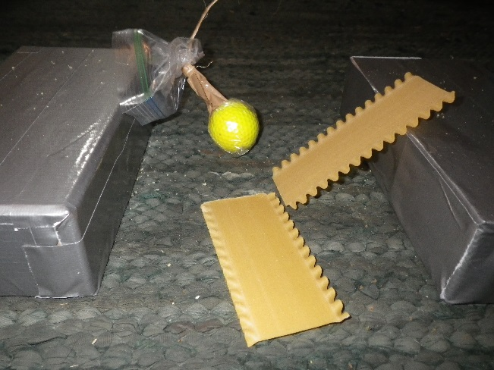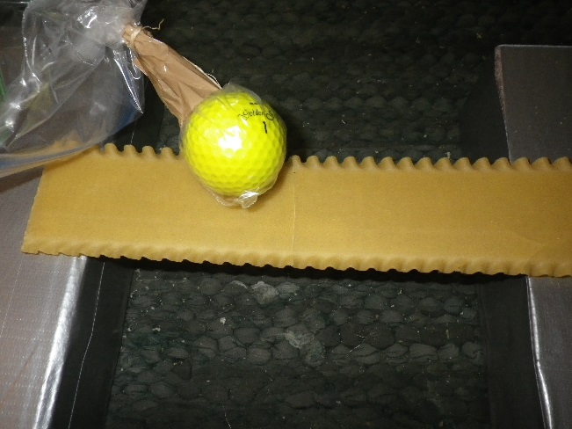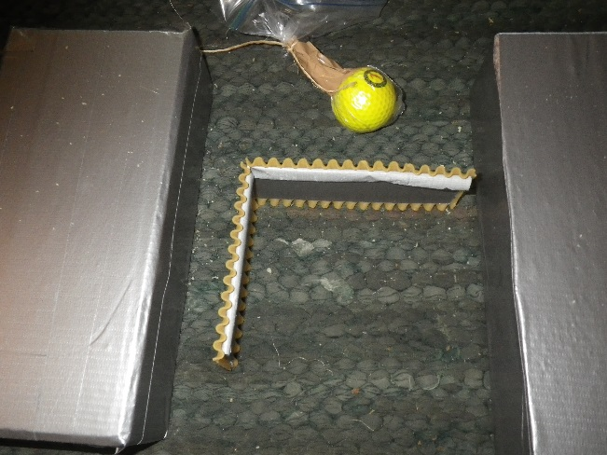

Figure 3: This is the same set up with a golf ball in a plastic bag as the weight for weaker beams. The unreinforced lasagna noodle broke when the weight was dropped from a height even with the first step of the ladder. The ball bounced off the reinforced noodle and a foam filled beam when dropped from the same height. Dropping the ball from the 3rd step of the ladder produced no damage to the foam filled beam, but the duct taped noodle cracked completely across the width and through the thickness (black arrow). The noodle beam remained intact and undeflected despite the crack because the duct tape on the underside provided reinforcement, but bent easily when picked up from the bricks.

**PVC Pipe Drop Weight Impact Test**

This method was contributed by ASM Master Teacher Scott Spohler.

Materials & Equipment

1 ¼” diameter PVC pipe, 5 feet long.

An old brass weight, a large ball bearing, a piece of 1” diameter steel bar etc. as the weight to be dropped.

1 long bolt or clevis pin, about ¼” diameter and 4” long.

3/8” drill bit and an electric drill or drill press.

Meter stick or tape measure

Permanent marker

String

Zip ties or wire

Optional: A PVC pipe connector if you want to cut the pipe into shorter lengths for easier storage.

Method

1. Mark the hole locations at 2” intervals along the length of the pipe.
2. Using a drill slightly larger than the bolt or clevis pin (3/8”in this case), and keeping the drill perpendicular to the PVC, drill a hole through the pipe. A drill press is a big help here. If you do it by hand, have a partner hold the pipe and with a nail, punch a starter point to help keep the drill steady. Or, drill a small pilot hole first.
3. Attach the PVC pipe to something that will keep it vertical using the zip ties or wire. The bottom of the pipe should be just above where you will place the beams supported by books or bricks to elevate them from the floor.
4. Tie a string to the clevis pin, insert it in the hole, then set the mass on it. Pull the pin!

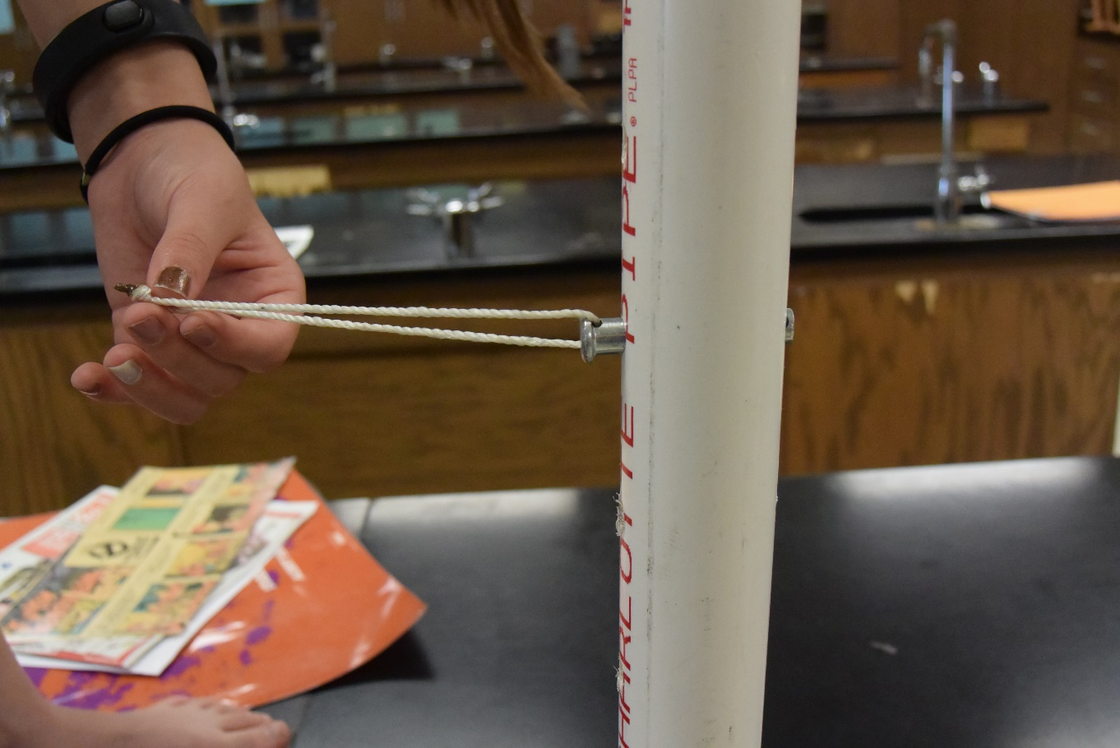

Figure 4: Clevis pin in PVC pipe.